MV4
MV Agusta Brutale 990/ 1090

Fitting kit for the left side
ID | Description | Cat.N | Qt
1 | Steel insert | X2 | 1
2 | Screw M12x95x1.25 | 900 | 1
3 | Dural roller | 1204 | 1
Fitting kit for the righ side
ID | Description | Cat.N | Qt
1 | Steel insert | X2 | 1
2 | Screw M12x95x1.25 | 900 | 1
3 | Dural roller | 1204 | 1

Instruction to assembly:
We recommend to finish one side and than the second one.

- Remove original screws from frame of motorcycle.
- Put steel insert ID1 on screw ID2.
- Through dural roller ID3 tighten protector with screw ID2.

Warning - use the glue on all threads (medium strong)

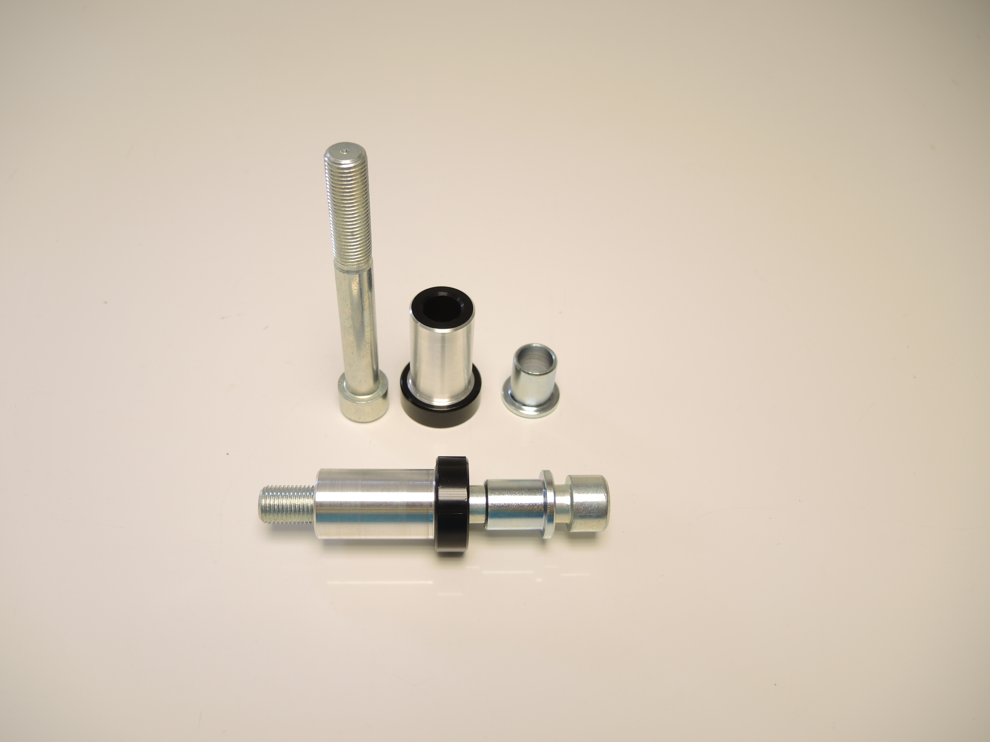

ID2

ID3

ID1

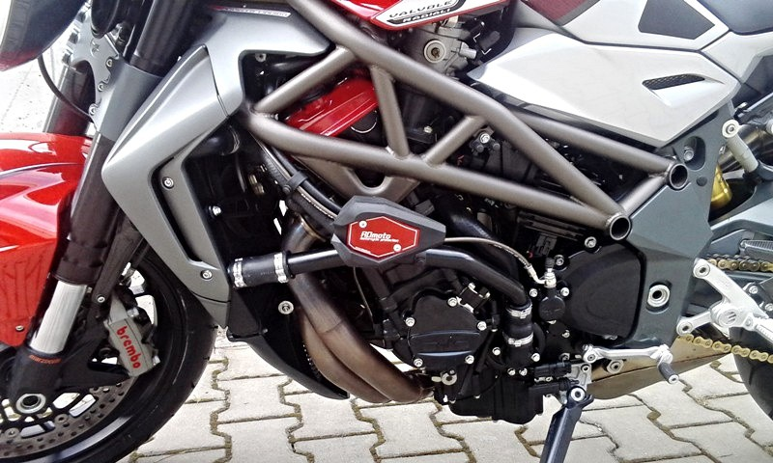
Illustrative picture

