MV5S
MV Agusta Brutale 910

ID. | Description | Cat.no. | Pcs
1 | Bolt M12x80x1,25 | 908 | 2
2 | Dural. cylinder | 1137 | 2
3 | Dural. cylinder 36mm | 1191 | 2
4 | Bolt M6x25 | 877 | 6
5 | Bolt M4x12 | 876 | 4

INSTRUCTIONS:

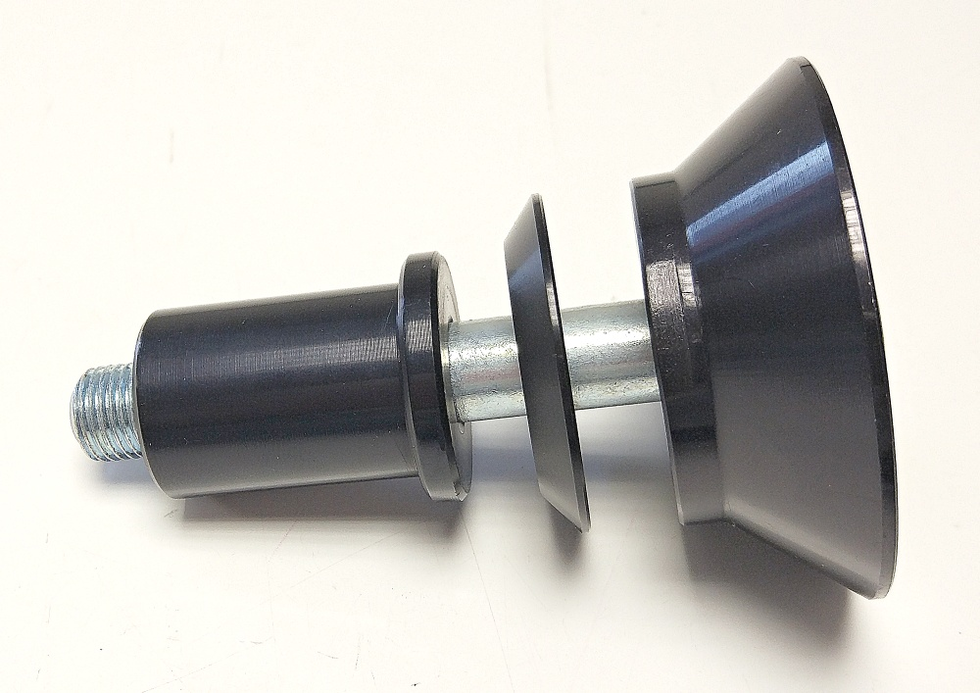
- Prepare bolt ID1 and place all cylinders on it according to the picture below.(the middle part is already part of part ID.2)
- Mount this kit on the frame of motorcycle.
- Fit protector using three M6 bolts.
- Fit cover using two M4 bolts.

We recommend to use safety glue on all threads.

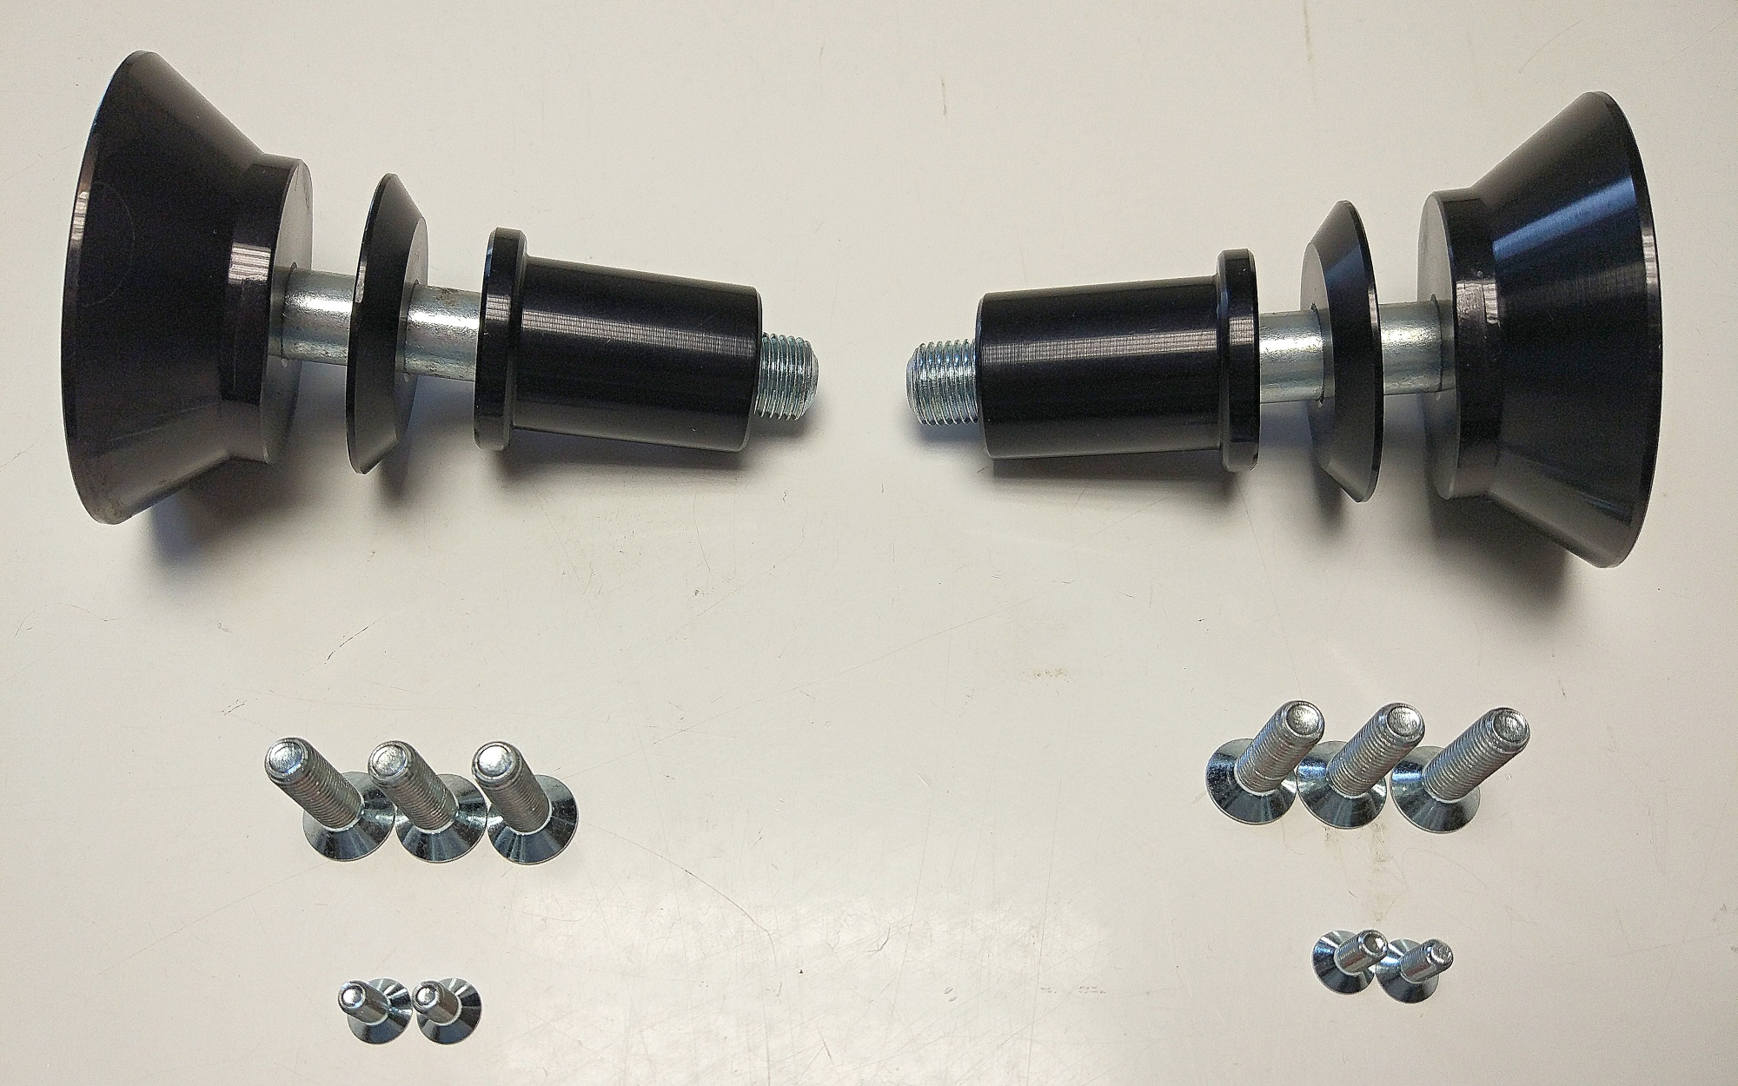
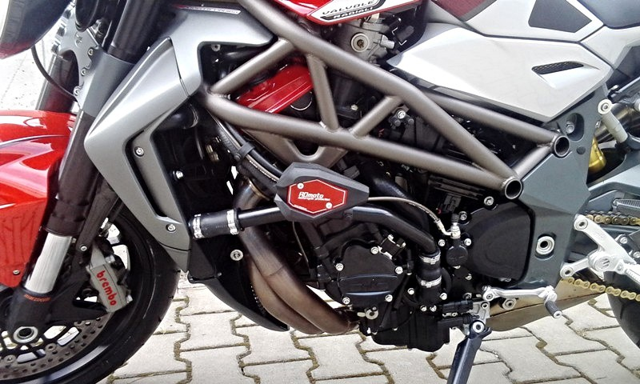
Ilustr. fotografi, místa montáže

