MV5
MV Agusta Brutale 910

ID. | Description | Cat.no. | Pcs
1 | Bolt M12x85x1,25 | 899 | 2
2 | Steel insert | X2 | 2
3 | Dural. cylinder 36mm | 1191 | 2

INSTRUCTIONS

- We recommend to use safety glue on all threads.
- Insert steel insert and bolt into protector.
- Insert cylinder into the frame of motrcycle.
- Fit protector on the frame.

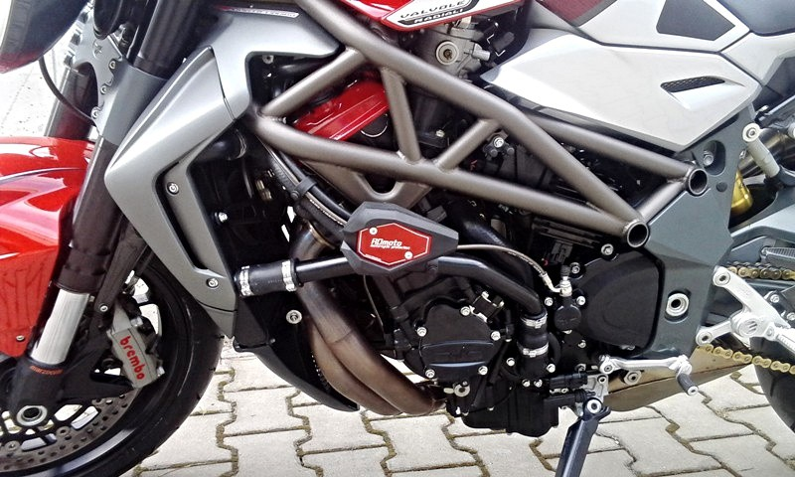
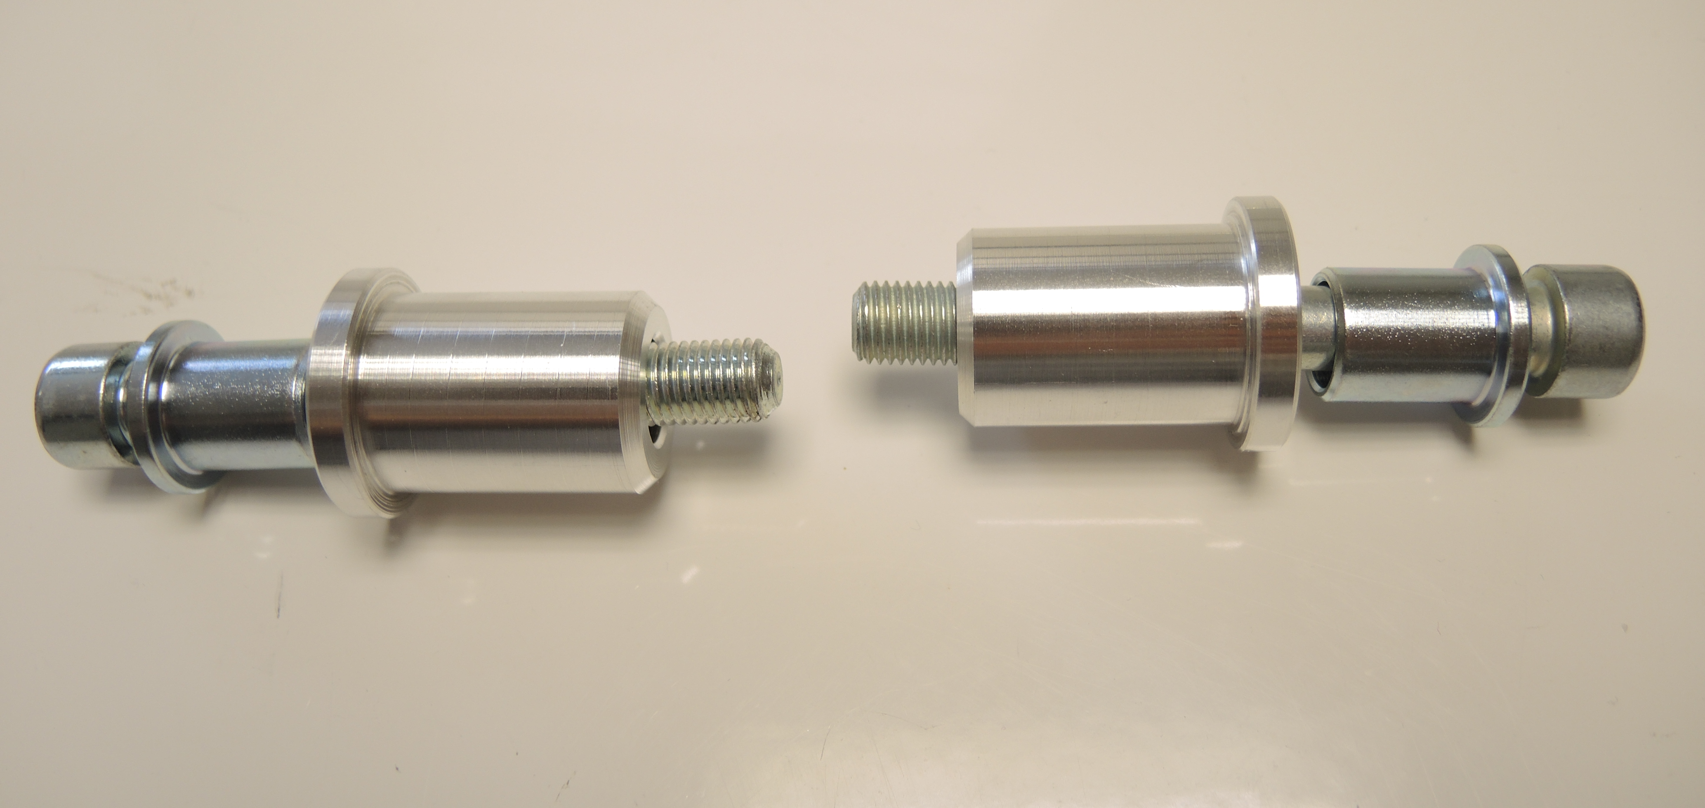
2
3
1
3
2
1

