Cagiva Navigator

Fitting kit left side: Fitting kit right side:
ID | Description | Cat.No | QTY
1 | Steel box M10 | X1 | 1
2 | Screw M10x150x1,25 |  | 1
3 | Dural.cylinder 68mm |  | 1
ID | Description | Cat.No | QTY
1 | Steel box M10 | X1 | 1
2 | Screw M10x135x1,25 |  | 1
3 | Dural.cylinder 77mm |  | 1

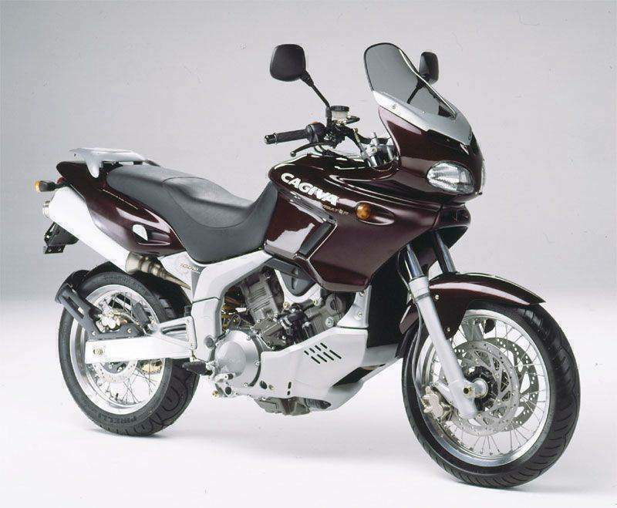

Assembly make to the frame, position on photos. Make first left side.

Assembly to left side:
- Take out original bolt from frame.
- Insert steel box ID.1 into the protector and after insert bolt ID.2.
- Take dural.cylinder ID.3 and insert it on the bolt.
- This kit mount into the frame.
- Thighten the safety bolt on frame.
Assembly to right side:
- Take out original bolt from frame.
- Insert steel box ID.1 into the protector and after insert bolt ID.2.
- Take dural.cylinder ID.3 and insert it on the bolt.
- This kit mount into the frame.

Warning:
We recommend use the glue of all threads. Medium strong.

