O1
Hyosung GT 650Naked/ GT650S

Fitting kit left side: Fitting kit right side:
ID | Description | Cat.N | Qty
1 | Steel box M10 | X1 | 1
2 | Bolt M10x125x1,25 | 924 | 1
3 | Dural.cylinder d=35 | 72 | 1
ID | Description | Cat.N | Qty
1 | Steel box M10 | X1 | 1
2 | Bolt M10x160x1,25 | 929 | 1
3 | Dural.cylinder d=80 | 73 | 1
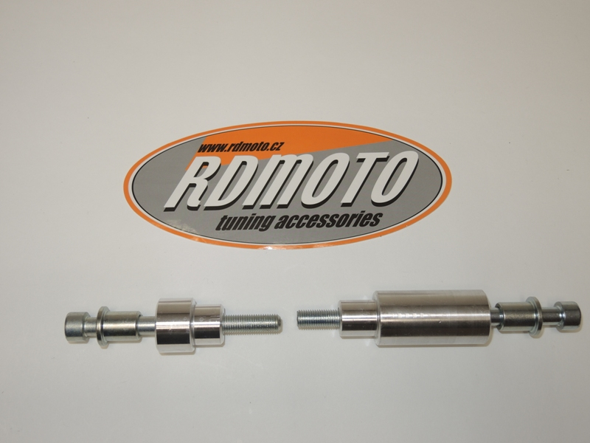

1

1
2
2

3

3

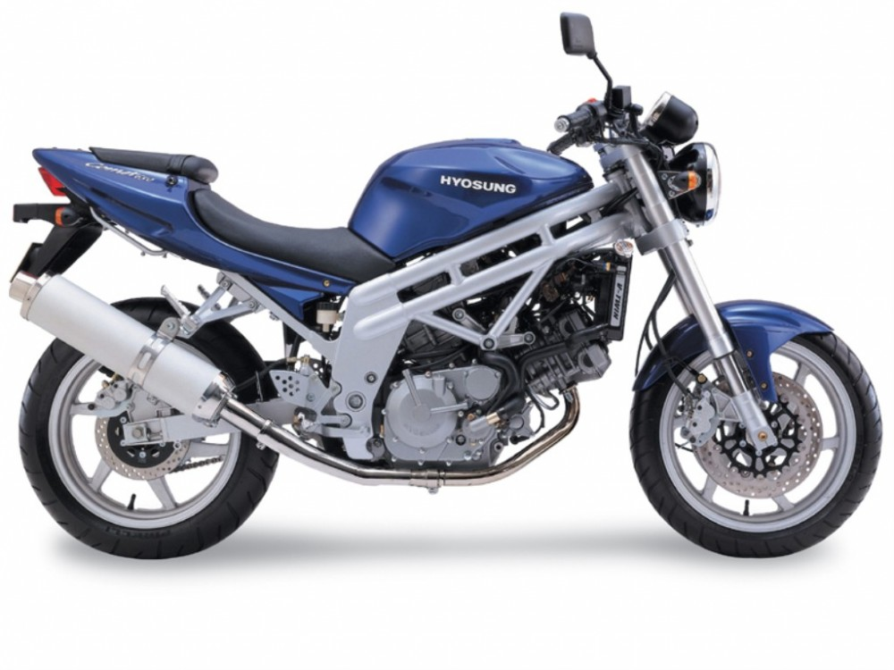

Instruction to assembly:
- Mount to make the place marked on the photo.
- The first dismantle bolt from frame on the right side.
- Into the protector insert steel box ID.1 and bolt ID.2.
- On the bolt insert dural.cylinder ID.3 and this set mount on the bike.
- For left side is same instruction.

Warning: We recommend use the glue of all threads. Medium strong.

