O2S
Hyosung GT650 R

Fitting kit left side: Fitting kit right side:
ID | Description | Cat.n | QTY
1 | Dural. adapter | 587 | 1
2 | XXX | X | 1
3 | Dural adapter for SL | 350 | 1
4 | Bolt M12x40 cone | 858 | 1
5 | Dural.cylinder d=36,5 | 212 | 1
6 | Dural.cylinder d=84 | 213 | 1
7 | Dural.cylinder d=5,5 | 214 | 1
8 | Bolt M10x90x1,25 | 890 | 1
9 | Bolt M10x135x1,25 | 930 | 1
10 | Bolt M10x25 | 868 | 1
11 | Washer | 801 | 1
12 | Bolt M4x16 | 876 | 2
13 | Bolt M6x25 | 877 | 3
ID | Description | Cat | QT
1 | Dural. adapter | 588 | 1
2 | XXX | X | 1
3 | Dural adapter for SL | 350 | 1
4 | Bolt M12x40 cone | 858 | 1
5 | Dural.cylinder d=28mm | 215 | 1
6 | Steel nut | 216 | 1
7 | Bolt M10x80x1,25 | 920 | 1
8 | Bolt M10x16 | 862 | 1
9 | Washer M10 (big) | 805 | 1
10 | Washer M10-spring | 801 | 1
11 | Bolt M4x16 | 876 | 2
12 | Bolt M6x25 | 877 | 3

RIGHT HAND SIDE
LEFT HAND SIDE

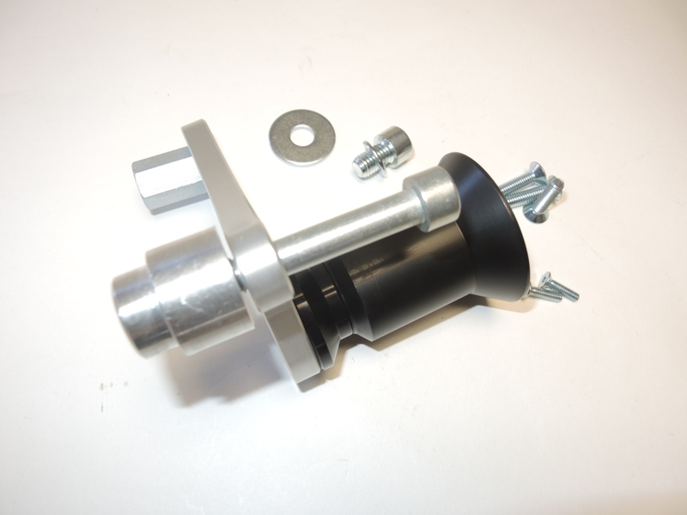
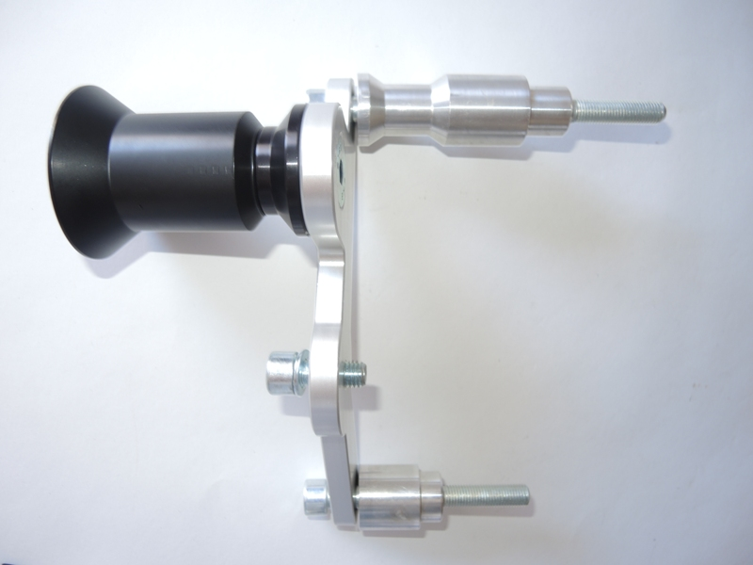
1
12
6
9
11
10
8
6
4
3
X
9
13
7
4
5
2
3
X
3
4
5
7
1
11
10
8
5
5
3
8
7
5
11
13
12
10
11
7
LEFT HAND SIDE
Instruction to assembly-left side:

- Remove original bolts from frame and side´s fairings.
- Take a duralumin adapter ID.1 and completing it (keep the instruction on photo).
- This set mount on the motorcycle.
- Put fairing back on the bike. Use duralumin cylinder ID.7 between the fairing and adapter
- Make assembly slider SL01. Use bolts ID.12. Insert cover, use bolts ID.13

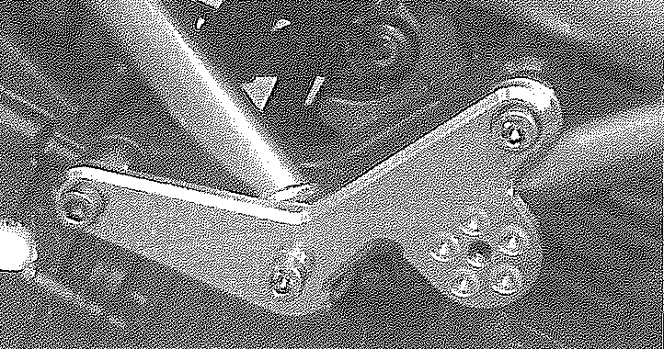

Instruction to assembly-right side:
- Remove original bolts from frame and side´s fairings.
- Take a duralumin adapter ID.1 and completing it (keep the instruction on photo).
- This set mount on the motorcycle.
- Put fairing back on the bike.
- Make assembly slider SL01. Use bolts ID.12. Insert cover, use bolts ID.12
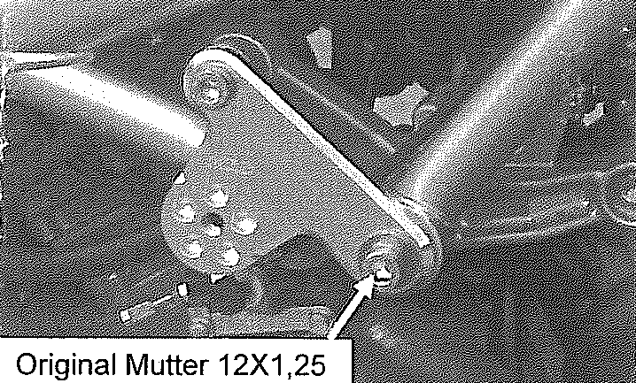

Warning: We recommend use the glue of all threads. Medium strong.

