O2
Hyosung GT650R

Kit for the left side |  |  |  |  | Kit for the right side
No. | Description | Cat.no. | Pcs |  |  | No. | Description | Cat.no. | Pcs
1 | Steel box M12 | X2 | 1 |  |  | 1 | Steel box M12 | X2 | 1
2 | Duralumin adapter | 587 | 1 |  |  | 2 | Duralumin adapter | 588 | 1
3 | Duralumin cylinder d=40mm | 282 | 1 |  |  | 3 | Duralumin cylinder d=40mm | 282 | 1
4 | Bolt M12x30mm | 855 | 1 |  |  | 4 | Bolt M12x30mm | 855 | 1
5 | Bolt M12x40mm | 857 | 1 |  |  | 5 | Bolt M12x40mm | 857 | 1
6 | Dural.cylinder d=36,5mm | 212 | 1 |  |  | 6 | Dural.cylinder d=28mm | 215 | 1
7 | Dural.cylinder d=84mm | 213 | 1 |  |  | 7 | Steel nut =26mm | 216 | 1
8 | Dural.cylinder d=5,5mm | 214 | 1 |  |  | 8 | Bolt M10x80x1,25mm | 920 | 1
9 | Bolt M10x90x1,25mm | 890 | 1 |  |  | 9 | Bolt M10x16mm | 862 | 1
10 | Bolt M10x135x1,25mm | 930 | 1 |  |  | 10 | Pad M10 (big) | 805 | 1
11 | Bolt M10x25mm | 868 | 1 |  |  | 11 | Pad M10 - spring | 801 | 1
12 | Pad M10 - spring | 801 | 1

Installation – the left side:

- remove the original side plastic and the bolts in the place of the installation
- take the duralumin adapter (No. 2), the other side of the adapter give a bolt (No. 4) and give the duralumin cylinder (No. 3) on this bolt
- mount the adapter (No. 2) according to the below attached pictures, give the bolts (No. 9, 10, 11) into the adapter, the other side of the duralumin adapter give the duralumin cylinder (No. 6 and No. 7) on this bolts
- this prepared adapter mount on the frame of the motorcycle
- give the steel box (No. 1) together with the bolt (No. 5) into the protector, all this set mount into thread in the duralumin cylinder (No. 3)
- check all, screw up and mount the side plastic back, you can use the duralumin pad (No. 8) for a space between the side plastics and fitting kit

Warning – we recommend to use safety glue on threads of all bolts (moderate strong – blue colour).

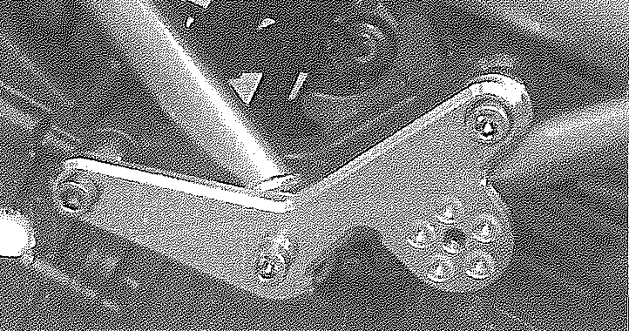

Installation – the right side:

- remove the original side plastic and the bolts in the place of the installation
- take the duralumin adapter (No. 2), the other side of the adapter give a bolt (No. 4) and give the duralumin cylinder (No. 3) on this bolt
- mount the steel nut (No. 7) into the frame of the motorcycle
- mount the adapter (No. 2) according to the below attached pictures, give the bolts (No. 8) into the adapter, the other side of the duralumin adapter give the duralumin cylinder (No. 6) on this bolt
- this prepared adapter mount on the frame of the motorcycle, mount the bolt (No. 9) together with the pad (No. 10) into the steel nut
- give the steel box (No. 1) together with the bolt (No. 5) into the protector, all this set mount into thread in the duralumin cylinder (No. 3)
- check all, screw up and mount the side plastic back

Warning – we recommend to use safety glue on threads of all bolts (moderate strong – blue colour).

