S10S
Suzuki GSX1400 2002-

Kit for the left side |  |  |  |  | Kit for the right side
No. | Description | Cat.no. | Pcs |  |  | No. | Description | Cat.no. | Pcs
1 | Slider adaapter | 314 | 1 |  |  | 1 | Slider adaapter | 314 | 1
2 | Bolt M12x30mm | 856 | 1 |  |  | 2 | Bolt M12x30mm | 856 | 1
3 | Bolt M12x30mm | 855 | 1 |  |  | 3 | Bolt M12x30mm | 855 | 1
4 | Bolt M10x120mm | 881 | 1 |  |  | 4 | Bolt M10x110mm | 879 | 1
5 | Steel clamp M8 | 950 | 1 |  |  | 5 | Steel clamp M8 | 950 | 1
6 | Dural. cylinder d=48,5mm | 50 | 1 |  |  | 6 | Dural. cylinder d=42mm | 49 | 1
7 | Dural. cylinder d=70mm | 412 | 1 |  |  | 7 | Dural. cylinder d=50mm | 283 | 1
8 | Steel adapter | 573 | 1 |  |  | 8 | Steel adapter | 574 | 1
9 | Nut M8 | 951 | 2 |  |  | 9 | Nut M8 | 951 | 2
10 | Nut M10 | 814 | 1 |  |  | 10 | Nut M10 | 814 | 1
11 | Pad M8-spring | 800 | 2 |  |  | 11 | Pad M8-spring | 800 | 2
12 | Plastic cover M10 | X4 | 1 |  |  | 12 | Plastic cover M10 | X4 | 1
13 | Tape 3M |  | 1 |  |  | 13 | Tape 3M |  | 1
14 | Bolt M6x25 | 877 | 3 |  |  | 14 | Bolt M6x25 | 877 | 3
15 | Bolt M4x16 | 876 | 2 |  |  | 15 | Bolt M4x16 | 876 | 2

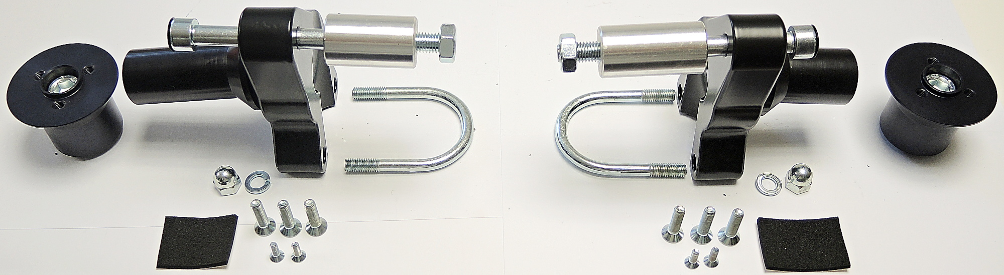

INSTRUCTIONS

- Unbolt original bolt from the frame of motorcycle.
- Stick 3M tape on the frame to prevent damage.
- Fit dural cylinder ID7 on the steel adapter ID8 using bolt ID3. Mount this kit into the frame of motorcycle using bolt M10 (ID4). Place cylinder ID6 on the bolt. Cover this bolt using plastic cap ID12. Tighten the bolt from backside using nut M10 ID10.
- Mount steel clamp ID5 over the frame of motorcycle into the steel adapter using nuts ID9 and washers ID10.
- Fit slider adapter on the cylinder using bolt ID2. Fit slider using three bolts M6 and cover using two bolts M4.

