S10
Suzuki GSX1400 2002-

Kit for the left side |  |  |  |  | Kit for the right side
No. | Description | Cat.no. | Pcs |  |  | No. | Description | Cat.no. | Pcs
1 | Steel box M12 | X2 | 1 |  |  | 1 | Steel box M12 | X2 | 1
2 | Bolt M12x50mm | 869 | 1 |  |  | 2 | Bolt M12x50mm | 869 | 1
3 | Bolt M12x30mm | 855 | 1 |  |  | 3 | Bolt M12x30mm | 855 | 1
4 | Bolt M10x120mm | 881 | 1 |  |  | 4 | Bolt M10x110mm | 879 | 1
5 | Steel clamp M8 | 950 | 1 |  |  | 5 | Steel clamp M8 | 950 | 1
6 | Dural. cylinder d=48,5mm | 50 | 1 |  |  | 6 | Dural. cylinder d=42mm | 49 | 1
7 | Dural. cylinder d=70mm | 412 | 1 |  |  | 7 | Dural. cylinder d=50mm | 283 | 1
8 | Duralumin adapter | 573 | 1 |  |  | 8 | Duralumin adapter | 574 | 1
9 | Nut M8 | 951 | 2 |  |  | 9 | Nut M8 | 951 | 2
10 | Nut M10 | 814 | 1 |  |  | 10 | Nut M10 | 814 | 1
11 | Pad M8-spring | 800 | 2 |  |  | 11 | Pad M8-spring | 800 | 2
12 | Plastic cover M10 | X4 | 1 |  |  | 12 | Plastic cover M10 | X4 | 1
13 | Tape 3M |  | 1 |  |  | 13 | Tape 3M |  | 1

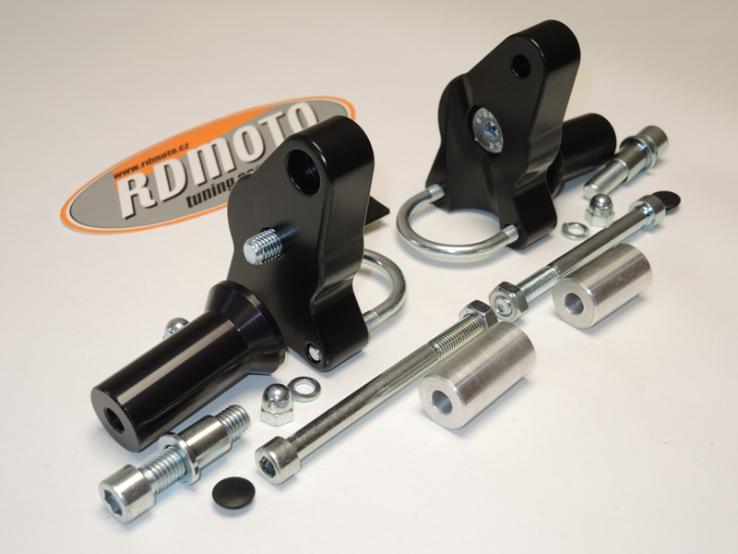

Installation – the left side:

- remove the original bolt M10 before the engine
- stick the tape 3M on the frame
- take the duralumin adapter (No. 8) and use the bolt (No. 3) for mounting of duralumin cylinder (No. 7)
- give the bolt (No. 4) into the adapter, the other side of the adapter give the duralumin cylinder (No. 6) on the bolt, this prepared adapter mount on the frame (don’t tighten the bolt M10)
- the other side of the frame of the motorcycle give the steel clamp (No. 5) into the duralumin adapter, give the pad M8 (No. 11) and use the nuts (No. 9) for the tightening of the adapter. Use the nut (No. 10) for the tightening of the bolt M10 too. Give the plastic cover (No. 12) on the head of the bolt M10.
- if the duralumin adapter is monted good together with the holder for the crash protector, so you can mount the crash protector
- give the steel box (No. 1) together with the bolt (No. 2) into the protector
- all this set mount into the thread on the adapter

Warning – we recommend to use safety glue on threads of all bolts (moderate strong – blue colour).

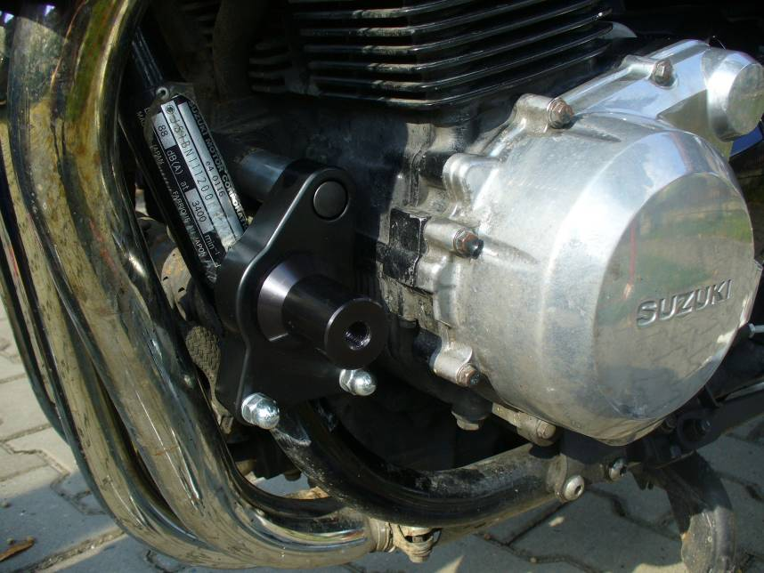

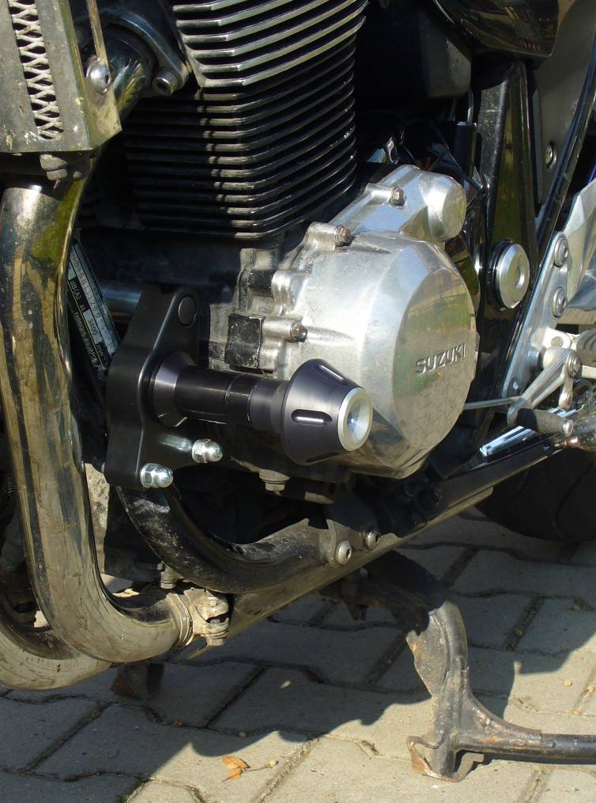
Installation – the right side:

- remove the original bolt M10 before the engine
- stick the tape 3M on the frame
- take the duralumin adapter (No. 8) and use the bolt (No. 3) for mounting of duralumin cylinder (No. 7)
- give the bolt (No. 4) into the adapter, the other side of the adapter give the duralumin cylinder (No. 6) on the bolt, this prepared adapter mount on the frame (don’t tighten the bolt M10)
- the other side of the frame of the motorcycle give the steel clamp (No. 5) into the duralumin adapter, give the pad M8 (No. 11) and use the nuts (No. 9) for the tightening of the adapter. Use the nut (No. 10) for the tightening of the bolt M10 too. Give the plastic cover (No. 12) on the head of the bolt M10.
- if the duralumin adapter is monted good together with the holder for the crash protector, so you can mount the crash protector
- give the steel box (No. 1) together with the bolt (No. 2) into the protector
- all this set mount into the thread on the adapter

Warning – we recommend to use safety glue on threads of all bolts (moderate strong – blue colour).

