S12
Suzuki GSX-R1000 2003-2004

Fitting kit left side: Fitting kit right side:
ID | Description | Cat.N | Qt.
1 | Steel box M10 | X1 | 1
2 | Bolt M10x90x1,25 | 890 | 1
3 | Dural.cylinder 28mm | 67 | 1
ID | Description | Cat.N | Qt.
1 | Steel box M10 | X1 | 1
2 | Bolt M10x90x1,25 | 890 | 1
3 | Dural.cylinder 14mm | 65 | 1
Ilustr.photo

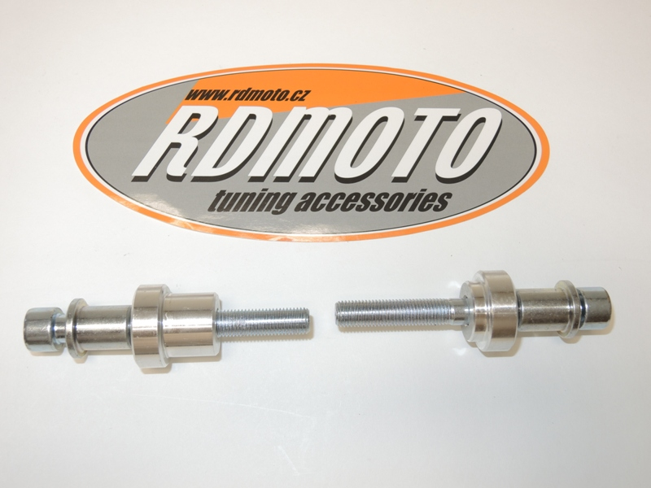

1
1
2
2

3
3

Instruction to assembly:
- Installation of the left and right protectors make in gripping so the picture.
- Insert steel box ID.1 into the protectors
- Through the protectors insert screws ID.2. Under the protectors put dural.cylinders.
- This kit mount on the frame.

Warning – we recommend to use safety glue on threads of all bolts (moderate strong – blue colour).

