S13
Suzuki GSX-R 1000 2005-2006

Fitting kit left side: Fitting kit right side:
ID | Description | Cat.N | Qty
1 | Steel box M10 | X1 | 1
2 | Bolt M10x90x1,25 | 890 | 1
3 | Dural.cylinder d=37 | 66 | 1
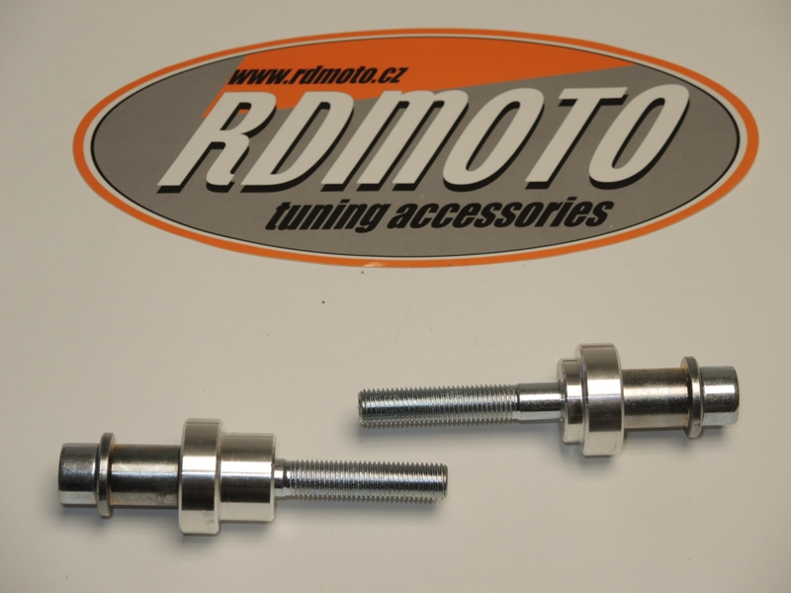
2
1
3
ID | Description | Cat.N | Qty
1 | Steel box M10 | X1 | 1
2 | Bolt M10x90x1,25 | 890 | 1
3 | Dural.cylinder d=27,5 | 65 | 1

3
1

2

Instruction to assembly left side:
- Take out orig. bolt from frame M10.
- Into the protector insert steel box ID.1 and after insert bolt ID.2.
- From back side put dural cylinder ID.3 on the bolt.
- This set mount on the frame. Replace orig. bolt.
Instruction to assembly right side:
- Take out orig. bolt from frame M10.
- Into the protector insert steel box ID.1 and after insert bolt ID.2.
- From back side put dural cylinder ID.3 on the bolt.
- This set mount on the frame. Replace orig. bolt.

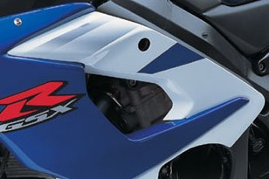
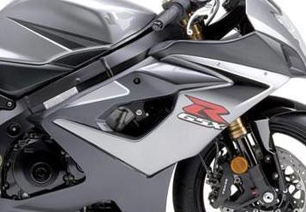
Warning: We recommend use the glue of all threads. Medium strong.

