S15SDM
Suzuki GSX-R1000 2007-2008

Kit for the left side: Kit for the right side:
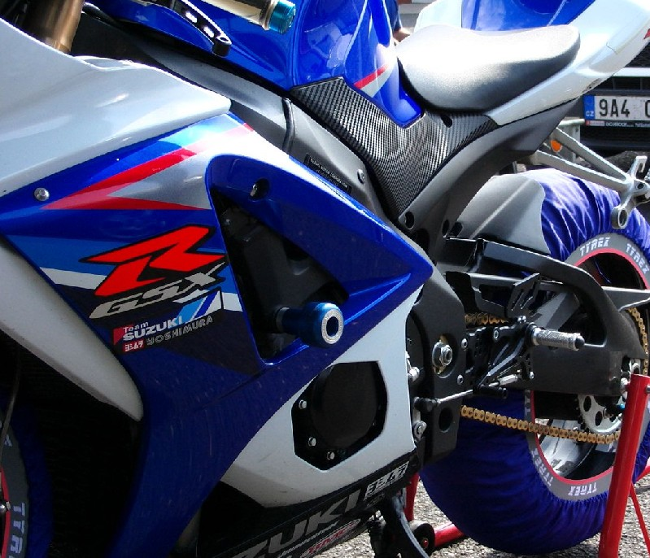
ID | Description | Cat.N | Qty
1 | Alu.adapter for slider | 537/B | 1
2 | Alu. spacer (cone) | 12 | 1
3 | Alu spacer d=23 | 39 | 1
4 | Bolt M10x110x1,25 | 928 | 1
5 | Bolt M6x20 | 1024 | 2
6 | Washer M6 | 1023 | 2
ID | Description | Cat.N | Qty
1 | Alu.adapter for slider | 537/B | 1
2 | Alu. spacer (cone) | 12 | 1
3 | Dural.cylinder d=11 | 38 | 1
4 | Bolt M10x110x1,25 | 928 | 1
5 | Bolt M6x20 | 1024 | 2
6 | Washer M6 | 1023 | 2
Ilustrační foto
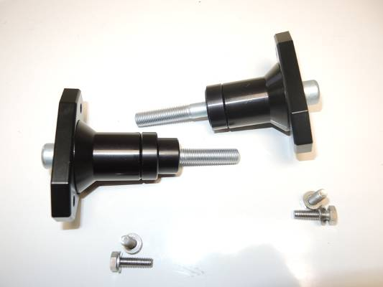
2
1
2
4
3
1
3
4
5,6
5,6

Instruction to assembly:
- Installation of the left and right protectors make in gripping as the picture.
- Place bolt through the ID.1,2,3 as you can see on the picture.
- This kit assembly into the chassi.
- Place slide rand tighten it by bolt ID.5 and washer ID.6.

Warning – we recommend to use safety glue on threads of all bolts (moderate strong – blue colour).

