S15S
Suzuki GSX-R1000 2007-2008

Kit for the left side |  |  |  |  | Kit for the right side
No. | Description | Cat.no. | Pcs |  |  | No. | Description | Cat.no. | Pcs
1 | Slider RDmoto | SL | 1 |  |  | 1 | Slider RDmoto | SL | 1
2 | Cover | SLcap… | 1 |  |  | 2 | Cover | SLcap… | 1
3 | Adapter slider | 317 | 1 |  |  | 3 | Adapter slider | 317 | 1
4 | Bolt M6x25 | 877 | 3 |  |  | 4 | Bolt M6x25 | 877 | 3
5 | Bolt M4x16 | 876 | 2 |  |  | 5 | Bolt M4x16 | 876 | 2
6 | Bolt M10x85x1,25mm | 934 | 1 |  |  | 6 | Bolt M10x85x1,25mm | 934 | 1
7 | Dural roller – 23mm | 39 | 1 |  |  | 7 | Dural roller – 11mm | 38 | 1

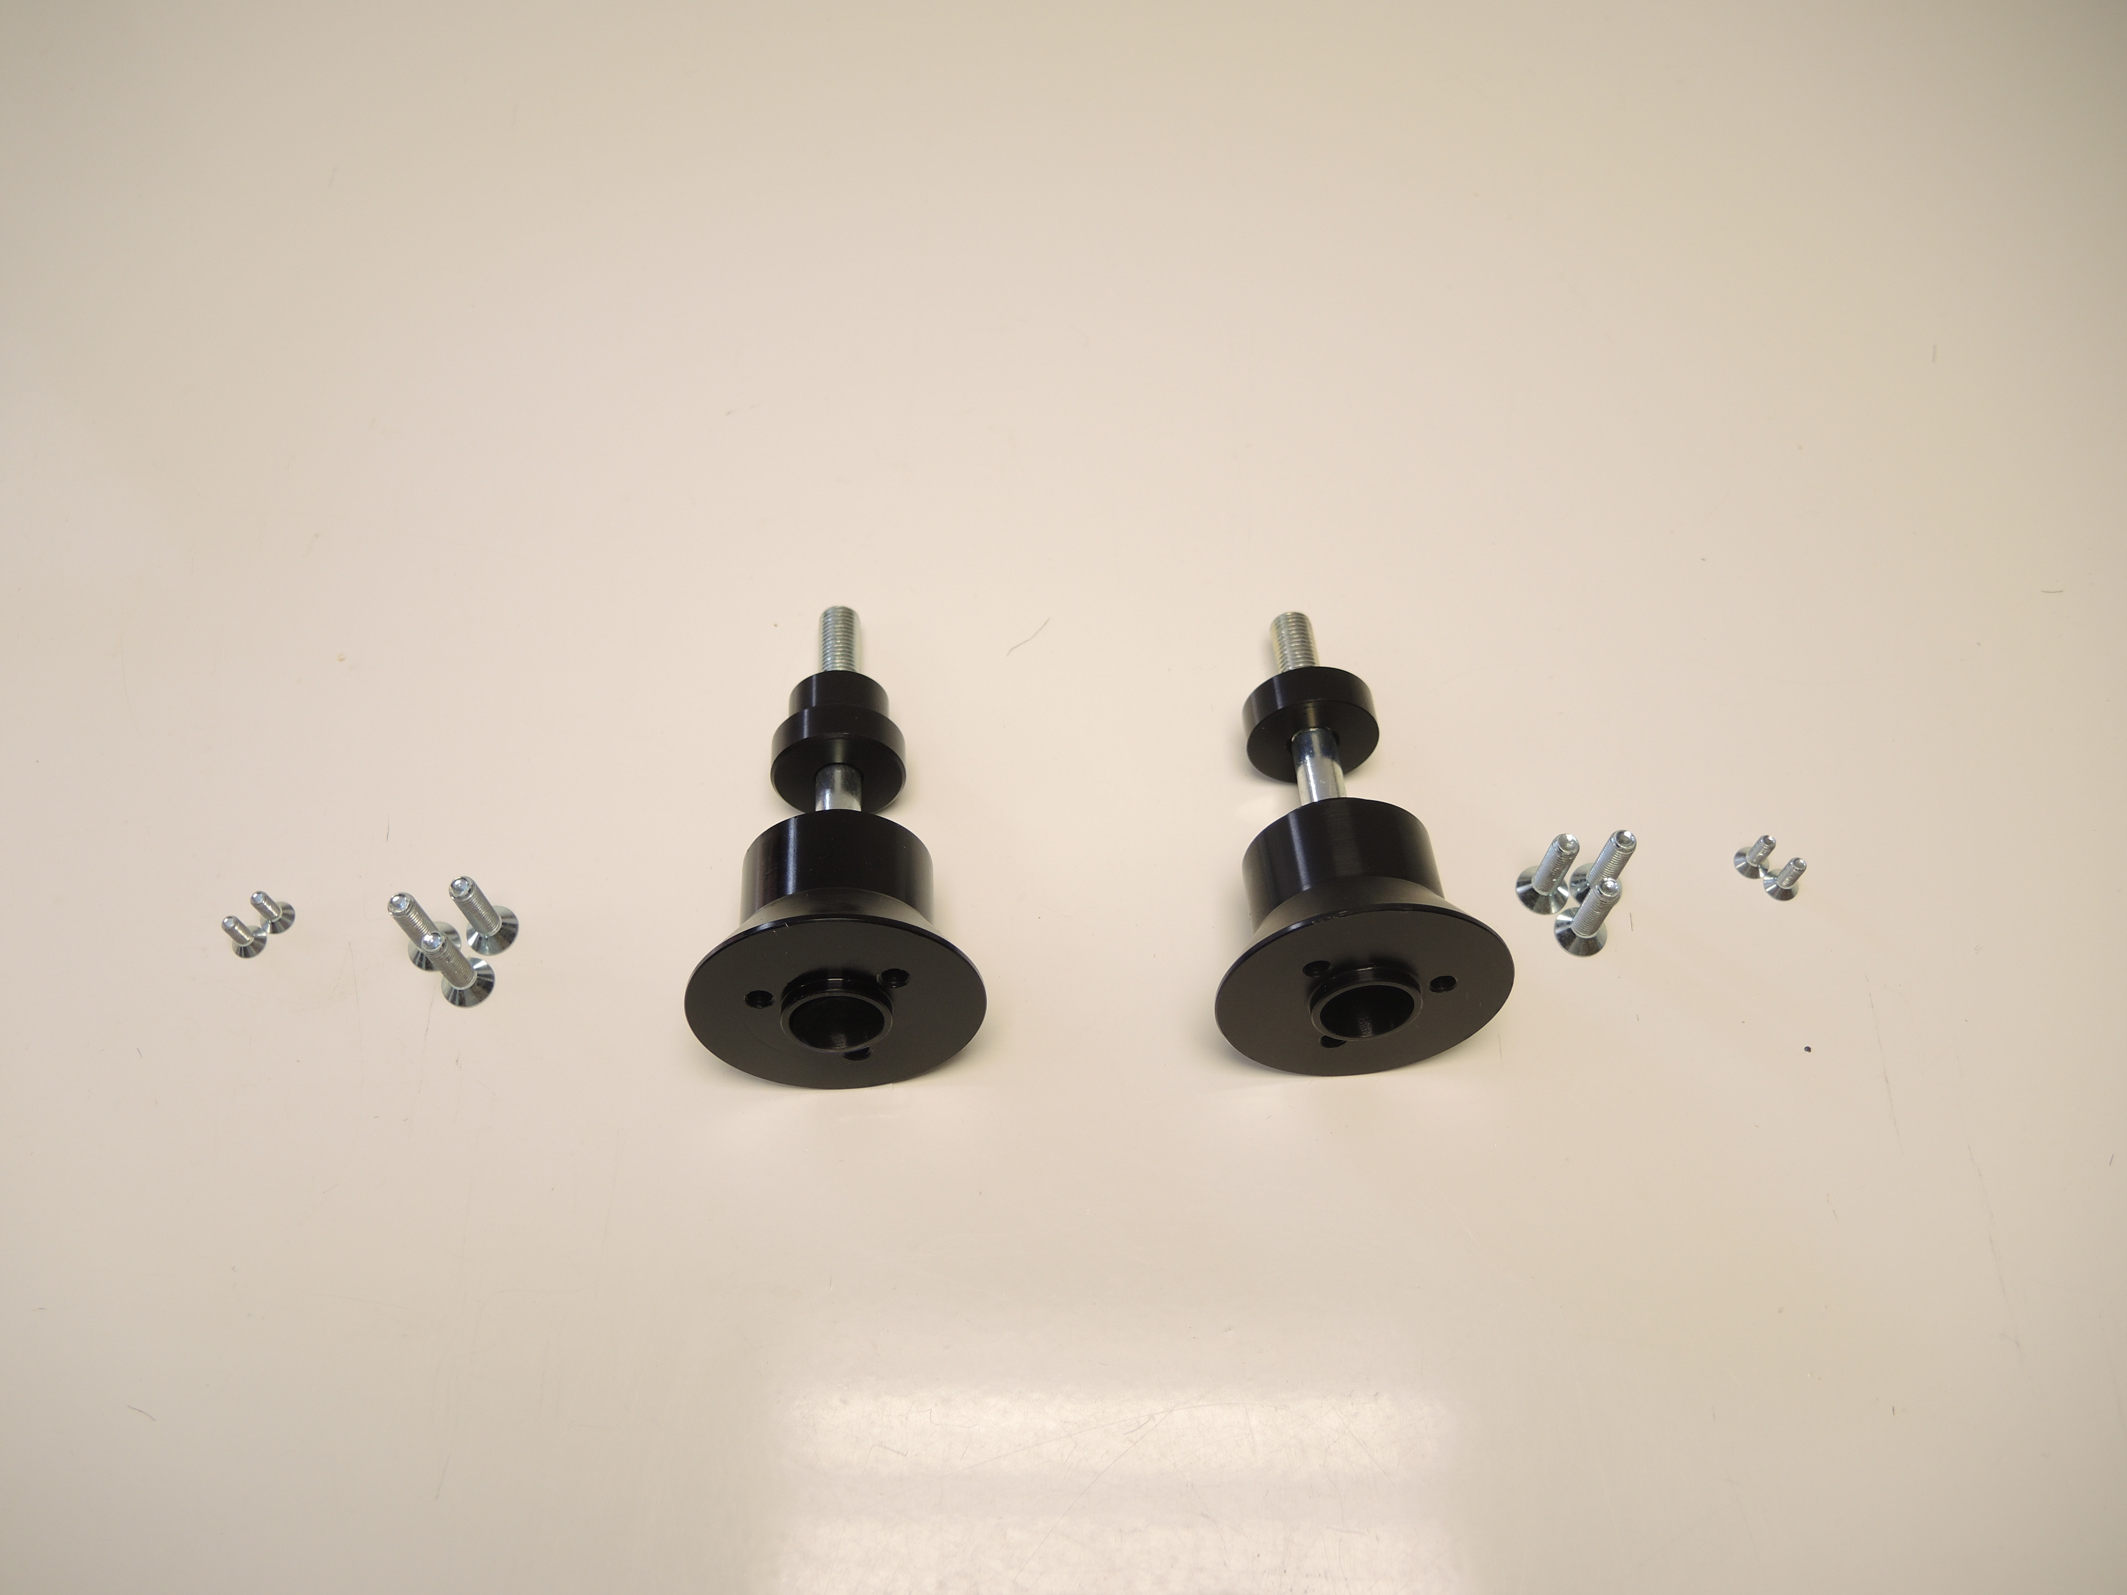
ID6
ID6

ID7
ID7
ID4
ID4

ID5
ID5

ID3
ID3

Installation:

- Remove original screws.
- Using screw M10 (ID6) fit slider adapter (ID3) and dural roller (ID7) on the frame of motorcycle. Don’t forget that on the left side is dural roller (ID7) a bit longer.
- Now fit slider on slider adapter using three screws M6 (ID4).
- In the end fit coloured cover using two screws M4 (ID5).

Warning – we recommend to use safety glue on threads of all bolts (moderate strong – blue colour).

