S15
Suzuki GSX-R1000 2007-2008

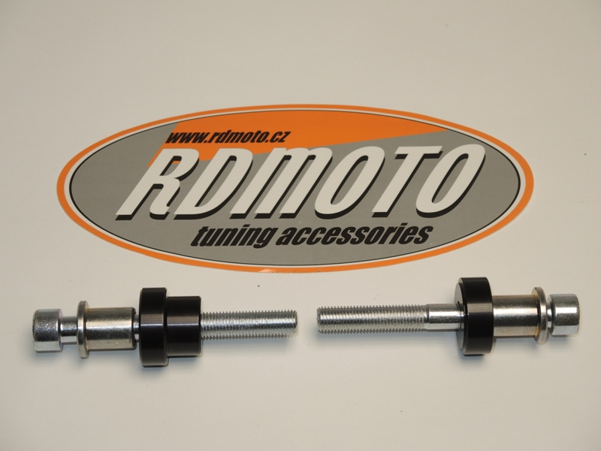
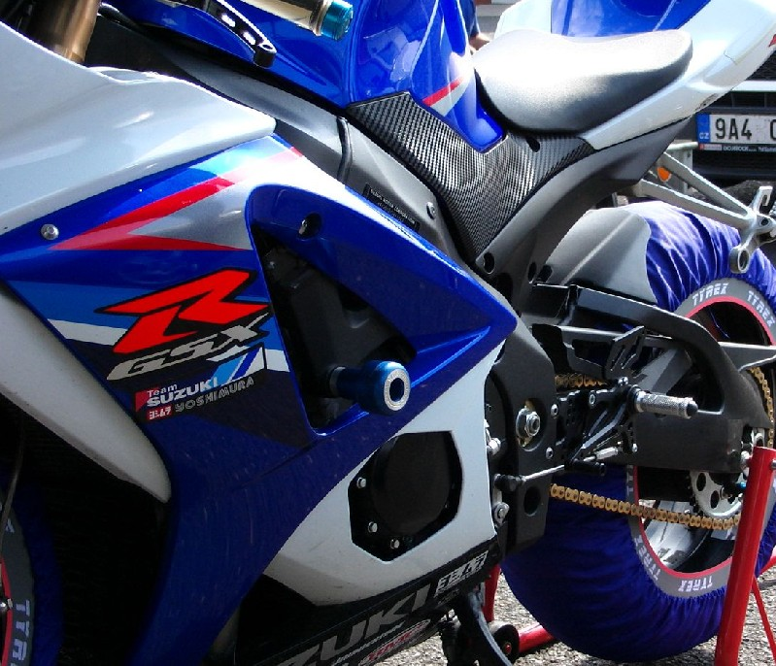
Kit for the left side: Kit for the right side:
ID | Description | Cat.N | Qty
1 | Steel box M10 | X1 | 1
2 | Bolt M10x90x1,25 | 890 | 1
3 | Dural.cylinder d=23 | 39 | 1
2
1
2
3
1
3
1
3
2
2
ID | Description | Cat.N | Qty
1 | Steel box M10 | X1 | 1
2 | Bolt M10x90x1,25 | 890 | 1
3 | Dural.cylinder d=11 | 38 | 1
Ilustrační foto

Instruction to assembly:
- Installation of the left and right protectors make in gripping so the picture.
- Insert steel box ID.1 into the protectors
- Through the protectors insert screws ID.2. Under the protectors put dural.cylinders.
- This kit mount on the frame.

Warning – we recommend to use safety glue on threads of all bolts (moderate strong – blue colour).

