S16S
Suzuki GSX 600/750F ´98-

Left side kit: Right side kit
ID | Description | Cat.N | Ks
1 | Steel adapter | 562 | 1
2 | Bolt M8x30 | 834 | 2
3 | Bolt M10x30 | 882 | 1
4 | Washer M8 | 802 | 2
5 | Washer M10 | 801 | 1
6 | Tape 3M | - | 1
7 | Dural. cylinder | DV313 | 1
8 | Bolt M6x25 | 877 | 3
9 | Bolt M4x16 | 876 | 2
INSTRUCTIONS
ID | Description | Cat.N | Ks
1 | Steel adapter | 563 | 1
2 | Bolt M8x30 | 834 | 2
3 | Bolt M10x30 | 882 | 1
4 | Washer M8 | 802 | 2
5 | Washer M10 | 801 | 1
6 | Tape 3M | - | 1
7 | Dural. cylinder | DV313 | 1
8 | Bolt M6x25 | 877 | 3
9 | Bolt M4x16 | 876 | 2
- We recommend to use safety glue on all threads.
- Dismantle side fairing and unbolt original bolts from the frame.
- Stick 3M tape on the frame to prevent damage.
- Fit steel adapter on the frame using two M8 bolts (ID2) and washers (ID4).
- Mount fairing back on the motorcycle.
- Put washer ID5 and dural cylinder ID7 on the bolt ID3. Fit this kit into the steel adapter.
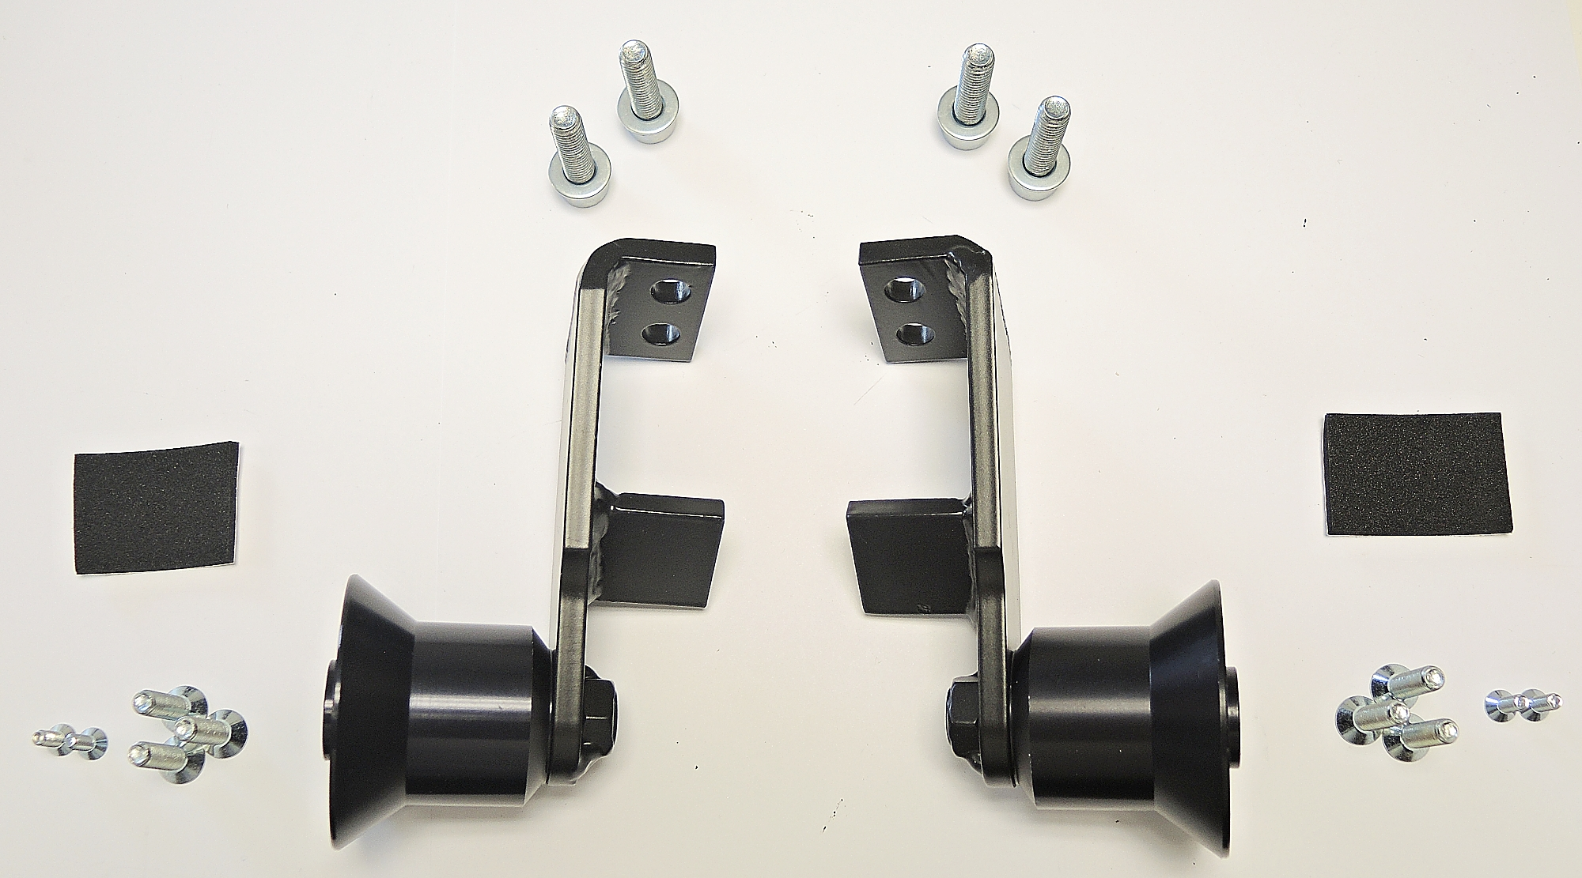
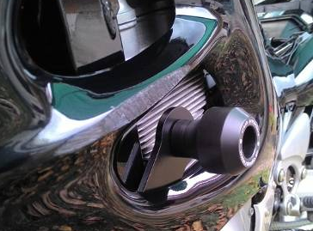
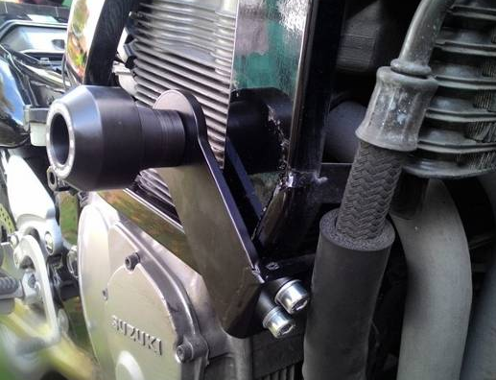
- In the end fit slider using three bolts M6 and coloured cover using two bolts M4.

