S16
Suzuki GSX 600/750F ´98-

Fitting kit:
2
1
2
3
ID | Description | Cat.N | Qt
1 | Steel sleeve M10 | X1 | 2
2 | Bolt M8x30 | 834 | 4
3 | Bolt M10x35 | 847 | 2
4 | Washer M8 | 802 | 4
5 | Tape 3M | - | 2
6 | Steel adapter | 562 | 1
7 | Steel adapter | 563 | 1

Assembly instruction:
- Plac for fitting you see on the pictures.
- Grip steel adapters for left and right side by bolts ID.2 and use washers ID.4.
- Insert steel sleeves ID.1 into the crash protectors.
- And fix protectors by bolts ID.2 on the steel adapters.

Note: We recommande to use medium strong glue during assembly on the threads.
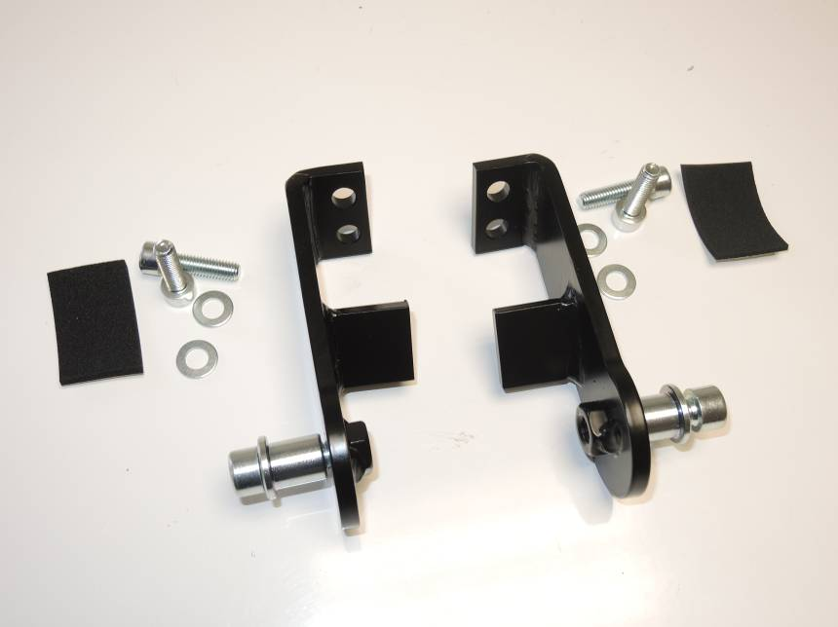
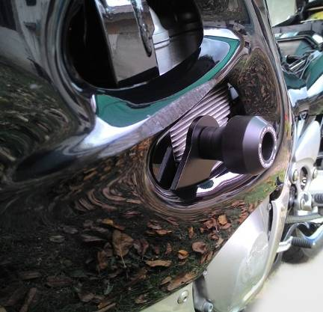

7
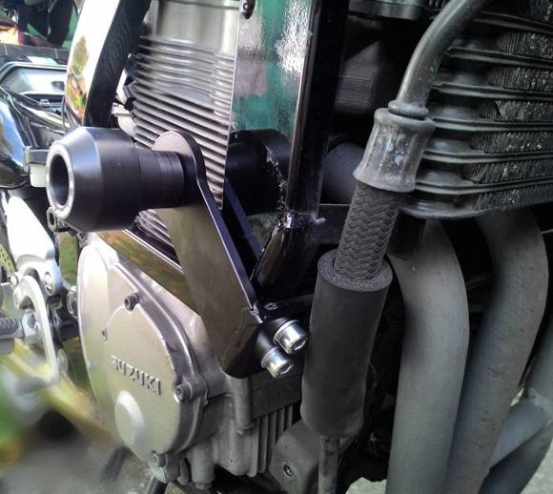
6
3
2
2
3
1
1
4
4

