S17S
Suzuki GSF600/GSX750 Inazuma ´95-´04
Suzuki GSF1200/GSX1200 Inazuma ´96-´05

Kit for the left side |  |  |  |  | Kit for the right side
ID | Description | Cat.no | Pcs |  |  | ID | Description | Cat.no | Pcs
1 | Slider adapter | 314 | 1 |  |  | 1 | Slider adapter | 314 | 1
2 | Bolt M12x30mm | 856 | 1 |  |  | 2 | Bolt M12x30mm | 856 | 1
3 | Dural. cylinder d=47mm | 48 | 1 |  |  | 3 | Dural. cylinder d=47mm | 48 | 1
4 | Dural. cylinder d=50mm | 283 | 1 |  |  | 4 | Dural. cylinder d=40mm | 282 | 1
5 | Dural. cylinder d=13mm | 86 | 1 |  |  | 5 | Dural. cylinder d=13mm | 86 | 1
6 | Bolt M10x120mm | 881 | 1 |  |  | 6 | Bolt M10x120mm | 881 | 1
7 | Bolt M8x80mm | 842 | 2 |  |  | 7 | Bolt M8x80mm | 842 | 2
8 | Bolt M12x30mm | 855 | 1 |  |  | 8 | Bolt M12x30mm | 855 | 1
9 | Pad M10 (plane) | 804 | 1 |  |  | 9 | Pad M10 (plane) | 804 | 1
10 | Nut M10 | 814 | 1 |  |  | 10 | Nut M10 | 814 | 1
11 | Duralumin adapter | 558 | 1 |  |  | 11 | Duralumin adapter | 559 | 1
12 | Bolt M6x25 | 877 | 3 |  |  | 12 | Bolt M6x25 | 877 | 3
13 | Bolt M4x16 | 876 | 2 |  |  | 13 | Bolt M4x16 | 876 | 2
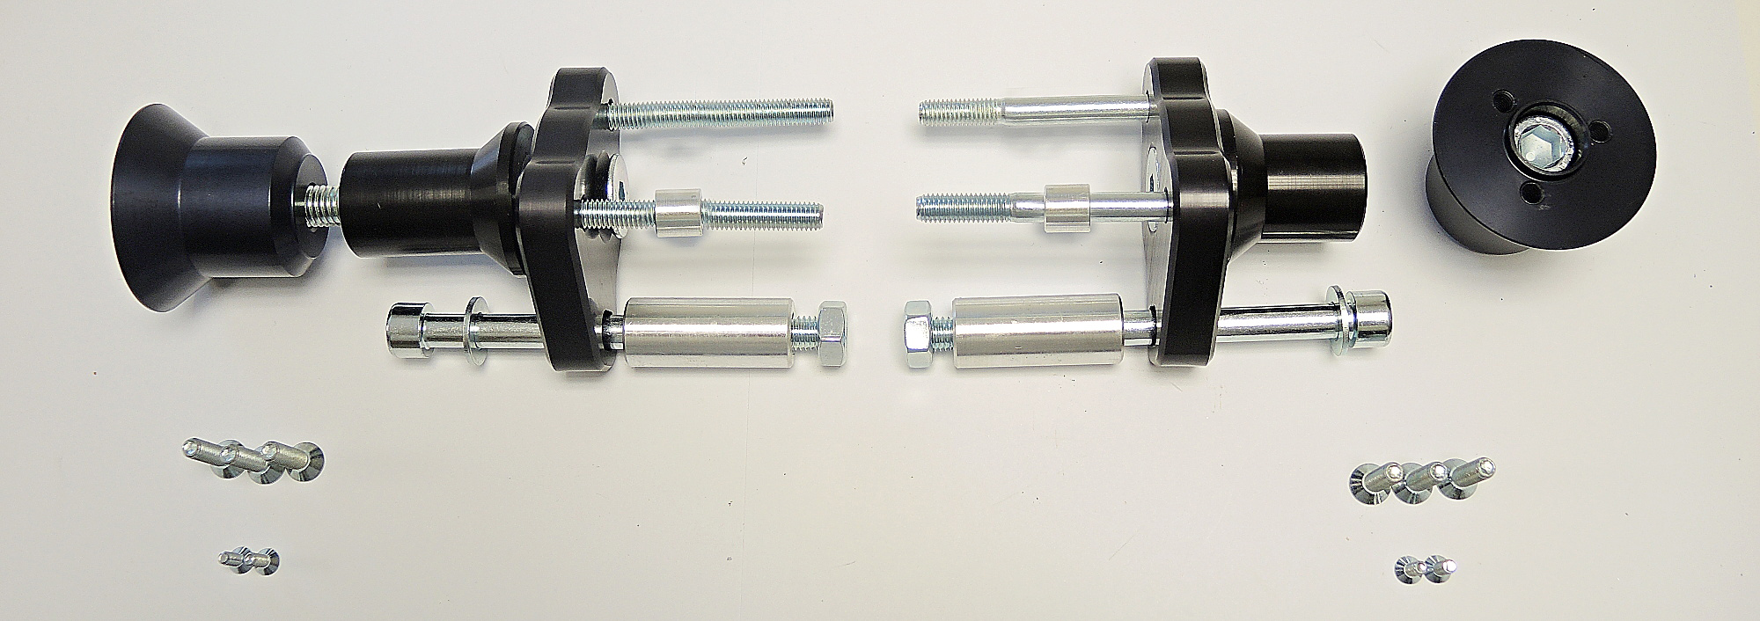

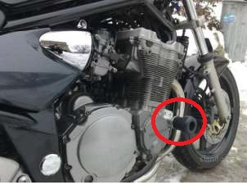
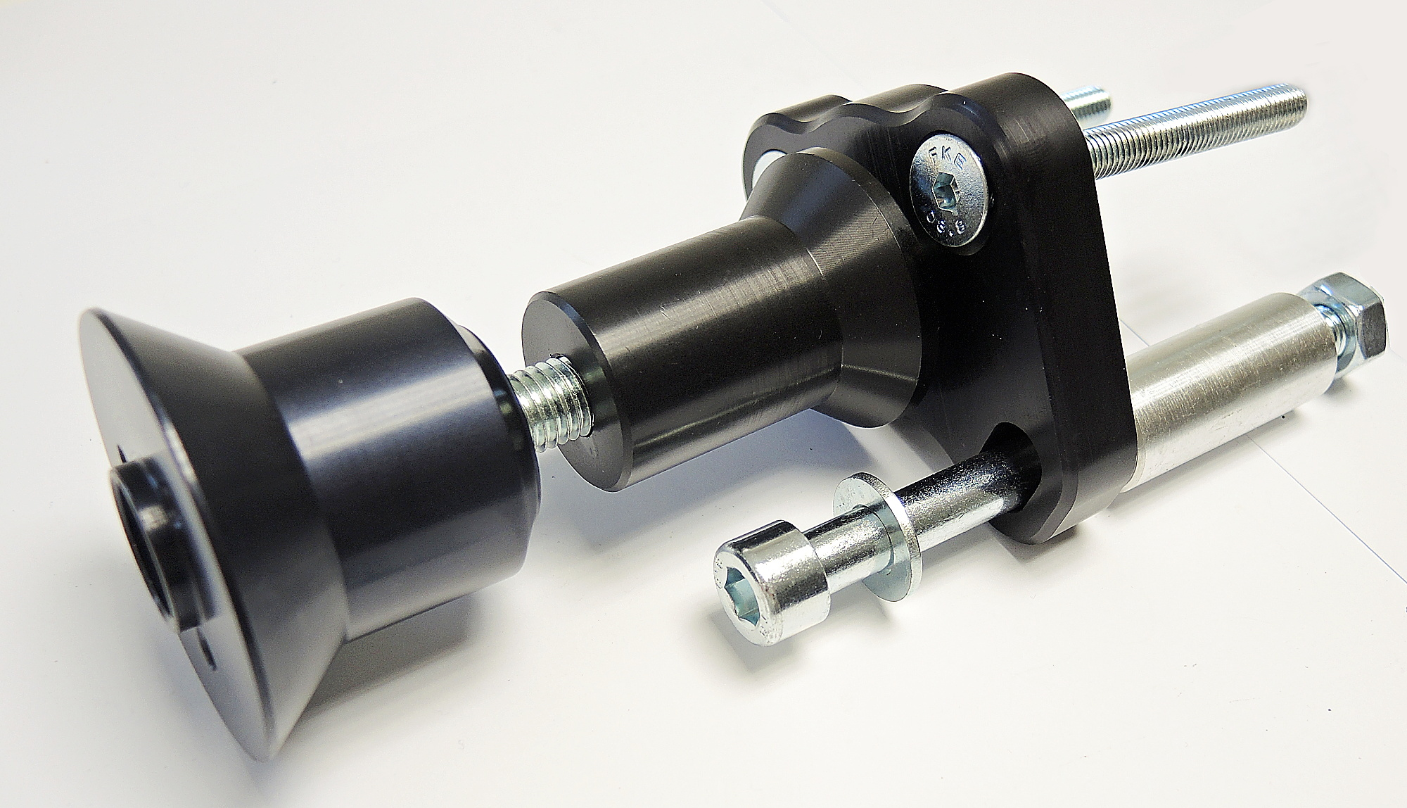

INSTRUCTIONS

- We recommend to use safety glue on all threads (medium strong).
- Unbolt original bolts from the frame of motorcycle.
- Fit cylinder ID4 on the adapter ID11 using bolt ID8. Please, be on mind that cylinder ID4 is longer on the left side. Fit this kit on the frame of motorcycle using bolt ID6 with washer and two bolts ID7. Place cylinder ID3 on the M10 bolt. Place cylinder ID5 on the upper bolt M8.
- Fit slider adapter ID1 into the cylinder ID4 using bolt ID2.
- Fit slider using three bolts M6.
- Fit cover using two bolts M4.

