S19*
Suzuki TL1000 R 1998-

Kit for left side : Kit for right side:
ID | Description | Cat.N | Qt
1 | Steel box M10 | X1 | 1
2 | Bolt M10x135x1,25 | 930 | 1
3 | Alu spacer d=74 | 240 | 1
ID | Description | Cat.N | Qt
1 | Steel box M10 | X1 | 1
2 | Bolt M125x1x1,25 | 924 | 1
3 | Alu spacer d=64 | 239 | 1

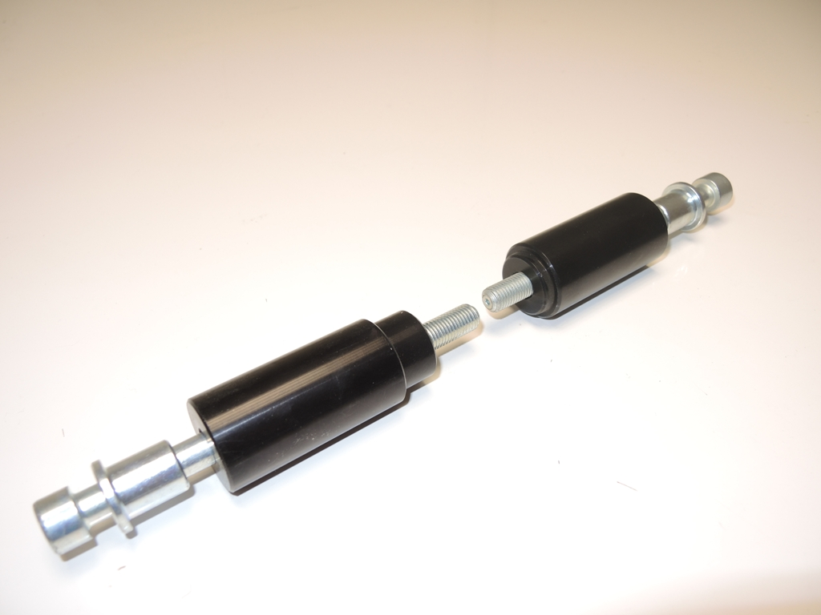

2
1

3
1

3

2

*It´s necessary to dril hole into the fairing.
Done left side first and after finishing make other side.
Left side instruction:
- Take off original bolt from chassi.
- Drill hole into the fairing diameter 30,5 mm
- Insert steel box ID.1 intoprotector and after insert bolt ID.2.
- Under the protector place dural. spacer ID.3.
- This kit mount on the chassi.
Right side instruction:
- Take off original bolt from chassi.
- Drill hole into the fairing diameter 30,5 mm
- Insert steel box ID.1 intoprotector and after insert bolt ID.2.
- Under the protector place dural. spacer ID.3.
- This kit mount on the chassi.
During assembly place Locktite glue on the threads.

