S1
Suzuki GS 500E
Fitting kit left side: Fitting kit right side:
4 | Stainless BAR M10x430(1,25)x30x30x |  | 1
ID | Description | Cat.N. | Qt
1 | Steel box | X1 | 1
2 | Special. nut M10 | X11 | 1
3 | Dural.cylinder | 51 | 1
ID | Description | Cat.N | Qt
1 | Steel box | X1 | 1
2 | Special. nut M10 | X11 | 1
3 | Dural.cylinder | 51 | 1

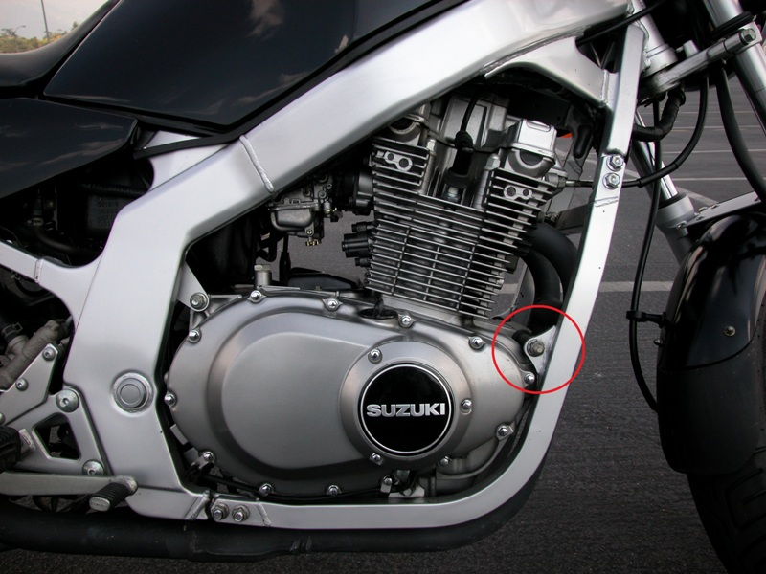

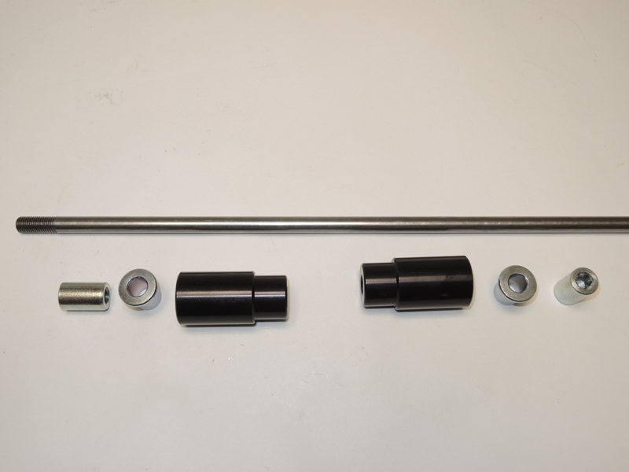
2
1
2
3
1
3
Fitting instruction:
- Mounting do the enclosure picture of this manual.
- Take out original bolt from frame.
- Through the engine and frame insert stainless bar ID.4.
- Put the dural. cylinders on the rod from left and right side ID.3.
- Into the protectors insert steel box ID.1.
- Put protectors on the bar and tighten it by nuts ID.2

Note: During installation, we recommend using glue on the threads (blue color).

