S20SD
Suzuki GSR600 2006-

Kit for the left side |  |  |  |  | Kit for the right side
No. | Description | Cat.n | Pcs |  |  | No. | Description | Cat.n | Pcs
1 | Steel bracket for SLD | 537 | 1 |  |  | 1 | Steel bracket for SLD | 537 | 1
2 | Dural.adapter cone | 10 | 1 |  |  | 2 | Dural.adapter cone | 10 | 1
3 | Dural.cylinder d=49 | 43 | 1 |  |  | 3 | Dural.cylinder d=34 | 40 | 1
4 | Bolt M10x130x1,25 | 905 | 1 |  |  | 4 | Bolt M10x95x1,25 | 927 | 1
5 | Bolt M8x25 | 815 | 2 |  |  | 5 | Bolt M8x25 | 815 | 2
6 | Spring washer M8 | 800 | 2 |  |  | 6 | Spring washer M8 | 800 | 2
Installation:
Installation of the left and right protector make in gripping about the attached photo below. Remove original bolts from frame.
Left side: On the bolt ID.4 insert bracket for diamond ID.1 under the steel bracket insert dural cone adapter ID.2. Into the frame insert dural.cylinder ID.3. This set mounting into the frame. Diamond gripping by bolts and washers ID.5 and ID.6.
Right side: On the bolt ID.4 insert bracket for diamond ID.1 under the steel bracket insert dural cone adapter ID.2. Into the frame insert dural.cylinder ID.3. This set mounting into the frame. Diamond gripping by bolts and washers ID.5 and ID.6.
Warning – we recommend to use safety glue on threads of all bolts (moderate strong – blue colour).
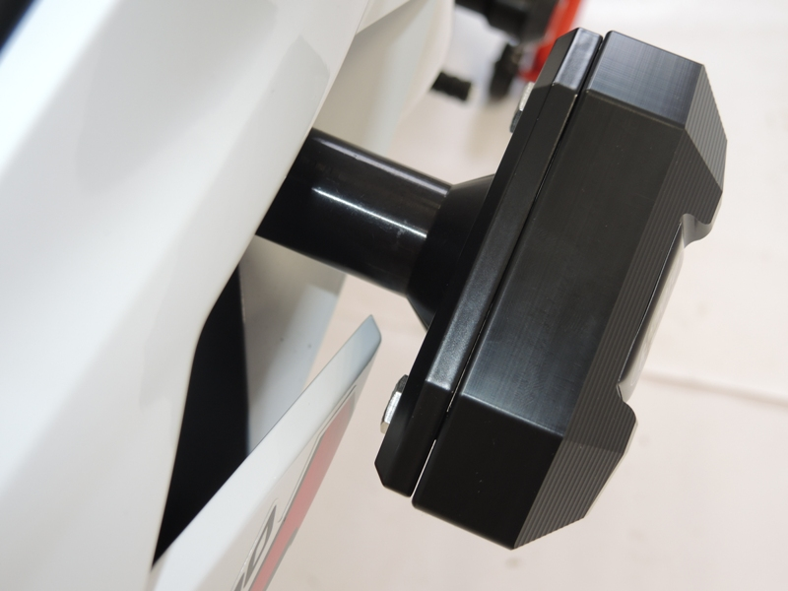
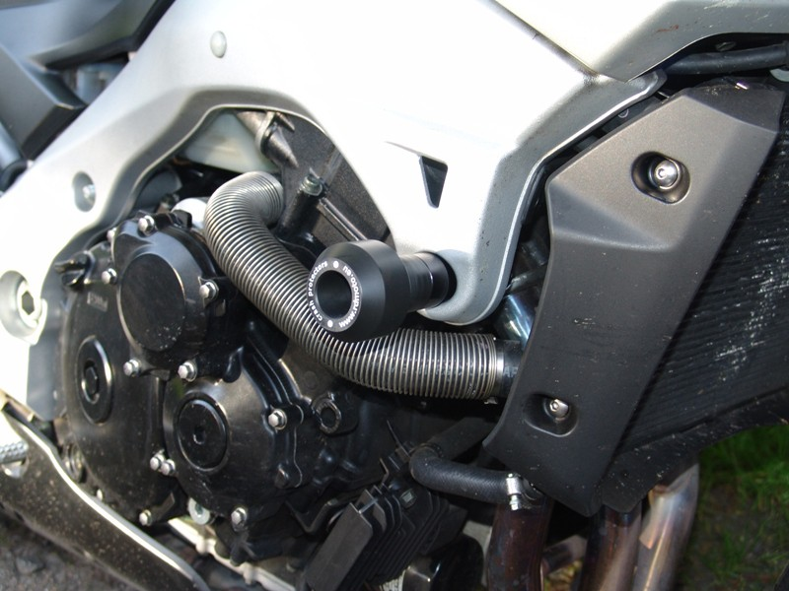
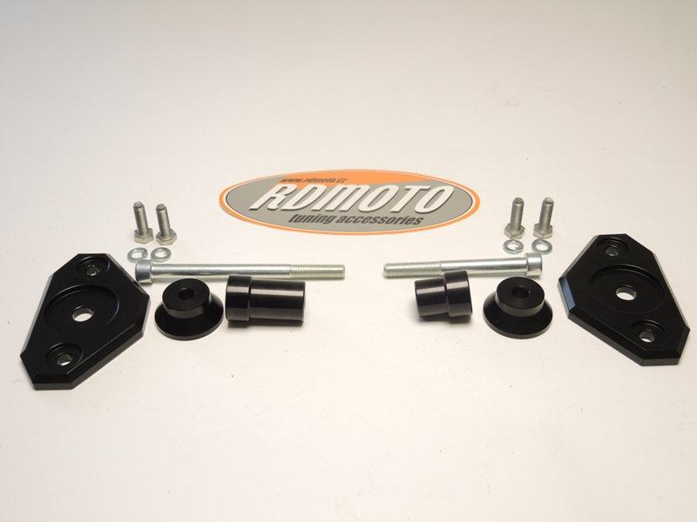
Ilustration foto- place for gripping protectors.
Ilustr.photo SLD.

