S21SDM
Suzuki GSX-R 600/750 2006-2007
Kit for the left side: | Kit for the right side:

ID | Description | Cat.N | Qty
1 | SLDM adapter | 537/B | 1
2 | Bolt M10x60x1,25mm | 896 | 1
3 | Dural. spacer d=5mm | 16 | 1
5 | Bolt M8x25mm | 832 | 2
6 | Poly nut d=20mm | X9 | 2
7 | Duralumin adapter | 561 | 1
8 | Tape 3M |  | 1
9 | Bolt M12x40 cone | 858 | 1
10 | Washer M12 | 803 | 1
11 | Dural cylinder – 70mm | 412 | 1
12 | Bolt M12x30 | 856 | 1
13 | Bolt M6x20 | 1024 | 2
14 | Washer M6 | 1023 | 2
ID | Description | Cat.N | Qty
1 | SLDM adapter | 537/B | 1
2 | Bolt M10x60x1,25mm | 896 | 1
3 | - | - | -
5 | Bolt M8x25mm | 832 | 2
6 | Poly nut d=20mm | X9 | 2
7 | Duralumin adapter | 560 | 1
8 | Tape 3M |  | 1
9 | Bolt M12x40 cone | 858 | 1
10 | Washer M12 | 803 | 1
11 | Dural cylinder - 40mm | 282 | 1
12 | Bolt M12x20 | 992 | 1
13 | Bolt M6x20 | 1024 | 2
14 | Washer M6 | 1023 | 2
15 | Dural. cylinder 15mm | 148 | 1

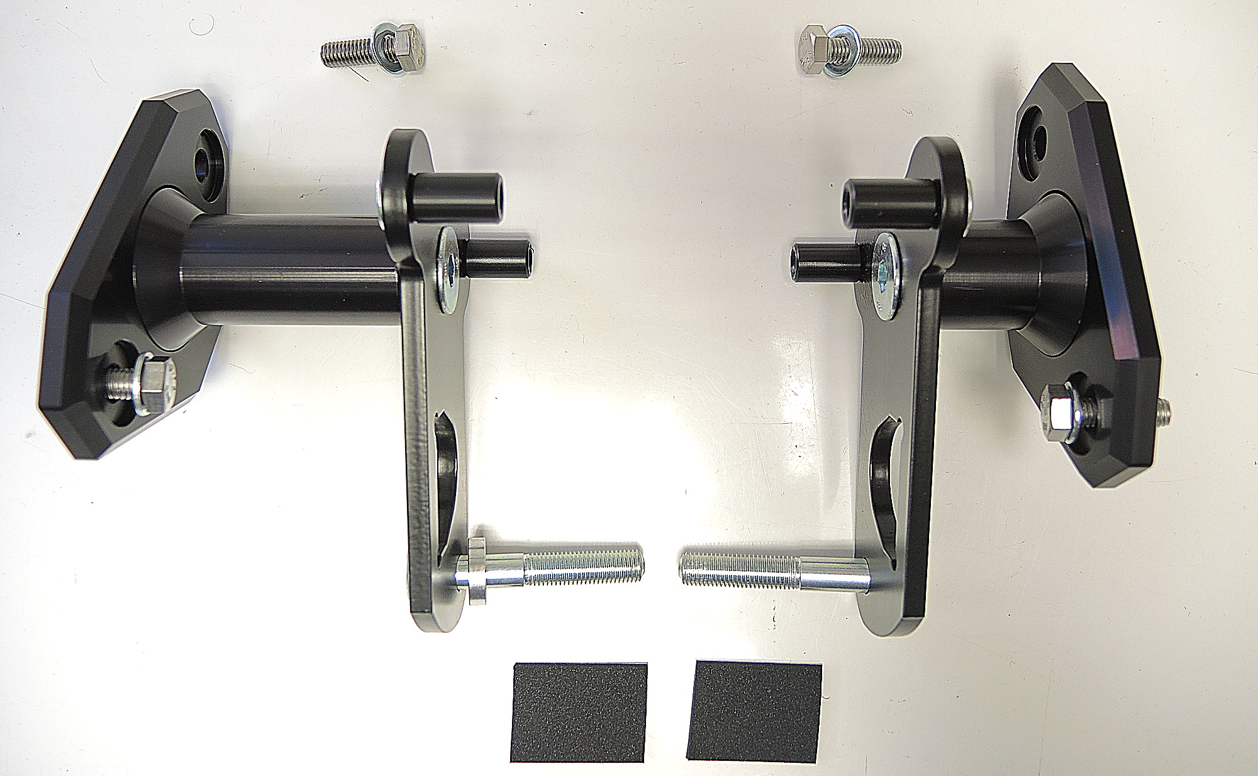
ID1
ID5+6
ID7
ID2
ID3
ID8
ID5+6
ID11
ID13+14
ID10+ID9
ID12
ID15+11

Installation:

- We recommend to use safety glue on threads (medium strong).
- Remove fairing of the motorcycle.
- Remove original bolt M10 from the frame.
- Build the kit for protectors according to the picture above.
- Note1: between ID7 and ID11 place washer ID10. On the left is also cylinder ID15 together with ID11.
- Note2: on the left side place spacer ID3 on bolt ID2.
- Note3: before tightening stick 3M tape on the frame.
- Put fairing back on the motorcycle.

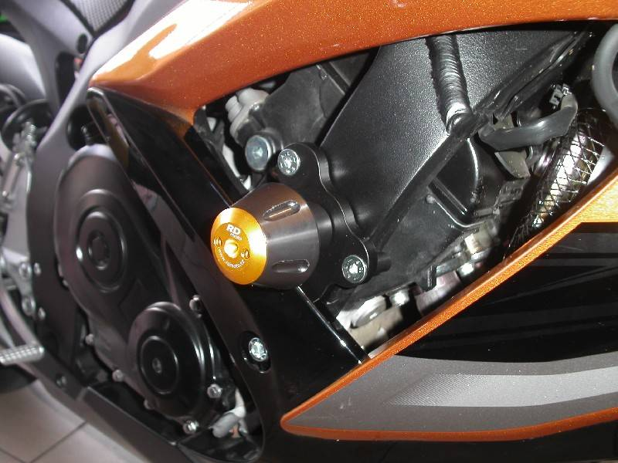
Illustrative photo

