S21S
Suzuki GSX-R600/750 2006-2007

Kit for the left side | Kit for the right side

ID | Description | Cat.no. | pcs |  | ID | Description | Cat.no. | pcs
1 | slider RDmoto | SL | 1 |  | 1 | slider RDmoto | SL | 1
2 | cover | SLcap | 1 |  | 2 | cover | SLcap | 1
4.1 | adapter moto | DV-349 | 1 |  | 4.2 | adapter moto | DV-357 | 1
7 | screw M6x25 | 877 | 3 |  | 7 | screw M6x25 | 877 | 3
8 | screw M12x30mm | 855 | 1 |  | 8 | screw M12x30mm | 855 | 1
9 | screw M4x12 | 876 | 2 |  | 9 | screw M4x16 | 876 | 2
10 | screw M8x25mm | 832 | 2 |  | 10 | screw M8x25mm | 832 | 2
11 | poly. roller d=20mm | X9 | 2 |  | 11 | poly. roller d=20mm | X9 | 2
12.1 | dural adapter | 561 | 1 |  | 12.2 | dural adapter | 560 | 1
13 | screw M10x60x1,25mm | 896 | 1 |  | 13 | screw M10x60x1,25mm | 896 | 1
15 | Dural roller d=5mm | 16 | 1 |  | 16 | Tape 3M |  | 1
16 | Tape 3M |  | 1
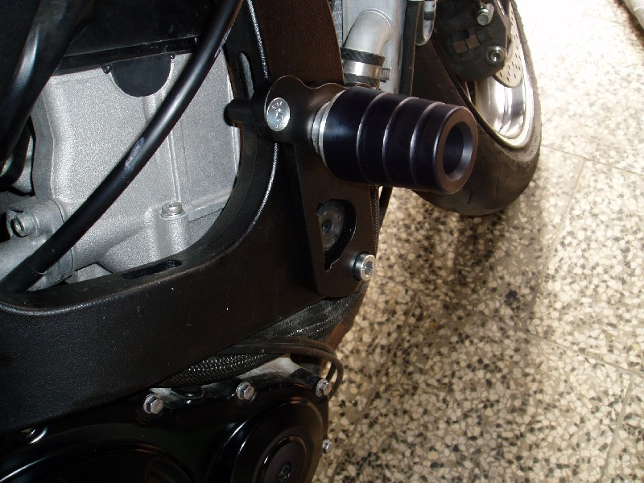
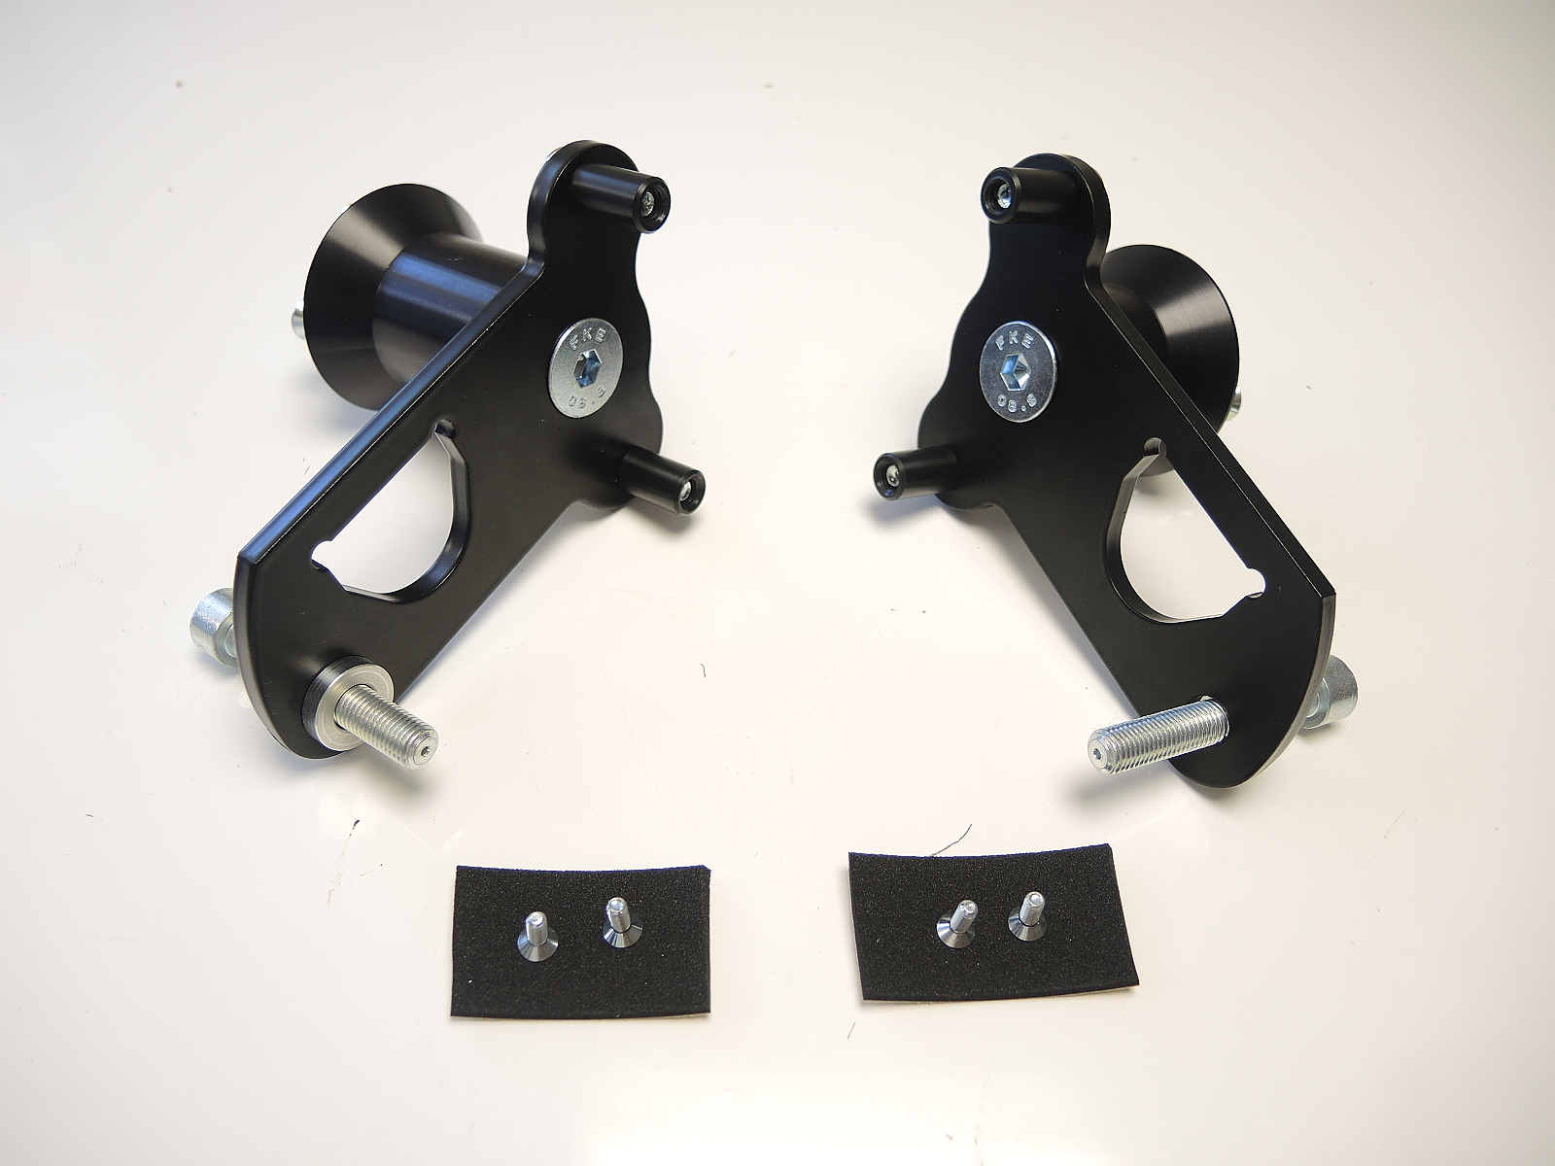
ID8
ID11
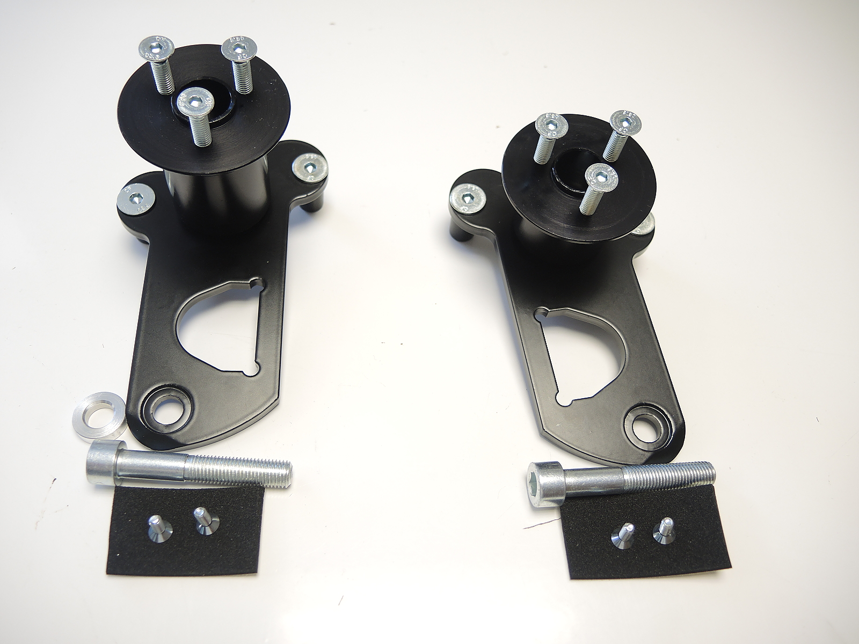
ID12.1
ID12.2
ID4.1
ID4.2
ID15
ID7
ID13
ID16
ID9
ID10

Instructions for the left side:

- Remove fairing and original screw M10 from frame of motorcycle.
- First, prepare dural adapter. Into dural adapter (ID12.1) place screws (ID10) and tighten them from backside with poly rollers (ID11).
- On the frame of motorcycle place 3M tape (ID16).
- With screw (ID8) connect dural adapter (ID12.1) with moto adapter (ID4.1).
- Dont forget to place dural roller (ID15) under dural adapter.
- Now you should have dural adapter on the frame of motorcycle. Tighten adapter with screw (ID13) and put fairing back.
- Fit slider (ID1) on moto adapter (ID4.1) with three screws (ID7).
- In the end fit cover (ID2) on slider (ID1) with two screws (ID7).

We recommend: use the glue for all threads (medium strong).

Instructions for the right side:

- On the right side are just few differences:
  - Instead of moto adapter (ID4.1) use moto adapter (ID4.2).
  - Instead of dural adapter (ID12.1) use dural adapter (ID12.2).
  - Under dural adapter (ID12.2) dont use dural roller (ID15).

We recommend: use the glue for all threads (medium strong).

