S22SDM
Suzuki SV650 N/S 2007-

Fitting kit left side: Fitting kit right side:
ID | Description | Cat.No | QTY
1 | SLDM adapter | 537/B | 1
2 | Bolt M10x110x1,25 | 928 | 1
3 | Dural. cylinder 20mm | 182 | 1
4 | Dural. cylinder 20mm | 10 | 1
5 | Bolt M6x20 | 1024 | 1
6 | Washer M6 | 1023 | 1
ID | Description | Cat.No | QTY
1 | SLDM adapter | 537/B | 1
2 | Bolt M10x160x1,25 | 929 | 1
3 | Dural.cylinder | 181 | 1
4 | Dural. cylinder 20mm | 10 | 1
5 | Bolt M6x20 | 1024 | 1
6 | Washer M6 | 1023 | 1

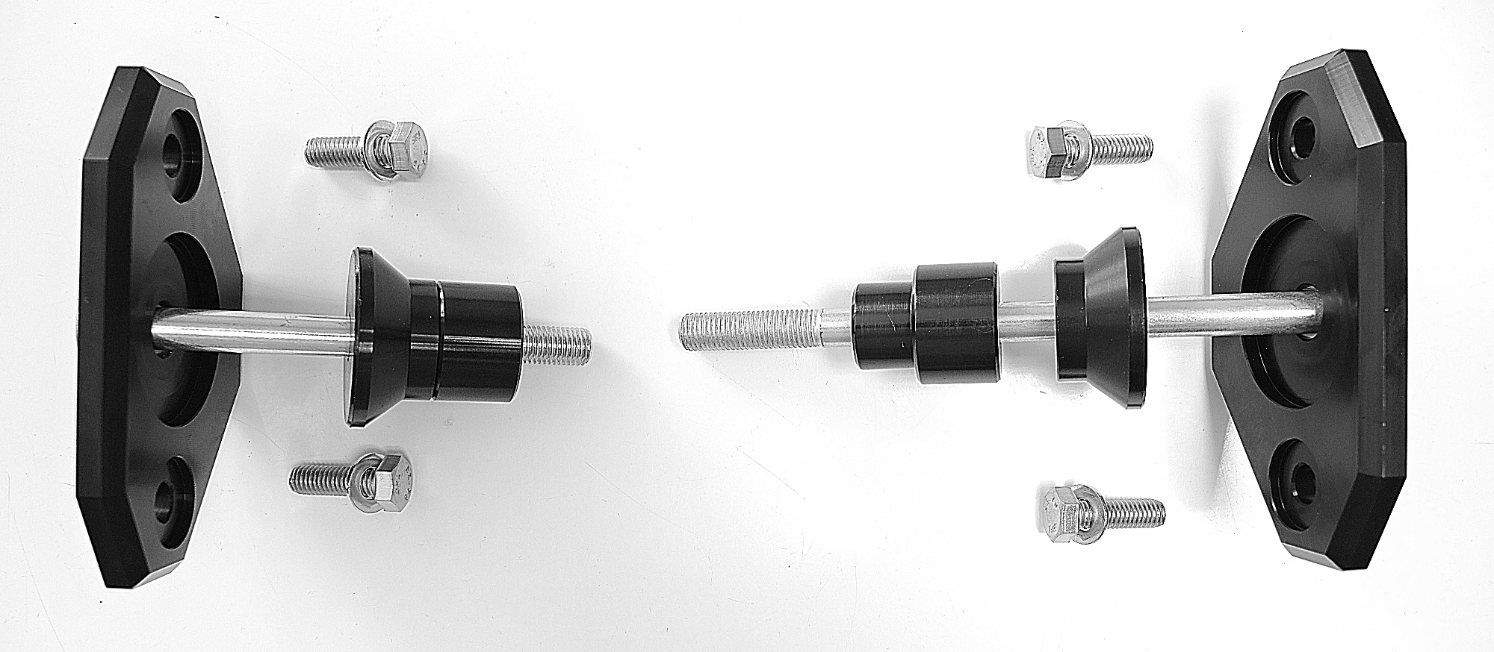
ID3
ID4

Instructions:

- We recommend to use the glue on all threads (medium strong).
- Remove original bolt from the frame of motorcycle.
- Prepare bolt M10 (ID2) and put SLD adapter ID1 and dural cylinders ID3 + ID4 on it.
- Mount this kit into the frame of motorcycle.
- In the end mount protector on the sld adapter using two M8 bolts + washers M8.
