S22SD
Suzuki SV650 N/S 2007-

Fitting kit left side: Fitting kit right side:
ID | Description | Cat.No | QTY
1 | SLD adapter | 537 | 1
2 | Bolt M10x110x1,25 | 928 | 1
3 | Dural. cylinder 20mm | 182 | 1
4 | Dural. cylinder 20mm | 10 | 1
5 | Bolt M8x25 | 815 | 1
6 | Washer M8 | 802 | 1
ID | Description | Cat.No | QTY
1 | SLD adapter | 537 | 1
2 | Bolt M10x160x1,25 | 929 | 1
3 | Dural.cylinder | 181 | 1
4 | Dural. cylinder 20mm | 10 | 1
5 | Bolt M8x25 | 815 | 1
6 | Washer M8 | 802 | 1

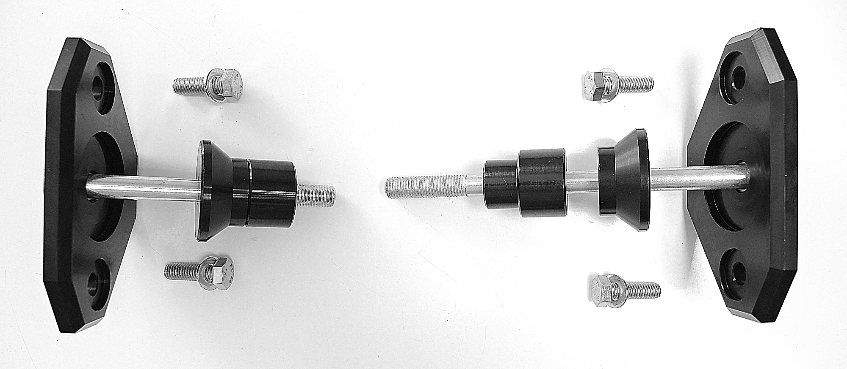
ID3
ID4

Instructions:

- We recommend to use the glue on all threads (medium strong).
- Remove original bolt from the frame of motorcycle.
- Prepare bolt M10 (ID2) and put SLD adapter ID1 and dural cylinders ID3 + ID4 on it.
- Mount this kit into the frame of motorcycle.
- In the end mount protector on the sld adapter using two M8 bolts + washers M8.
