S22
Suzuki SV650 N/S 2007-

Fitting kit left side: Fitting kit right side:
ID | Description | Cat.No | QTY
1 | Steel box M10 | X1 | 1
2 | Screw M10x110x1,25 | 928 | 1
3 | Dural.cylinder d=20 | 182 | 1
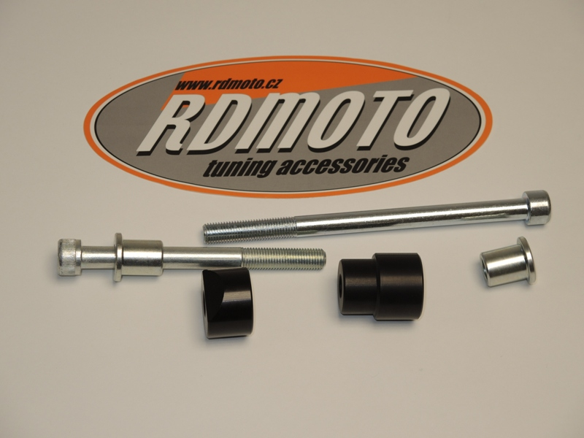
ID | Description | Cat.No | QTY
1 | Steel box M10 | X1 | 1
2 | Screw M10x160x1,25 | 929 | 1
3 | Dural.cylinder | 181 | 1

2
1

1
2
3

3

Assembly make to the frame, position on photos. Make first left side.

Assembly to left side:
- Take out original bolt from frame.
- Insert steel box ID.1 into the protector and after insert bolt ID.2.
- Take dural.cylinder ID.3 and insert it on the bolt.
- This kit mount into the frame.
- Thighten the safety bolt on frame.

Assembly to right side:
- Take out original bolt from frame.
- Insert steel box ID.1 into the protector and after insert bolt ID.2.
- Take dural.cylinder ID.3 and insert it on the bolt.
- This kit mount into the frame.

Warning:
We recommend use the glue of all threads. Medium strong.
