S23
Suzuki GSX-R 600/750 2008-2010
Kit for the left side: | Kit for the right side:

ID | Description | Cat.N | Qty
1 | Thread bush | X17 | 1
2 | Bolt M10x60x1,25mm | 896 | 1
3 | Dural. spacer d=5mm | 16 | 1
4 | Dural. spacerer d=30mm | 171 | 1
5 | Bolt M12x55mm cone | 1026 | 1
6 | Bolt M8x25mm | 832 | 2
7 | Poly nut d=20mm | X9 | 2
8 | Duralumin adapter | 561 | 1
9 | Tape 3M |  | 1
ID | Description | Cat.N | Qty
1 | Thread bush | X17 | 1
2 | Bolt M10x60x1,25mm | 896 | 1
3 | Bolt M12x25mm cone | 1008 | 1
4 | Bolt M8x25mm | 832 | 2
5 | Poly nut d=20mm | X9 | 2
6 | Duralumin adapter | 560 | 1
7 | Tape 3M |  | 1

4
5
4
3
1
5
3
8
1
4
6
6
7
7
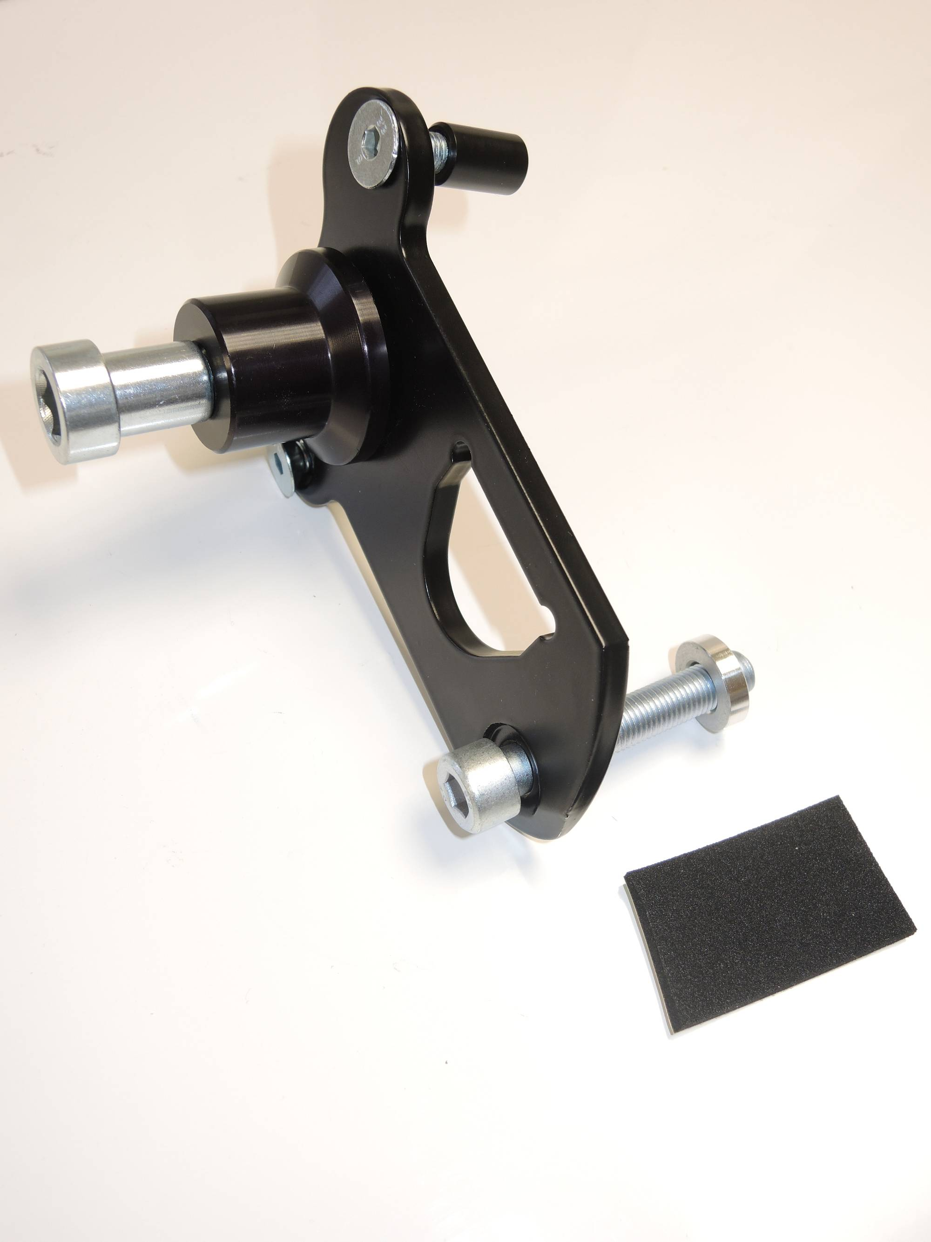
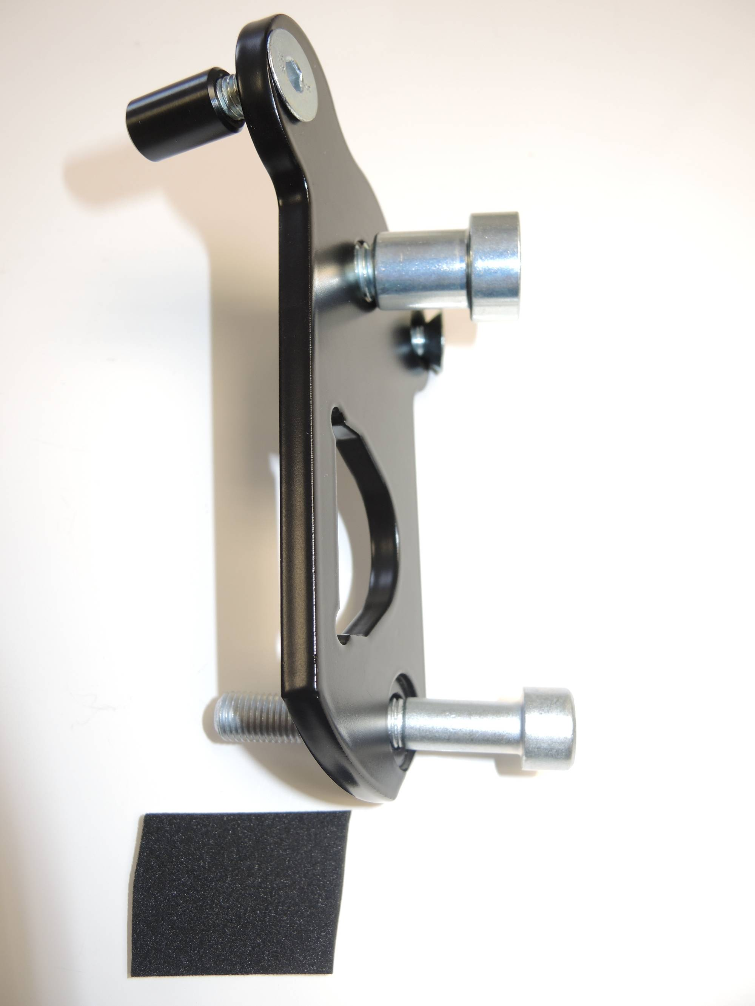
2
2

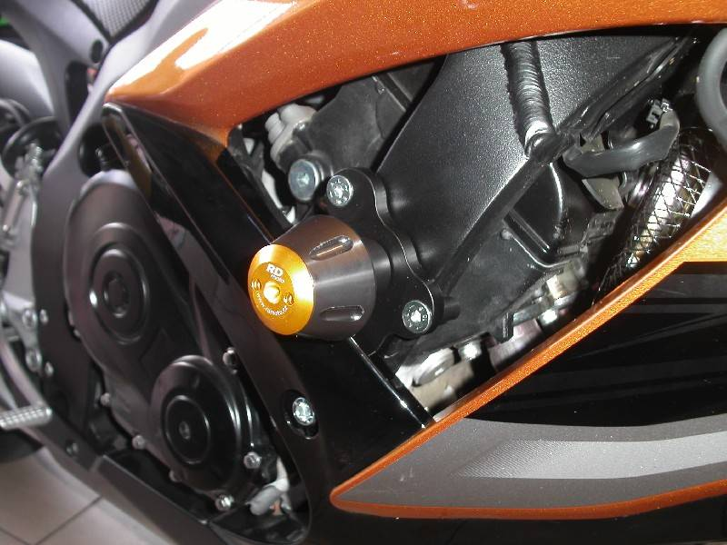

Installation – the left side:
- remove the original side plastic and bolt M10 in frame of the motorcycle
- complete adapter (No. 8) together, use bolts (No. 5) from back side adapter. Insert no.1 into the protector and under the protector place no.4. Thighten this kit. Stick 3Mtape on the chassi.
- Insert bolts no.6 into the holder protector and assembly poly nut from back side.
- This kit assembly on the chassi. Into the frame insert no.3 spacer. Fix this kit on the bike by bolt no.2.
- Put fairing back the bike.

Installation – the rigth side:

- remove the original side plastic and bolt M10 in frame of the motorcycle
- complete adapter (No. 6) together, use bolts (No. 3) from back side adapter. Insert no.1 into the protector and thighten this kit. Stick 3Mtape on the chassi.
- Insert bolts no.4 into the holder protector and assembly poly nut from back side.
- This kit assembly on the chassi. Fix this kit on the bike by bolt no.2.
- Put fairing back the bike

Warning – we recommend to use safety glue on threads of all bolts (moderate strong – blue colour).

