S24SDM
Suzuki GSX-R1300 Hayabusa 2008-

Kit for the left side |  |  |  |  | Kit for the right side
ID. | Description | Cat.no. | pcs |  |  | ID. | Description | Cat.no. | pcs
1 | Slider diamond RDmoto | SLDM | 1 |  |  | 1 | Slider diamond RDmoto | SLDM | 1
2 | Dural.adapter (cylinder) | DV149 | 1 |  |  | 2 | Dural.adapter (cylinder) | DV149 | 1
3 | Washer M6 | 1023 | 2 |  |  | 3 | Washer M6 | 1023 | 2
4 | Bolt M6x20 | 1024 | 2 |  |  | 4 | Bolt M6x20 | 1024 | 2
5 | Slider adapter | 537/B | 1 |  |  | 5 | Slider adapter | 537/B | 1
6 | Bolt M10x70x1,25mm | 898 | 1 |  |  | 6 | Bolt M10x60x1,25mm | 896 | 1
7 | Dural. cylinder - 80mm | 142 | 1 |  |  | 7 | Dural. cylinder - 90mm | 143 | 1
8 | Bolt M8x25mm | 831 | 1 |  |  | 8 | Bolt M8x25mm | 831 | 1
9 | Bolt M12x120mm | 968 | 1 |  |  | 9 | Bolt M12x130mm | 886 | 1
10 | Washer M10 (stringed) | 801 | 1 |  |  | 10 | Washer M10 (stringed) | 801 | 1
11 | Steel adapter | 571 | 1 |  |  | 11 | Steel adapeter | 572 | 1
12 | Tape 3M |  | 1 |  |  | 12 | Tape 3M |  | 1
13 | Dural. cylinder d=15mm | 109 | 1 |  |  | 13 | Bolt M8x40mm | 828 | 1
14 | Dural. rod AL16(M8)x358x30x30 |  | 1 |  |  | 14 | Washer M8 (stringed) | 800 | 1

Instructions:

- We recommend to use the glue on all threds (blue color – medium strong).
- Remove fairing of motorcycle.
- Remove original bolts M10 from both sides and one bolt M8 from the right side of motorcycle.
- Stick tape 3M between adapter and frame of motorcycle.
- Fit steel adapters on the frame of motorcycle. Tighten it using bolts (ID6) and (ID13 – only right side). Add dural. cylinder (ID13) on the left side. Do not forget to place washers.
- Insert dural. rod between adapters and tighten it using botls (ID8)
- Put fairing back.
- In the end fit slider.
  - Prepare bolt (ID9) and put slider adapter (ID5), dural. adapter (cylinder – ID2),and dural cylinder (ID7) on it.
  - Fit this kit on the steel adapter.
  - Fit protector (ID1) on the slider adapter (ID5) using two bolts and washers (ID5 + ID3).

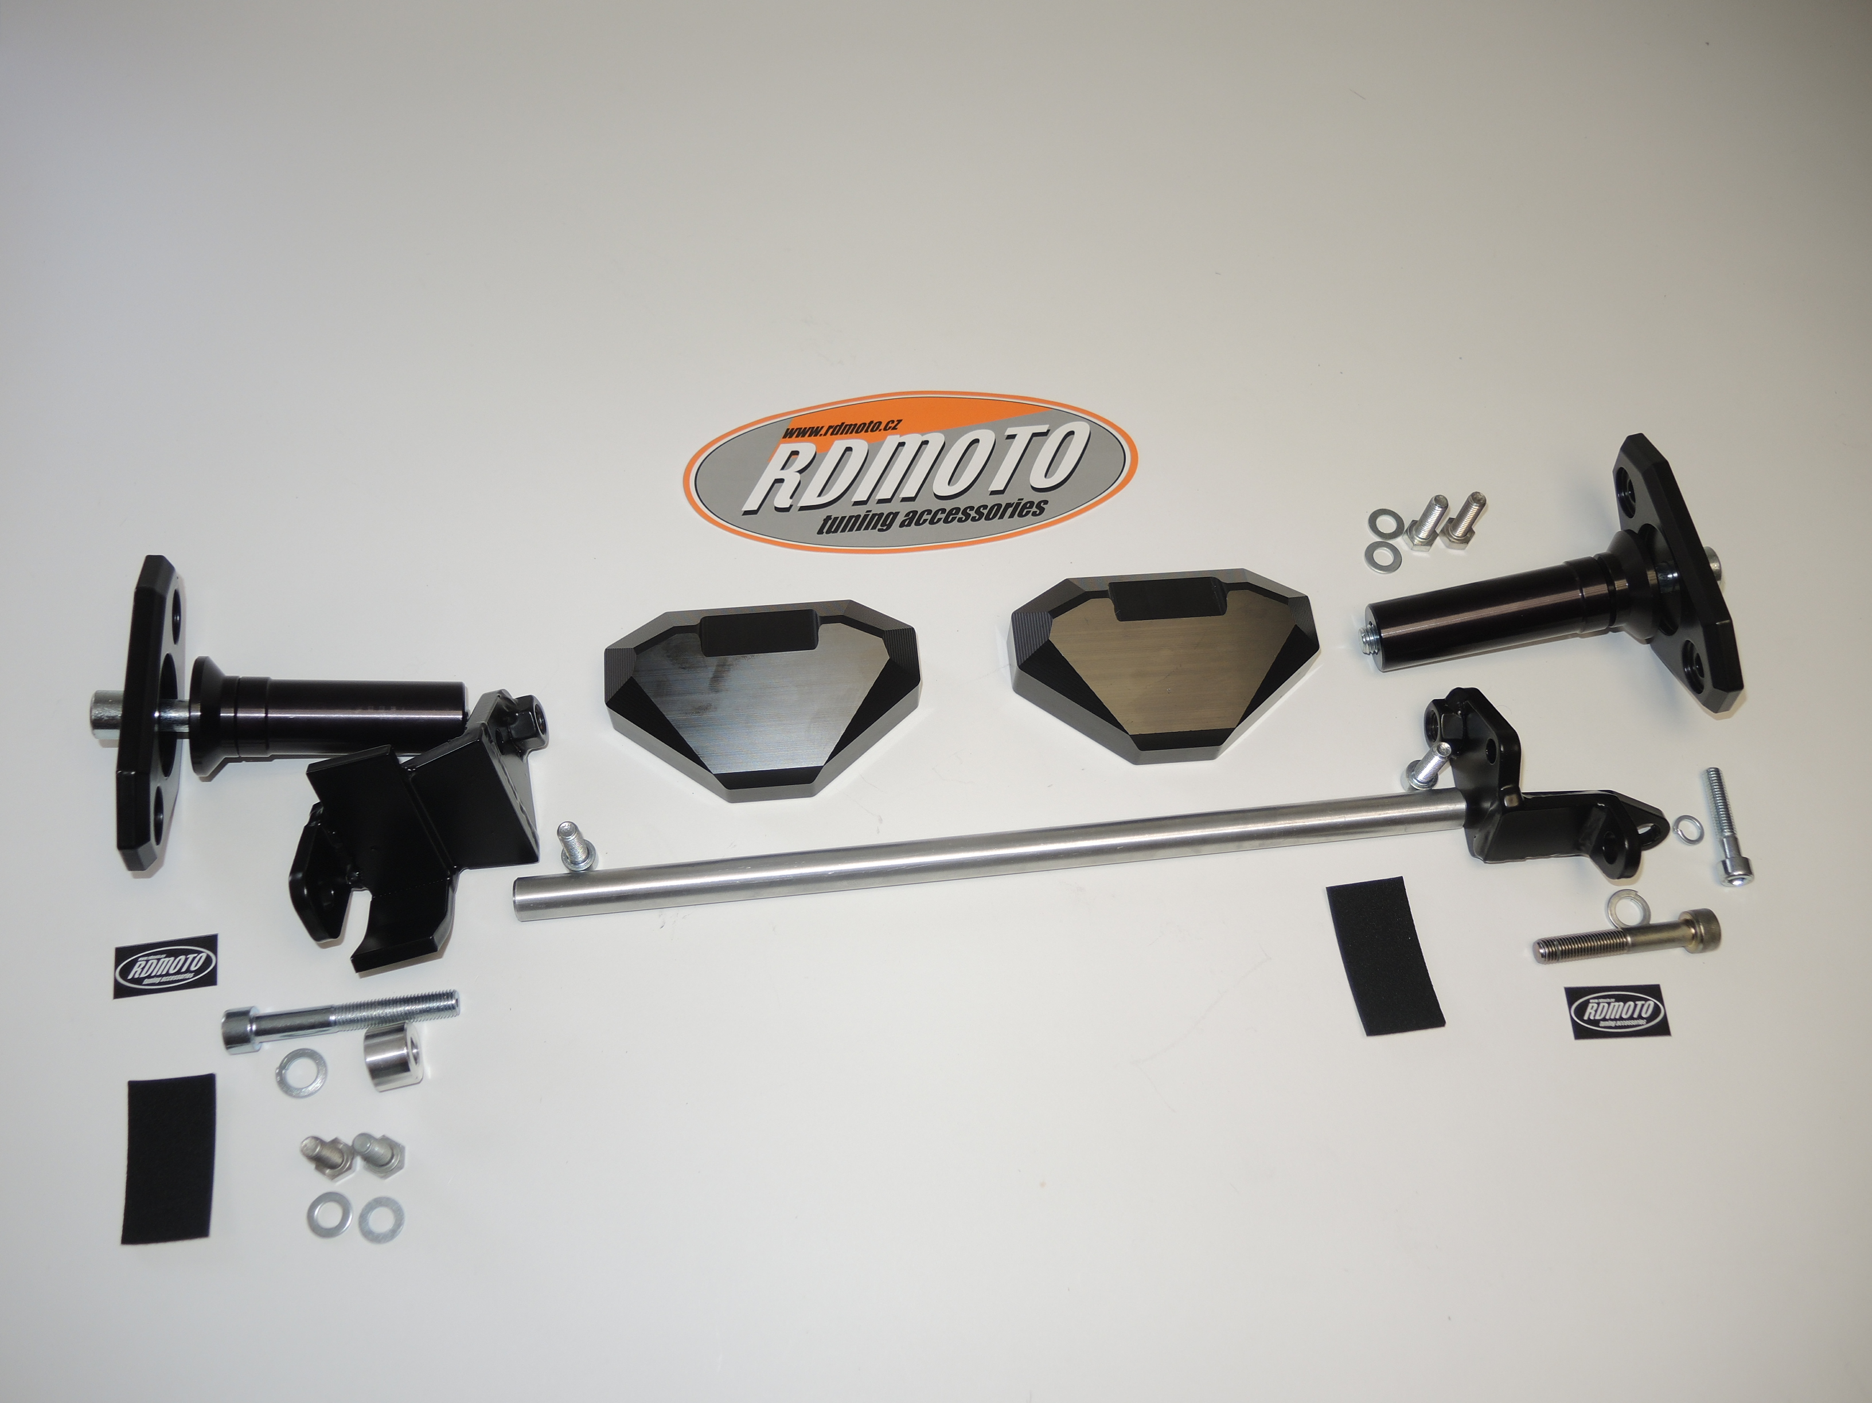
9
13
7
11
5
2
1
3,4
7
2
6,10
3,4
5
9
8
1
8
11
6,10
13,14
12
14

