S24S
Suzuki GSX-R1300 Hayabusa 2008-

Kit for the left side |  |  |  |  | Kit for the right side
No. | Description | Cat.no | Pcs |  |  | No. | Description | Cat.no | Pcs
1 | slider RDmoto | SL | 1 |  |  | 1 | slider RDmoto | SL | 1
2 | cover | SLcap.. | 1 |  |  | 2 | cover | SLcap.. | 1
-- | -- | -- | - |  |  | -- | -- | -- | -
4 | adapter moto | DV-314 | 1 |  |  | 4 | adapter moto | DV-314 | 1
-- | -- | -- | - |  |  | -- | -- | -- | -
6 | bolt M6x25 | 877 | 3 |  |  | 6 | bolt M6x25 | 877 | 3
-- | -- | -- | - |  |  | -- | -- | -- | -
8 | bolt M4x16 | 876 | 2 |  |  | 8 | bolt M4x16 | 876 | 2
9 | bolt M10x70x1,25mm | 898 | 1 |  |  | 9 | bolt M10x60x1,25mm | 896 | 1
10 | dural. cylinder d=80mm | 142 | 1 |  |  | 10 | dural. cylinder d=90mm | 143 | 1
11 | bolt M8x25mm | 831 | 1 |  |  | 11 | bolt M8x25mm | 831 | 1
12 | bolt M12x120mm | 968 | 1 |  |  | 12 | bolt M12x130mm | 886 | 1
13 | pad M10 (spring) | 801 | 1 |  |  | 13 | pad M10 (spring) | 801 | 1
14 | steel adapter | 571 | 1 |  |  | 14 | steel adapter | 572 | 1
15 | tape 3M |  | 1 |  |  | 15 | tape 3M |  | 1
16 | dural. cylinder d=15mm | 109 | 1 |  |  | 16 | bolt M8x40mm | 828 | 1
17 | dural.bar AL16(M8)x358x30x30 |  | 1 |  |  | 17 | pad M8 (spring) | 800 | 1
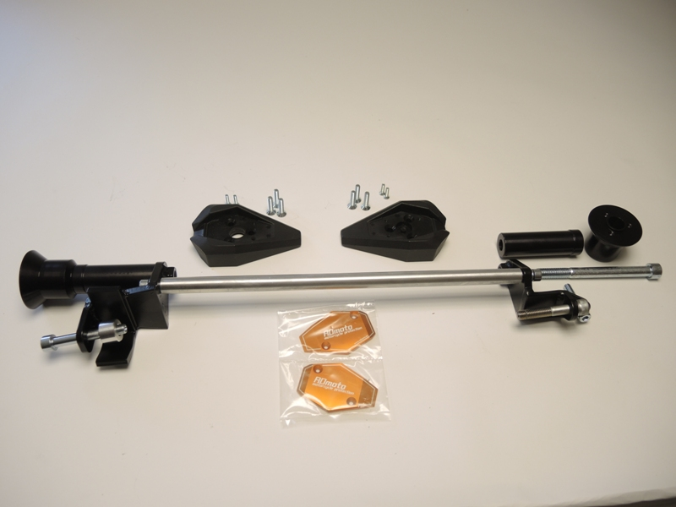

8
11
1
10
6

4

12
11

9+13
2
16

17
14

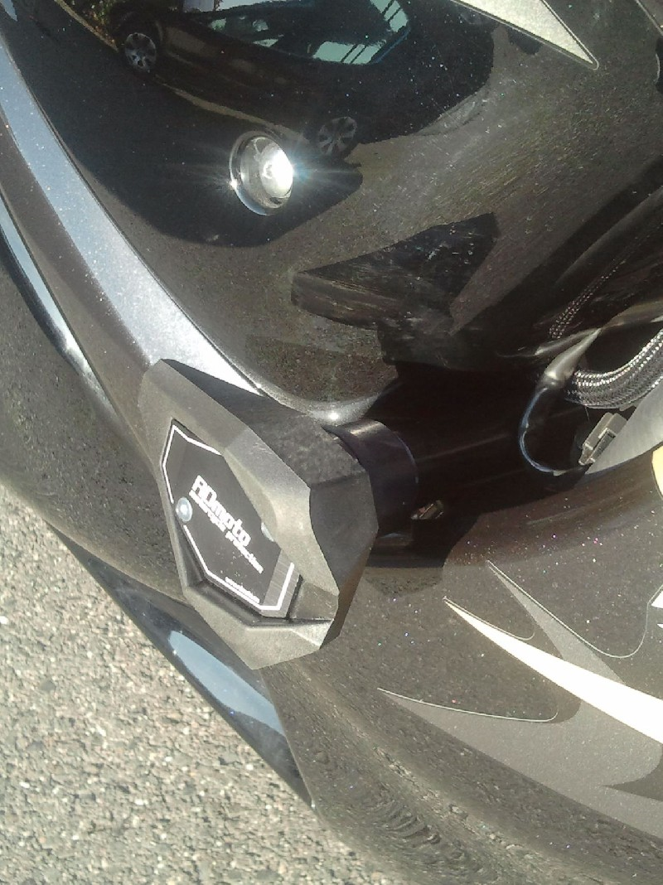

Installation:
1. Remove the side cover set
2. Remove the original screws M10 and screw M8 on the right side
3. To the mounting of steel adapters use 3M tape to define the space between the adapter and the frame of the motorcycle
4. On the left and right side of the motorcycle frame mount steel adapters, attached photos below. Right adapter insert between the motorcycle frame and by screws (item 9) and (item 16) tighten. Not forget put washers under the screws.
5. Left adapter mount by the screw (item 9), not forget insert the duralumin cylinder between the motorcycle frame and the adapter (item16)
6. Between the left and right adapter insert aluminum alloy rod, tighten by the screws (item 11)
7. Everything thoroughly tighten, you can mount the plastic side
8. Now begin to mount attaching for slider. On the steel adapter mount by the screw (item 12) duralumin adapter (item 4) with duralumin cylinder (item 10). For the correct rotation of slider you must attach the adapter by thread M6 up.
9. Attach the slider (item 1) and mount by the screws (item 6)
10. Insert the cover to the slider (item 2) and mount by the screws (item 8)
11. Use the same procedure on the opposite side

Warning – we recommend to use safety glue on threads of all bolts (moderate strong – blue colour).

