S27
Suzuki GSX 1250 Bandit ´07-

Fitting kit left side: Fitting kit right side:
ID | Description | Cat.no | QTY
1 | Bolt M8x40 | 828 | 2
2 | Alu.frame adapter | 568 | 1
3 | Special alu spacer | 187 | 1
4 | Alu. black adapter | 566 | 1
5 | Bolt M8x20 | 823 | 2
6 | Bolt M12x40 | 858 | 1
7 | Bolt M8x30 | 834 | 1
8 | Washer M8 | 802 | 1
9 | Al.spa. under protec | 283 | 1
10 | Steel box | X2 | 1
11 | Bolt M12x40 | 857 | 1
ID | Description | Cat.no | QTY
1 | Spec. Alu. spacer | 186 | 1
2 | Bolt M10x30 | 882 | 1
3 | Plastic cover | X4 | 1
4 | Steel U stirrup | 950 | 1
5 | Nut M8 | 951 | 2
6 | Washer M8 | 802 | 2
7 | Bolt M12x40 | 858 | 1
8 | Al.spa. under protec | 283 | 1
9 | Bolt M12x40 | 857 | 1
10 | Steel box | X2 | 1
11 | Alu. black adapter | 567 | 1
12 | 3M Tape | 3M | 1

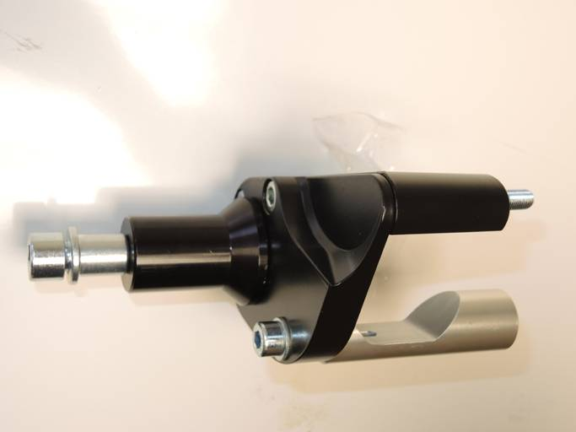

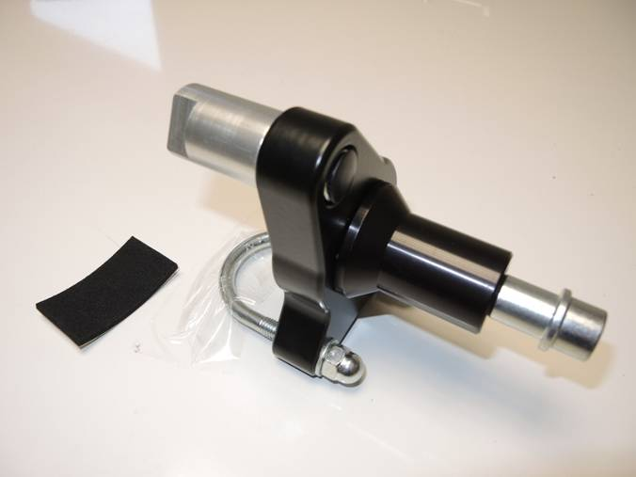
1
5,6
5
4
5
2,3
11
1
2
9
7
11
10

8
10
4
9

3
7, 8

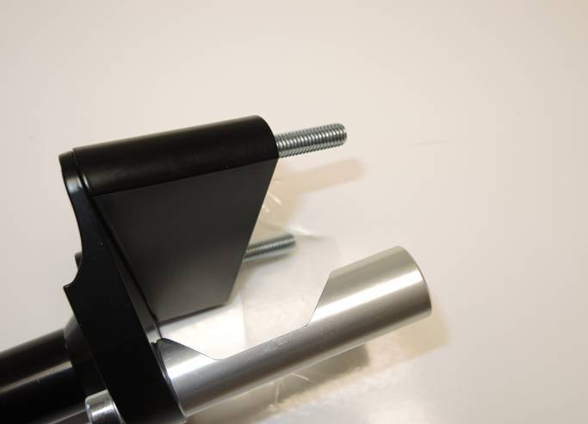
5,6

1
2

6
1

Instruction to assembly-left side:
- Dismantle original bolt M8 from frame.
- Insert bolts ID.1 into the adapter ID.2. This adapter assembly on the frame.
- Take bolt ID.7 and washer ID.8 and mount alu.spacer ID.3 from back side on the black alu. adapter.
- Place bolt cone M12x40 ID.6 from back side and assembly ID.9.
- By bolts ID.5 assembly adapter ID.4 on the frame adapter.
- Insert steel box into the protector ID.10 and assemby protector by bolt ID.11.

Instruction to assembly-right side:
- Dismantle nut from frame in fron of the engine. Assebmly ID.1 on the thread.
And tighte it by wrench 19mm.
- Place bolt cone M12x40 ID.7 from back side and assembly ID.8.
- Stick 3M tape on the chassis, place stirrup ID.4 andtighten it easy by nuts and washers ID.5, ID.6.
- Tighten bolt ID.2 with alu. spacer ID.1 on the top. Place plastic cover ID.3. Tighten stirrup.
- Insert steel box into the protector ID.10 and assemby protector by bolt ID.9.

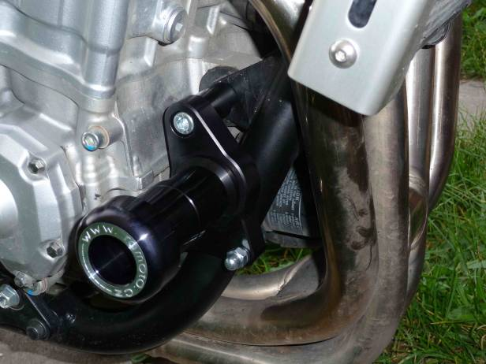
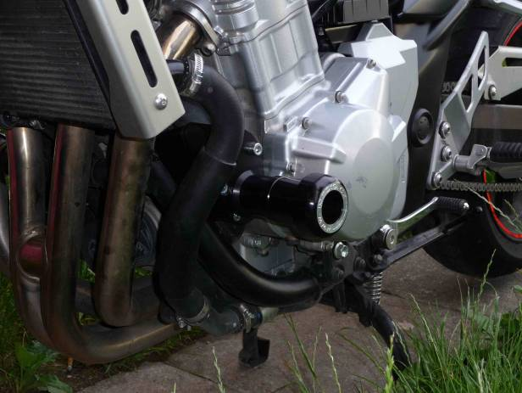
Warning: We recommend use the glue of all threads. Medium strong.

