S28
Suzuki GSF 1200 Bandit 2006
LEFT SIDE KIT |  |  |  |  |  |  |  | RIGHT SIDE KIT
ID | Description |  | Cat.no. |  | Pcs |  |  | ID |  | Description |  | Cat.no. |  | Pcs
1 | Dural. adapter |  | 558 |  | 1 |  |  | 1 |  | Dural. adapter |  | 559 |  | 1
2 | Steel insert M12 |  | X2 |  | 1 |  |  | 2 |  | Steel insert M12 |  | X2 |  | 1
3 | Bolt M12x40 |  | 857 |  | 1 |  |  | 3 |  | Bolt M12x40 |  | 857 |  | 1
4 | Dural. cylinder 50mm |  | 283 |  | 1 |  |  | 4 |  | Dural. cylinder 40mm |  | 282 |  | 1
5 | Dural. cylinder 47mm |  | 48 |  | 1 |  |  | 5 |  | Dural. cylinder 47mm |  | 48 |  | 1
6 | Dural. cylinder 13mm |  | 86 |  | 1 |  |  | 6 |  | Dural. cylinder 13mm |  | 86 |  | 1
7 | Bolt M10x85x1,25 |  | 934 |  | 1 |  |  | 7 |  | Bolt M10x85x1,25 |  | 934 |  | 1
8 | Bolt M8x80mm |  | 842 |  | 2 |  |  | 8 |  | Bolt M8x80mm |  | 842 |  | 2
9 | Bolt M12x30mm |  | 855 |  | 1 |  |  | 9 |  | Bolt M12x30mm |  | 855 |  | 1
10 | Washer M10 |  | 804 |  | 1 |  |  | 10 |  | Washer M10 |  | 804 |  | 1

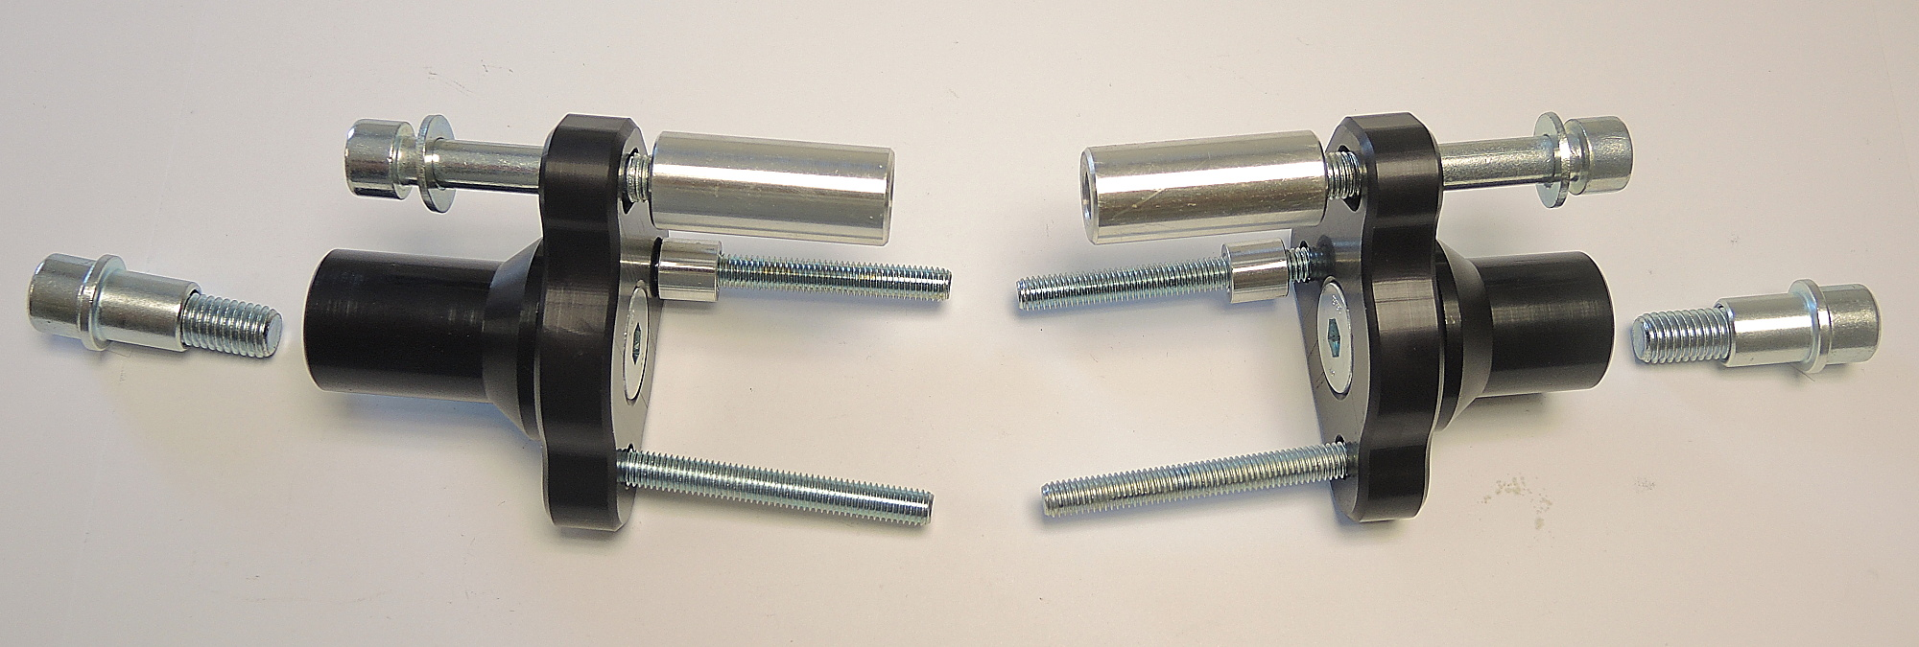
ID5
ID7
ID10
ID3

ID8
ID6
ID1
ID2
ID4
ID9

Instructions:

- We recommend to use the glue on all threads (medium strong).
- Fit dural. cylinder ID4 on the dural adpter ID1 using bolt ID9.
- Mount this kit on the frame of motorcycle using two bolts ID8 (place cylinder ID6 on the front bolt) and one bolt ID7 with washer ID10 and cylinder ID5.
- Fit protectors using bolt ID3 with steel insert ID2.

