S29SD
Suzuki B-KING 2008-

LEFT SIDE KIT | RIGHT SIDE KIT

ID | Description | Cat.no | Pcs
1 | SLD Adapter | 537 | 1
2 | Bolt M10x125x1,25 | 924 | 1
3 | Dural. cylinder 60mm | 22 | 1
4 | Dural. adapter 15mm | DV9 | 1
5 | Washer M10 (spring) | 801 | 1
6 | Bolt M8x25 | 815 | 2
7 | Washer M8 | 800 | 2
ID | Description | Cat.no | Pcs
1 | SLD adapter | 537 | 1
2 | Bolt M10x125x1,25 | 924 | 1
3 | Dural. cylinder 50mm | 21 | 1
4 | Dural. adapter 15mm | DV9 | 1
5 | Washer M10 (spring) | 801 | 1
6 | Bolt M8x25 | 815 | 2
7 | Washer M8 | 800 | 2
INSTRUCTIONS

- We recommend to use safety glue on all threads (medium strong).
- Unbolt original bolt M10 from the frame.
- Fit washer ID5, adapter ID1, cylinder ID3 and adapter ID4 on the frame using bolt ID2.
- Mount this kit into the frame of motorcycle.
- Fit slider using bolts ID6 and washers ID7.

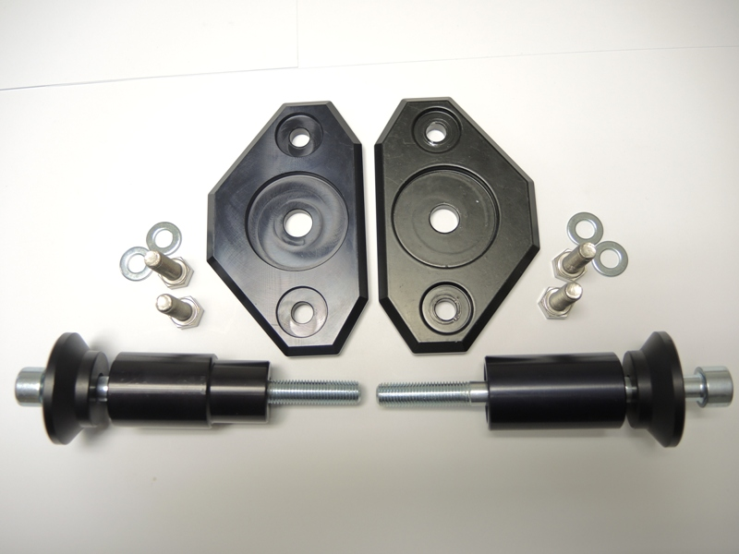
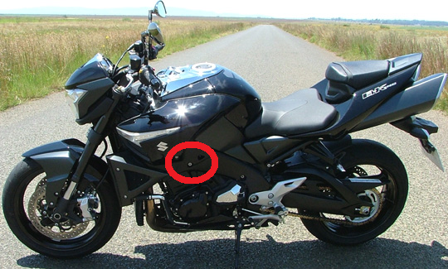

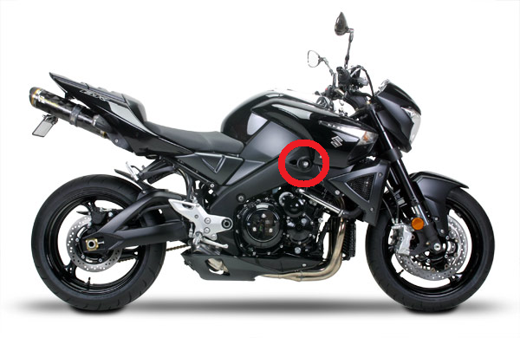
2
1
2
3
1
3

