S29S
Suzuki B-KING 2008-

Left side mounting kit: Right side mounting kit:
ID | Description | Cat.no. | pcs
1 | Dural. cylinder | 317 | 1
2 | Bolt M10x115x1,25 | 894 | 1
3 | Dural. cylinder 60mm | 22 | 1
4 | Šroub M6x25 | 877 | 3
5 | Šroub M4x16 | 876 | 2
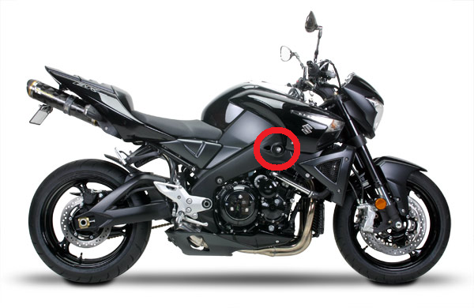
ID | Description | Cat.no. | pcs
1 | Dural. cylinder | 317 | 1
2 | Bolt M10x115x1,25 | 894 | 1
3 | Dural cylinder 50mm | 21 | 1
4 | Bolt M6x25 | 877 | 3
5 | Bolt M4x16 | 876 | 2

Instructions:

- Remove original bolt M10 from the frame according to the picture below.
- Using bolt ID2 fit dural cylinder ID1 and ID3.
- Mount slider using three bolts M6.
- In the end mount colored cover using two bolts M4.

We recommend to use the glue on all threads (medium strong).

