S29
Suzuki B-KING 2008-

Fitting kit left side: Fitting kit right side:
ID | Description | Cat.N | QTY
1 | Steel box M10 | X1 | 1
2 | Bolt M10x125x1,25 | 924 | 1
3 | Dural.cylinder d=60 | 22 | 1
ID | Description | Cat.N | QTY
1 | Steel box M10 | X1 | 1
2 | Bolt M10x125x1,25 | 924 | 1
3 | Dural.cylinder d=50 | 21 | 1
Instruction to assembly left side:
- Dismantle orig. bolt M10 from frame.
- Into the protector insert steel box ID.1.
- Through the protector insert bolt ID.2, from back side put dural.cylinder ID.3.
- This kit gripping on the frame.

We recommande, make the left side first and after finishing make to other side.

Instruction for right side are same so for left side.

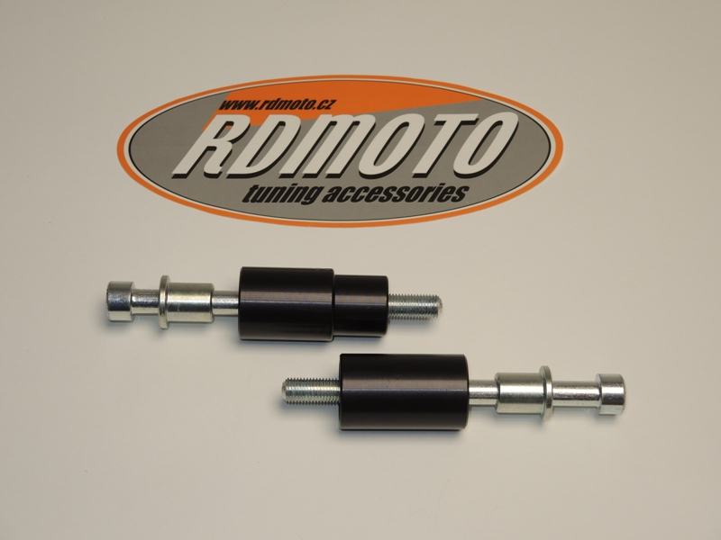
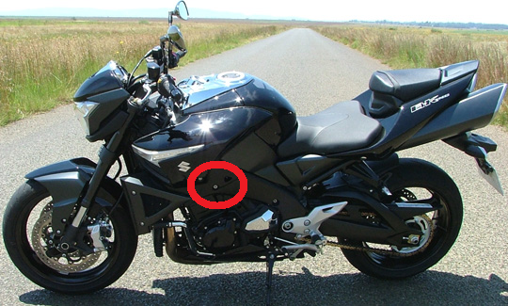
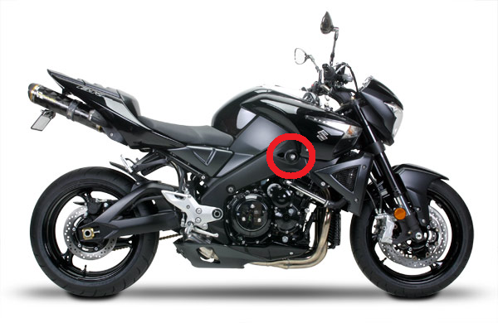
Warning: We recommend use the glue of all threads. Medium strong.

2
1
2
3
1
3

