S30SD
Suzuki SFV 650 Gladius 2008-
Left side kit:
Note | Description | No | Quant.
1 | Washer M8 | 800 | 2
2 | Aluminium adapter | 27 | 1
3 | Aluminium plate SLD | 537 | 1
4 | Nut M12 | 811 | 1
5 | bolt M8x25 | 815 | 2
6 | Stainless bar 12x445x30x30 |  | 1

Right side kit:

Note | Description | No. | Quant.
1 | Washer M8 | 800 | 2
2 | Aluminium adapter | 27 | 1
3 | Aluminium plate SLD | 537 | 1
4 | Nut M12(samojistící) | 811 | 1
5 | Bolt M8x25 | 815 | 2

For connecting of the left and right side use the stainless steel bar (note. 6) with a length of 445 mm, at both ends of the threads M12x1,5mm, which is included mounting kit.

During the installation is necessary to make a hole to plastic cover ont the frame.

Installation:

- remove the plastic cover on the frame
- remove original bolt from frame
- insert stainless bar (note 6)
- maket he hole to plastic cover
- put on the frame plstic cover with hole
- put on aluminium adapter (note 2) on the steel bar
- put on the adapter aluminium plate (note 3) and fixed by nut (not 4)
- Mounting slider on the plate, by bol (note 5) and washers note 1.

Warning – we recommend to use safety glue on threads of all bolts (moderate strong – blue colour).

Photogallery:

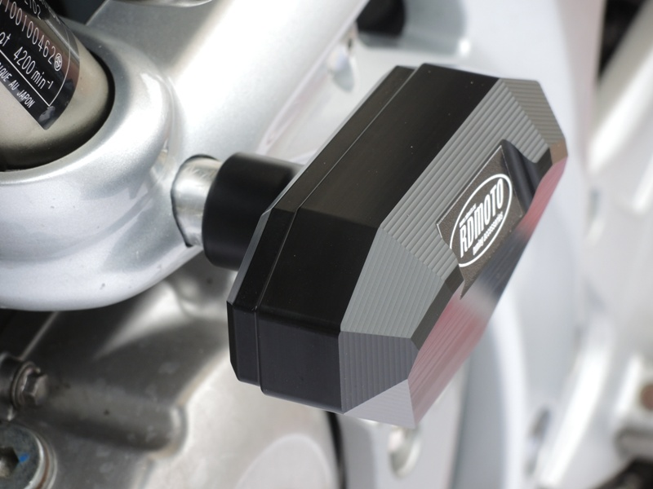
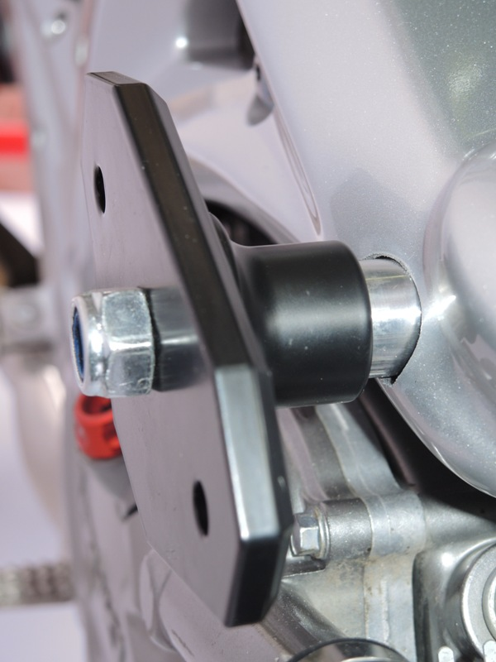
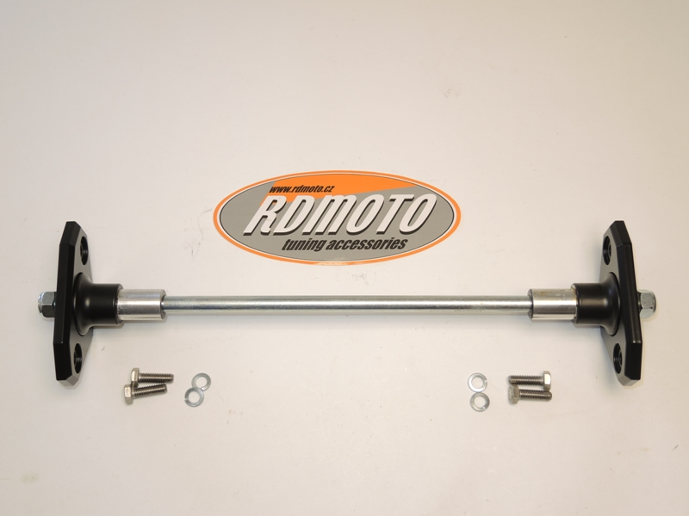
6
5
5
4
4
3
3
2
2
1
1

