S30S*
Suzuki SFV 650 Gladius 2008-
Left side kit:

ID. | Description | Cat.N | Qt
1 | Aluminium adapter d= 90mm | DV-338 | 1
2 | Bolt M6x25 | 877 | 3
3 | Bolt M4x16 | 876 | 2
4 | Steel nut M12 | X12 | 1
5 | Stainless bar M12x(1,25)x385x30x30 |  | 1

Right side kit:

ID. | Description | Cat.N | Qt
1 | Alluminium adapter d= 90mm | DV-338 | 1
2 | bolt M6x25 | 877 | 3
3 | bolt M4x16 | 876 | 2
4 | Steel nut M12 | X12 | 1

For connecting of the left and right side use the stainless steel bar ID.5 with length of 385 mm, at both ends of the threads M12x1,25mm, which is included mounting kit.

Installation:

- remove the original bolt
- place bar ID.7 through the frame
- place adapter ID.1 on the booth sides the stainless steel bar
- for tightening use nuts ID.4
- put sliders and use bolts ID.2 for mounting
- insert in cover into the slider and use bolts ID.3 for gripping

Warning – we recommend to use safety glue on threads of all bolts (moderate strong – blue colour).

*During the installation is necessary to make a hole to plastic cover ont the frame.

Photogallery:

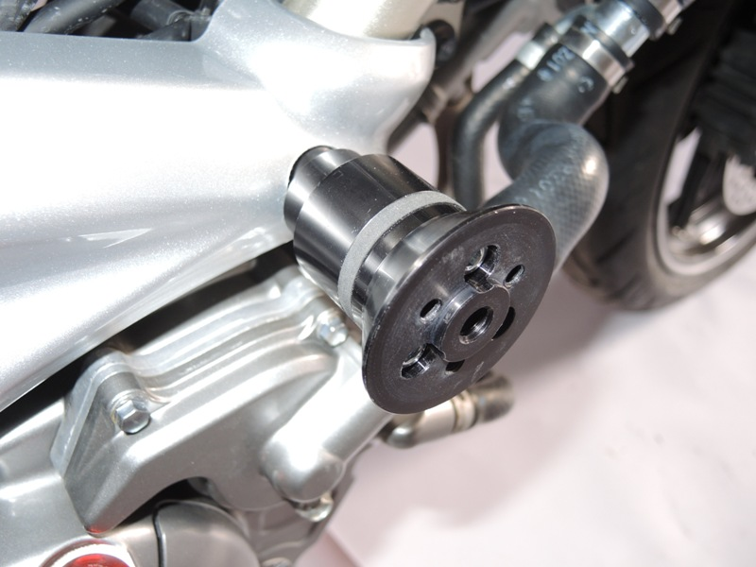
1
(Illustration photo- older type of adapter)

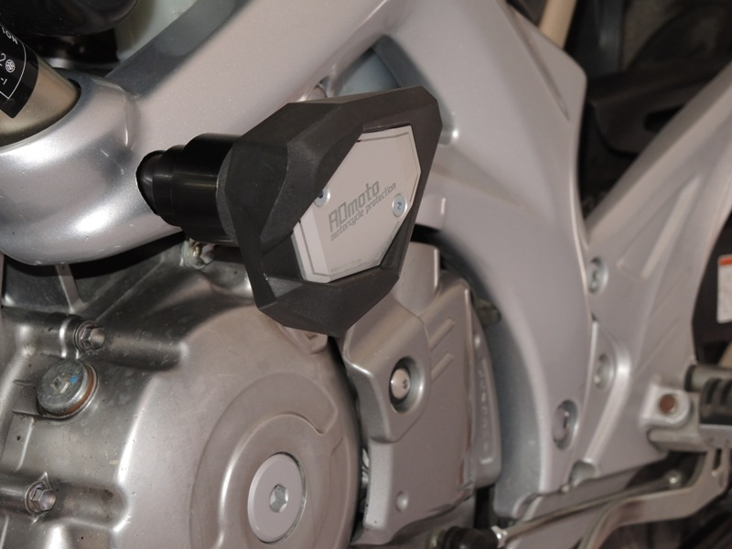
1

