S32SD
Suzuki GSX-R 600/750 2011-

Kit for the left side |  |  |  |  | Kit for the right side
No. | Description | Cat.no. | Pcs |  |  | No. | Description | Cat.no. | Pcs
1 | SLD adapter | 537 | 1 |  |  | 1 | SLD adapter | 537 | 1
2 | Bolt M10x60x1,25mm | 896 | 1 |  |  | 2 | Bolt M10x60x1,25mm | 896 | 1
3.1 | Bolt M10x60 | 851 | 1 |  |  | 3.2 | Bolt M10x35 | 847 | 1
4 | Washer M10 (stringed) | 801 | 1 |  |  | 4 | Washer M10 (stringed) | 801 | 1
5.1 | Duralumin adapter | 599 | 1 |  |  | 5.2 | Duralumin adapter | 600 | 1
6 | Tape 3M |  | 1 |  |  | 6 | Tape 3M |  | 1
7.1 | Dural cylinder – 50mm | 13 | 1 |  |  | 7.2 | Dural cylinder – 20mm | 10 | 1
8 | Bolt M8x25 | 802 | 2 |  |  | 8 | Bolt M8x25 | 802 | 2
9 | Washer M8 | 815 | 2 |  |  | 9 | Washers M8 | 815 | 2

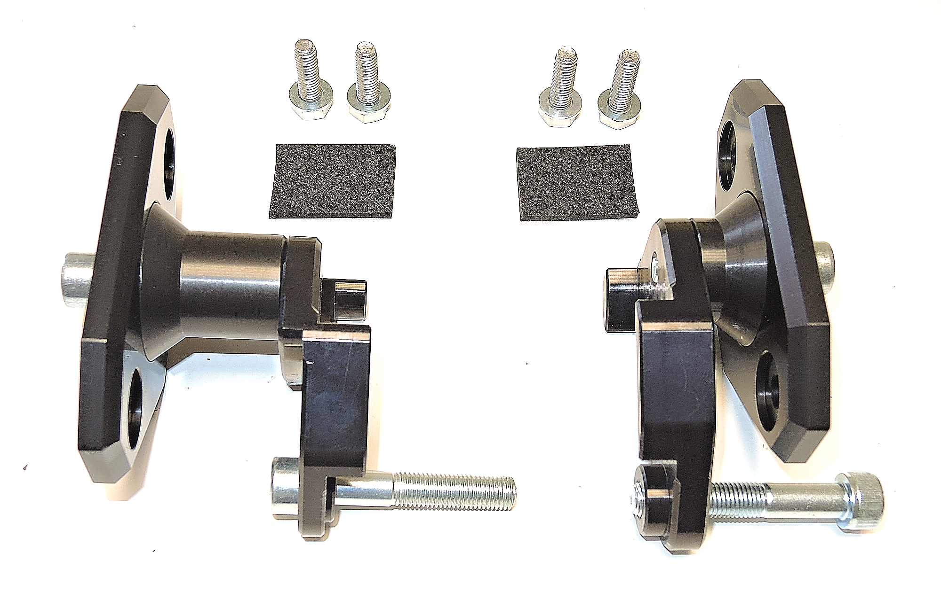
ID8+ID9

ID1

ID6

ID3.2+ID4
ID3.1+ID4
ID7.2

ID7.1

ID5.2
ID5.1

ID2

Installation (left side):

- Remove fairing of motorcycle.
- Remove original M10 bolt.
- Stick tape 3M (ID6) on the adapter ID5.1.
- Fit adapter on the motorcycle using bolt M10 (ID2).
- Now you can mount fairing back.
- Fit SLD adapter (ID1) with dural cylinder (ID7.1) using bolt ID3.1 and washer ID4 on the adapter.
- In the end fit protector using bolts ID15 and washers ID14.

We recommend to use the glue on all threads (medium strong).

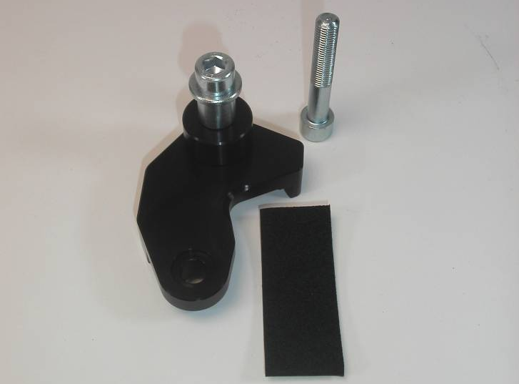

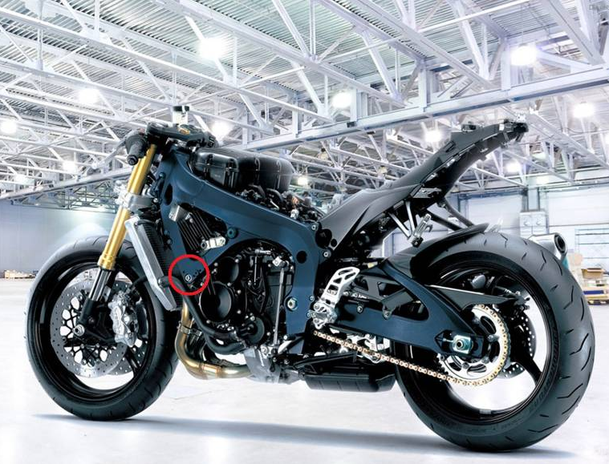

Installation – the right side:

- Remove fairing of motorcycle.
- Remove original M10 bolt.
- Stick tape 3M (ID6) on the adapter ID5.2.
- Fit adapter on the motorcycle using bolt M10 (ID2).
- Now you can mount fairing back.
- Fit SLD adapter (ID1) with dural cylinder (ID7.2) using bolt ID3.2 and washer ID4 on the adapter.
- In the end fit protector using bolts ID15 and washers ID14.

We recommend to use the glue on all threads (medium strong).

