S32S
Suzuki GSX-R600/750 2011-

Kit for the left side: | Kit for the right side:

ID | Description | Cat.N | Qty
1 | Dural.adapter for SL01 | 316 | 1
2 | Dural bracket | 599 | 1
3 | Bolt M10x60x1,25 | 896 | 1
4 | Bolt M10x20mm | 819 | 1
5 | Bolt M6x25 | 877 | 3
6 | Bolt M4x16 | 876 | 2
7 | 3M Tape | 3M | 1
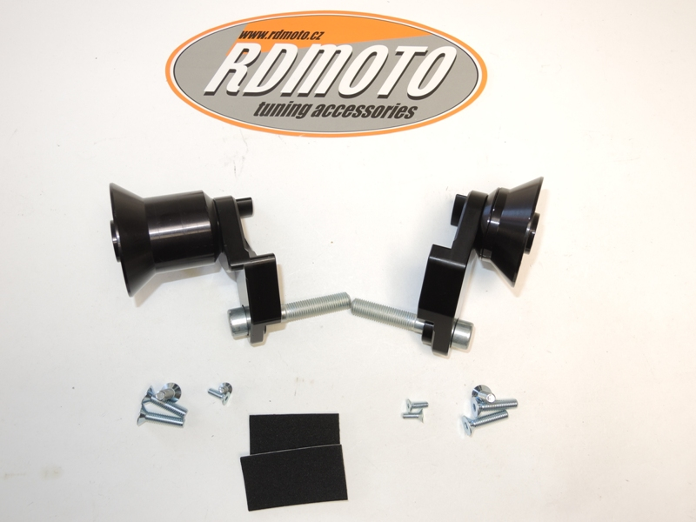
ID | Description | Cat.N | Qty
1 | Dural.adapter for SL01 | 292 | 1
2 | Dural bracket | 600 | 1
3 | Bolt M10x60x1,25 | 896 | 1
4 | Bolt M10x25mm | 868 | 1
5 | Bolt M6x25 | 877 | 3
6 | Bolt M4x16 | 876 | 2
7 | 3M Tape | 3M | 1

1
1
2

2
4
4

3
3

5
5
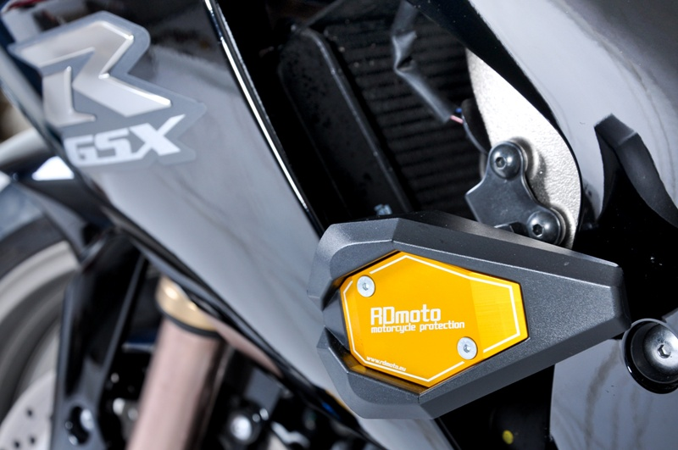
6
6

7

Installation – the left side:

- Remove the fairing and original bolt M10 from frame.
- Use the bolt ID.3 for mounting of duralumin bracket ID.2. Stick the 3M tape ID.7 on the frame of the motorcycle at the point of touching.
- Now put left side fairing back to bike.
- You can mounting dural.adapter for SL01 ID.1. Use bolt ID.4 for mounting of duralumin adapter ID.1 on the duralumin bracket. . Check the photo for right position of slider.
- Put slider and use the bolts ID.5 for mounting.
- Insert cover and use the bolts ID.6 for gripping.

Installation – the rigth side:

- Remove the fairing and original bolt M10 from frame.
- Use the bolt ID.3 for mounting of duralumin bracket ID.2. Stick the 3M tape ID.7 on the frame of the motorcycle at the point of touching.
- Now put right side fairing back to bike.
- Insert dural. adapter ID.1 on the bolt ID.4. This kit mounting on the dural. bracket on the bike. Check the photo for right position of slider.
- Put slider and use the bolts ID.5 for mounting.
- Insert cover and use the bolts ID.6 for gripping.

Warning – we recommend to use safety glue on threads of all bolts (moderate strong – blue colour).

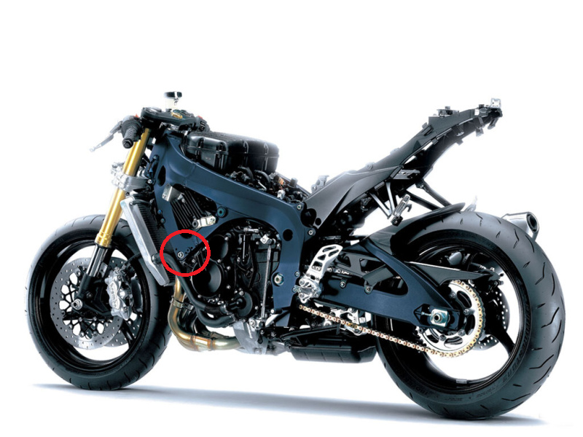

ILLUSTRATIVE PHOTOS OF Place of the installation

