S32
Suzuki GSX-R 600/750 2011-

Kit for the left side |  |  |  |  | Kit for the right side
No. | Description | Cat.no. | Pcs |  |  | No. | Description | Cat.no. | Pcs
1 | Steel box M10 | X1 | 1 |  |  | 1 | Steel box M10 | X1 | 1
2 | Bolt M10x60x1,25mm | 896 | 1 |  |  | 2 | Bolt M10x60x1,25mm | 896 | 1
3 | Bolt M10x50mm | 849 | 1 |  |  | 3 | Bolt M10x35mm | 847 | 1
4 | Dural. cylinder d=20mm | 2 | 1 |  |  | 4 | XXX | XXX | X
5 | Duralumin adapter | 599 | 1 |  |  | 5 | Duralumin adapter | 600 | 1
6 | Tape 3M |  | 1 |  |  | 6 | Tape 3M |  | 1

Installation – the left side:

- remove the original side plastic and bolt M10 in frame of the motorcycle
- stick on reverse side of adapter tape 3M (No. 6)
- use the bolt (No. 2) and screw up adapter to frame of the motorcycle
- check all and then you can mount the original side plastic back
- put steel box (No. 1) in protector together with bolt (No. 3), give duralumin cylinder (No. 4) under protector, the cylinder give on bolt
- all this set mount to thread on adapter

Warning – we recommend to use safety glue on threads of all bolts (moderate strong – blue colour).

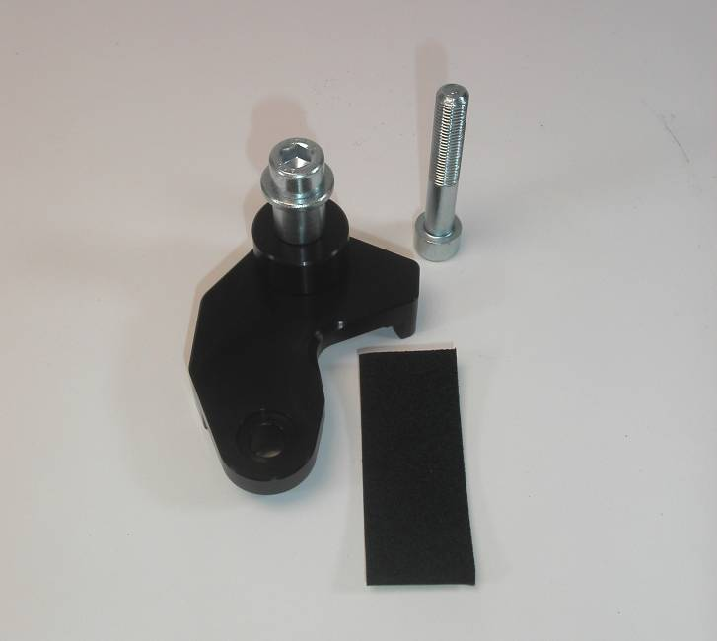

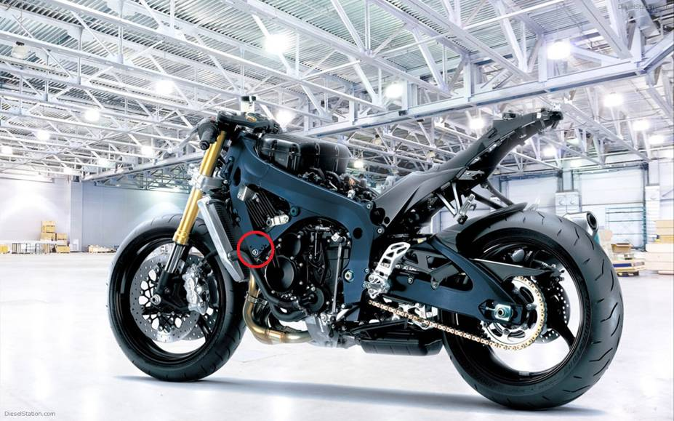
Installation – the right side:

- remove the original side plastic and bolt M10 in frame of the motorcycle
- stick on reverse side of adapter tape 3M (No. 6)
- use the bolt (No. 2) and screw up adapter to frame of the motorcycle
- check all and then you can mount the original side plastic back
- put steel box (No. 1) in protector together with bolt (No. 3)
- all this set mount to thread on adapter

Warning – we recommend to use safety glue on threads of all bolts (moderate strong – blue colour).

