S33S
Suzuki GSR 750 2011-

Kit pro levou stranu |  |  |  |  | Kit pro pravou stranu
ID | Description | Cat.no. | Pcs |  |  | ID | Description | Cat.no | pcs
1 | slider RDmoto | SL | 1 |  |  | 1 | slider RDmoto | SL | 1
2 | cover | SLcap.. | 1 |  |  | 2 | cover | SLcap.. | 1
3 | Moto adapter | DV-328 | 1 |  |  | 3 | Moto adapter | DV-320 | 1
4 | Bolt M6x25 | 877 | 3 |  |  | 4 | Bolt M6x25 | 877 | 3
5 | Bolt M4x16 | 876 | 2 |  |  | 5 | Bolt M4x16 | 876 | 2
6 | Bolt M10x75x1,25mm | 938 | 1 |  |  | 6 | Bolt M10x75x1,25mm | 938 | 1
7 | Washer M10 – spring | 801 | 1 |  |  | 7 | Washer M10 – flat | 801 | 1
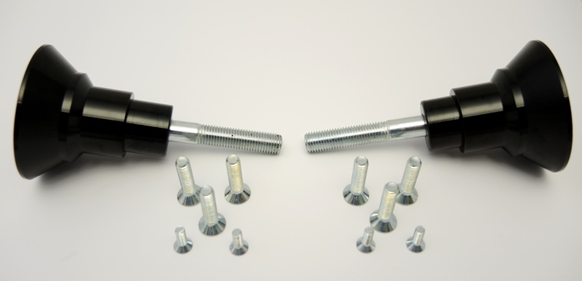

Instructions (left side):

- Remove original bolt from frame.
- Insert bolt M10 into adapter and mount it into the frame of motorcycle. Spring washer M10 between frame of motorcycle and adapter.
- Mount slider on the slider adapter using three bolts M6.
- Mount cover into the slider using two bolts M4.

We recommend to use the glue on all threads (medium strong).

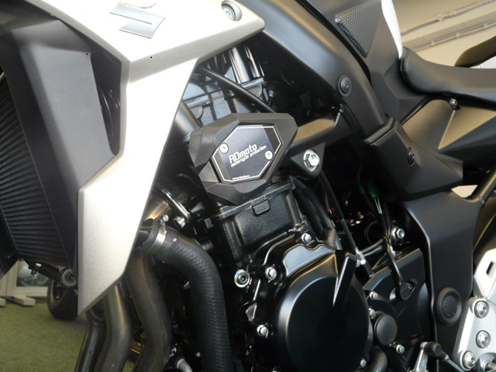

Instructions (left side):

- Remove original bolt from frame.
- Insert bolt M10 into adapter and mount it into the frame of motorcycle. Place flat washer M10 under bolt.
- Mount slider on the slider adapter using three bolts M6.
- Mount cover into the slider using two bolts M4.

We recommend to use the glue on all threads (medium strong).

