Instructions for the right side:
- Remove fairing of motorcycle.
- Remove original bolts from the frame of motorcycle.
- Mount dural. adapter ID1 into the frame of motorcycle using bolts ID4.
- Put dural. connection rod ID6 through the frame and use bolt ID5.

Instructions for the left side:
- Remove fairing of motorcycle.
- Fit dural adapter ID1 on the frame of motorcycle. Tighten it usin stirrup ID2 and bolt ID6.
- Stick 3M tape on the frame of motorcycle.
- Tighten rod using bolt ID5

Now put fairing back on motorcycle.

Instructions for crash protectors:
- Insert bolt ID4 through ID9, ID7 and ID3.
- Fit this kit into the adapter ID1.
- Fit protectors using bolts and washers (ID10 and ID11).

We recommend to use safety glue on all threads (medium strong).

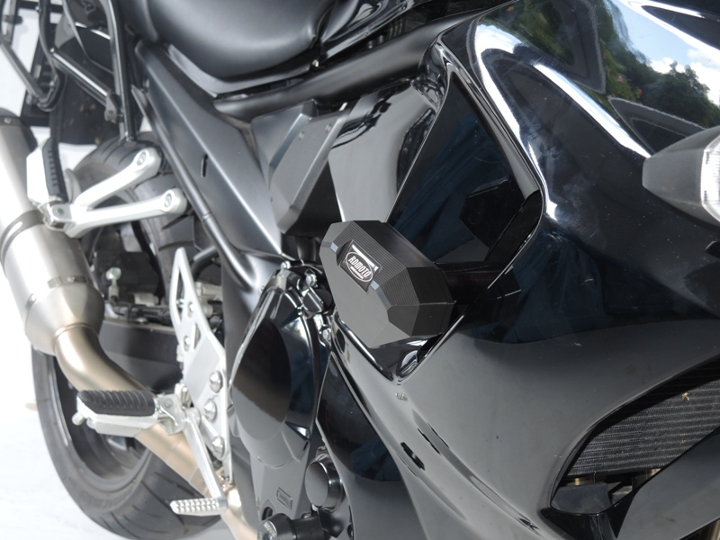

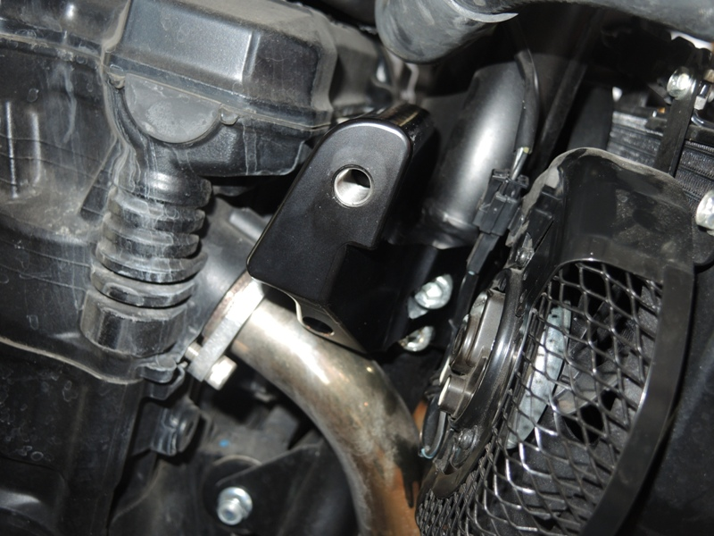
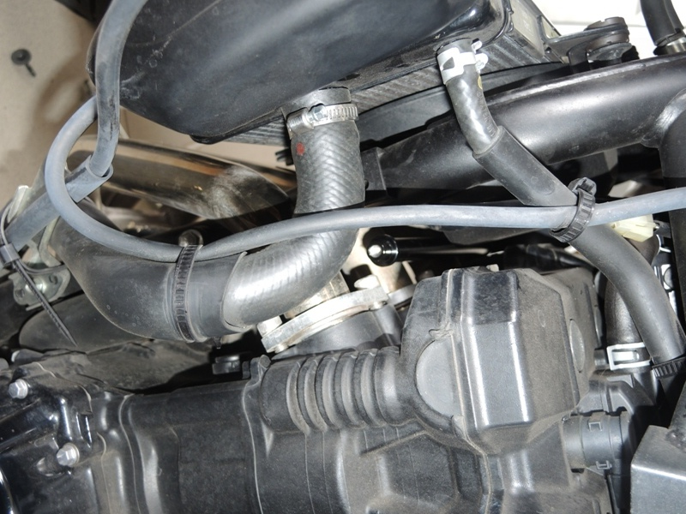

S35SD
Suzuki GSX 1250 FA-2010
ID | Description | Cat.no. | Pcs
1 | Dural. adapter | 664 | 1
2 | Threaded stirrup | 665 | 1
3 | Dural. cylinder 90mm | 143 | 1
4 | Bolt M12x135x1,25 | 991 | 1
5 | Bolt M6x30 | 863 | 1
6 | Bolt M6x50 | 867 | 2
7 | Dural. cylinder 15mm | 149 | 1
8 | 3M Tape | 3M | 1
9 | Dural. adapter for SLD | 537 | 1
10 | Bolt M8x25 | 815 | 2
11 | Washer M8 (stringed) | 800 | 2
ID | Description | Cat.no. | Pcs
1 | Dural. adapter | 666 | 1
2 | Dural. cylinder 90mm | 143 | 1
3 | Bolt M12x135x1,25 | 991 | 1
4 | Bolt M10x50x1,25 | 921 | 2
5 | Bolt M6x30 | 863 | 1
6 | Dural. rod | 667 | 1
7 | Dural. cylinder 15mm | 149 | 1
8 | 3M tape | 3M | 2
9 | Dural. adapter for SLD | 537 | 1
10 | Bolt M8x25 | 815 | 2
11 | Washer M8 (stringed) | 800 | 2
Kit for the left side Kit for the right side

3
4
9
8
9
6
3
2
1
2
5
1
7
6
7
5
4

