S35S
Suzuki GSX 1250FA 2010
Kit for left side: Kit for right side:
ID | Description | Cat.n | Qty
1 | Dural.holder for SL01 | 664 | 1
2 | Dural. special clevis | 665 | 1
3 | Dural.cylinder | 296 | 1
4 | Dural adapter | DV314 | 1
5 | Bolt M12x110x1,25 | 910 | 1
6 | Bolt M6x30 | 863 | 1
7 | Bolt M6x50 | 867 | 2
8 | Slider | SL01 | 1
9 | Cap | SLcap | 1
10 | Bolt M6x25 | 877 | 3
11 | Bolt M4x16 | 876 | 2
12 | 3M tape | 3M | 2

ID | Description | Cat.n | Qty
1 | Dural.holder for SL01 | 666 | 1
2 | Dural.cylinder | 296 | 1
3 | Dural. adapter | DV314 | 1
4 | Bolt M12x110x1,25 | 910 | 1
5 | Bolt M10x50x1,25 | 921 | 2
6 | Bolt M6x30 | 863 | 1
7 | Dural.bar | 667 | 1
8 | Slider | SL01 | 1
9 | Cap | SLcap | 1
10 | Bolt M6x25 | 877 | 3
11 | Bolst M4x16 | 876 | 2
12 | 3M tape | 3M | 2

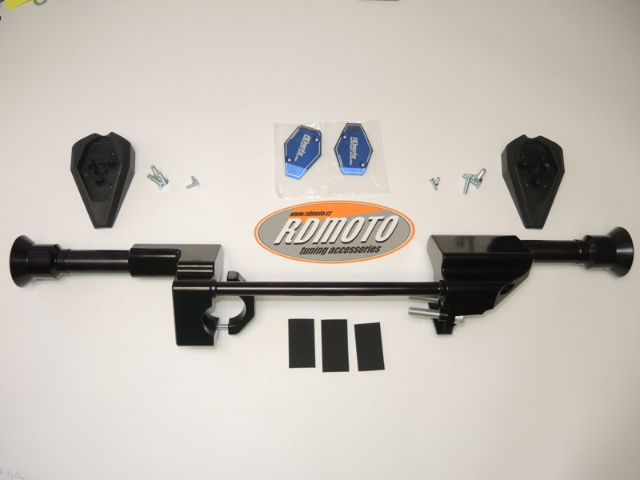

8
9
8
10
11
10
11
5
2
6
7
1
4
3
1
3
5
4
6
7
12
2

Instruction right side:
- Take out fairing.
- To give way bolts on coolant.
- Dismantle originál bolts from frame and mount dural. bracket ID.1 use bolts ID5.
- Mount duralumin bar ID.7 and use bolts ID.6.

Instruction left side:
- Take out fairing.
- Mount dural. bracket ID.1 use special clevis from back side ID.2 and use bolts ID7.
- Stick 3M tape on the frame ID.12, not to scratch frame
- Mount dural. bar use bolt ID.6

Mount fairing and coolant back to bike.

Instruction to assembly for protectors:
- Insert bolts ID. 5 into the dural.adapter for SL01 ID.4 a ID.3 after dural.cylinder ID.3 and ID.2
- This set mount on the bike.
- Mount slider ID.10, insert colour caps ID.9, use bolts ID.11
Use glue of all threads.

