Instruction right side:
- Take out fairing.
- To give awaz bolts from coolant.
- Take out originál bolts from frame and mount dural. bracket ID.1 use bolts ID4.
- To put through dural.bar ID.6 use bolts ID.5

Instruction left side::
- Take out fairing.
- Mount dural.bracket on the frame ID.1 use special clevis ID.2 and bolts ID.6.
- Mount dural. bar. And use bolt ID.5

Mount fairing coolant back to bike.

Instruction to assembly crash protectors:
- Insert into the protektor steel box ID.9
- To put through bolts ID. 4 a ID. 3 M12x135x1,25 to crash protektor.
- Put on the bolt dura. cylinder ID.2 a ID. 3
- This set mount on the bike

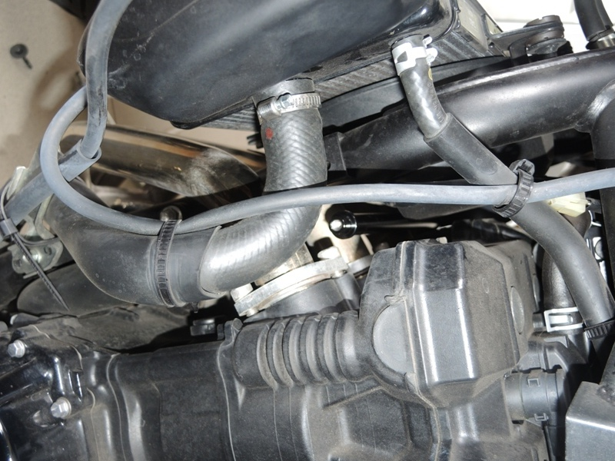
Use glue of all threads.
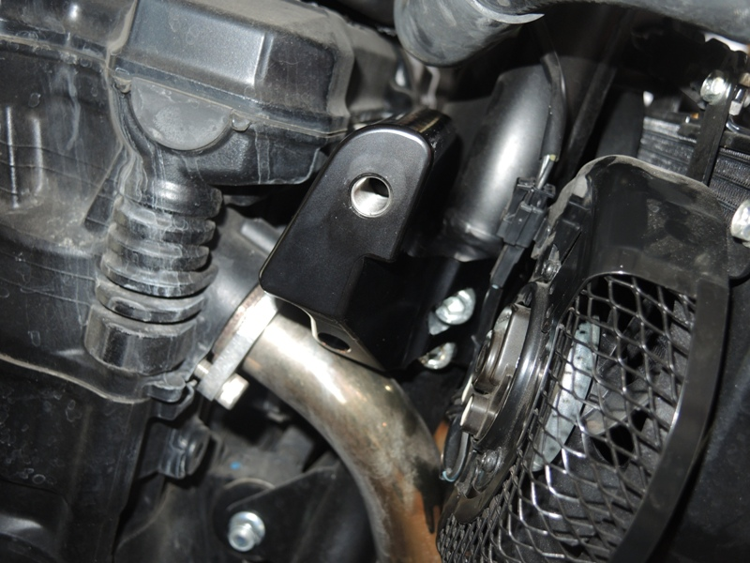

S35
Suzuki GSX 1250 FA-2010
ID | Description | Cat.n | Qty
1 | Dural.bracket | 664 | 1
2 | Dural. special clevis | 665 | 1
3 | Dural.cylinder d=90 | 143 | 1
4 | Bolt M12x135x1,25 | 991 | 1
5 | Bolt M6x30 | 863 | 1
6 | Bolt M6x50 | 867 | 2
7 | Crash protektor | PH | 1
8 | 3M tape |  | 1
9 | Steel box | X2 | 1
ID | Description | Cat.n | Qty
1 | Dural.bracket | 666 | 1
2 | Dural.cylinder d=90 | 143 | 1
3 | Bolt M12x135x1,25 | 991 | 1
4 | Bolt M10x50x1,25 | 921 | 2
5 | Bolt M6x30 | 863 | 1
6 | Dural.bar | 667 | 1
7 | Crash protector | PH | 1
8 | 3M tape | 3M | 2
9 | Steel box | X2 | 1
Fitting kit left side: Fitting kit right side:

