S36S
Suzuki GSX-R1000 2012-

Kit for the left side | Kit for the right side

ID | Description | Cat.n | qt |  | ID | Description | Cat.n | qt
3 | Alu.adapter for slider | 317 | 1 |  | 3 | Alu.adapter for slider | 317 | 1
4 | Bolt M10x30mm | 882 | 1 |  | 4 | Bolt M10x30mm | 882 | 1
5 | Bolt M6x25 | 877 | 3 |  | 5 | Bolt M6x25 | 877 | 3
6 | Bolt M4x16 | 876 | 2 |  | 6 | Bolt M4x16 | 876 | 2
7 | Boltb M10x60x1,25mm | 896 | 1 |  | 7 | Boltb M10x60x1,25mm | 896 | 1
8 | Alu. spacer d=10mm | 108 | 1 |  | 8 | Alu.spacer d=3mm | 284 | 1
9 | Steel adapter | 570 | 1 |  | 9 | Steel adapter | 569 | 1
11 | 3M tape |  | 1 |  | 11 | 3M tape |  | 1
12 | Poly.nut d=20mm | X10 | 1 |  | 12 | Poly. nut d=20mm | X10 | 1
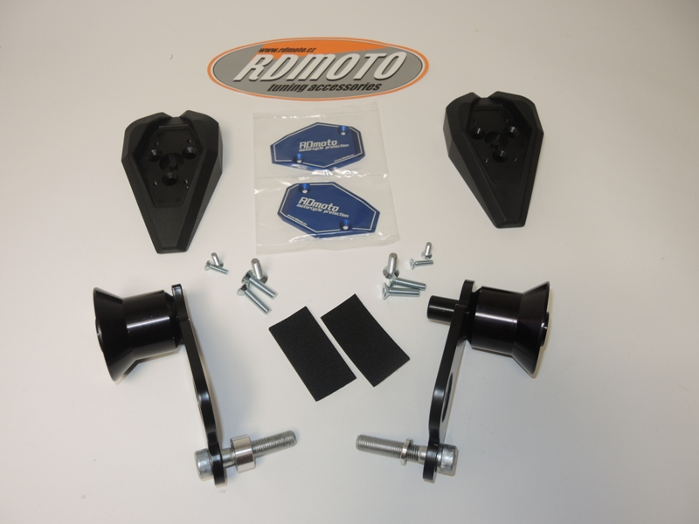

6
6
3
3
12
5
4
4
12

9
9

7
7

87
8

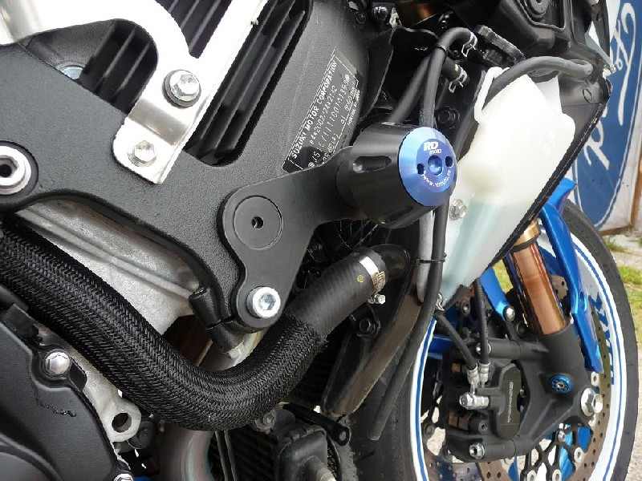
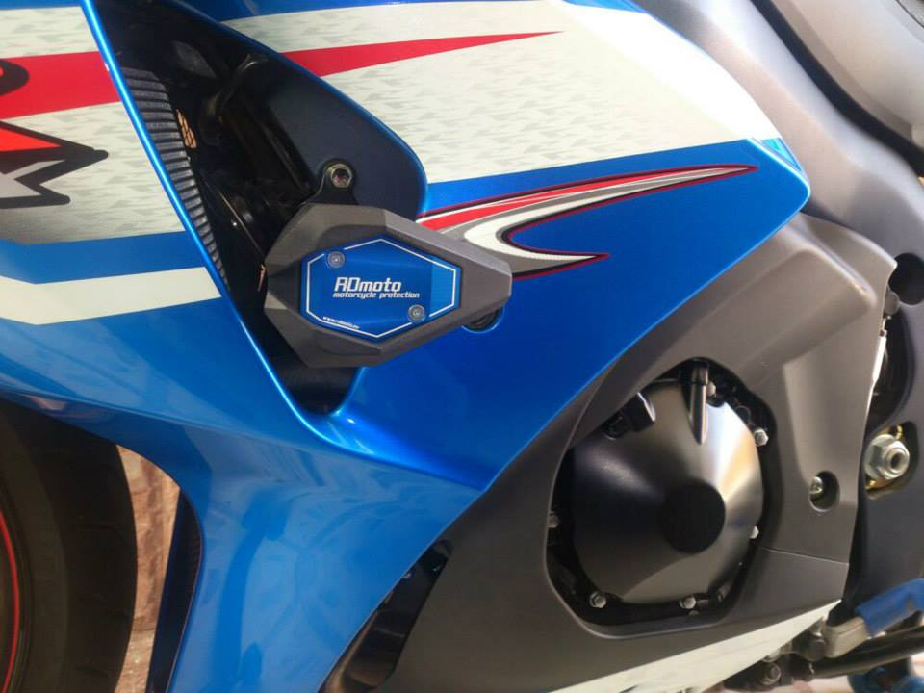

Installation – the left side:

- remove frame and the original bolt M10 from frame
- place ID.3 on the steel bracket and tighten it by bolt ID.4 from back side mount poly. Nut ID.12 on the bolt
- use the bolt ID.7 for mounting of the steel adapter ID9. Give the duralumin cylinder ID.8 under the adapter during the installation. Stick the 3M tape ID.11 on the frame of the motorcycle at the point of touching.
- Put fairing back the bike.
- use bolts ID.5 for gripping slider. Insert cover into the slider and use the bolts ID.6 for gripping

Installation – the right side:

- remove frame and the original bolt M10 from frame
- place ID.3 on the steel bracket and tighten it by bolt ID.4 from back side mount poly. Nut ID.12 on the bolt
- use the bolt ID.7 for mounting of the steel adapter ID9. Give the duralumin cylinder ID.8 under the adapter during the installation. Stick the 3M tape ID.11 on the frame of the motorcycle at the point of touching.
- Put fairing back the bike.
- use bolts ID.5 for gripping slider. Insert cover into the slider and use the bolts ID.6 for gripping

Warning – we recommend to use safety glue on threads of all bolts (moderate strong – blue colour).

