S36
Suzuki GSX-R1000 2012-

Kit for the left side |  |  |  |  | Kit for the right side
No. | Description | Cat.no | Pcs |  |  | No. | Description | Cat.no | Pcs
1 | Steel box M10 | X1 | 1 |  |  | 1 | Steel box M10 | X1 | 1
2 | Bolt M10x60x1,25mm | 896 | 1 |  |  | 2 | Bolt M10x60x1,25mm | 896 | 1
3 | Dural. cylinder d=10mm | 108 | 1 |  |  | 3 | Dural. cylinder d=3mm | 284 | 1
4 | Bolt M10x45mm | 848 | 1 |  |  | 4 | Bolt M10x45mm | 848 | 1
5 | Steel adapter | 570 | 1 |  |  | 5 | Steel adapter | 569 | 1
6 | Tape 3M | - | 1 |  |  | 6 | Tape 3M | - | 1
7 | Poly nut M10 d=20mm | X10 | 1 |  |  | 7 | Poly nut M10 d=20mm | X10 | 1
Installation – the left side:
- Remove the original side fairing and bolt M10 from frame.
- Stick 3M tape ID.6 on the steel adpter.
- Insert duralumin spacer ID. 3 into the frame, use the bolt ID. 2 and screw up adapter to frame of the motorcycle.
- Place steel box No. 1 into protector together with bolt ID. 4
- All this set mount to thread on adapter, mount poly nut ID. 7 on back side.
- Check all and now you can mount the original side fairing back.
Installation – the right side:

- Remove the original side fairing and bolt M10 from frame.
- Stick 3M tape ID.6 on the steel adpter.
- Insert duralumin spacer ID. 3 into the frame, use the bolt ID. 2 and screw up adapter to frame of the motorcycle.
- Place steel box No. 1 into protector together with bolt ID. 4
- All this set mount to thread on adapter, mount poly nut ID. 7 on back side.
- Check all and now you can mount the original side fairing back.

Warning – we recommend to use safety glue on threads of all bolts (moderate strong – blue colour).
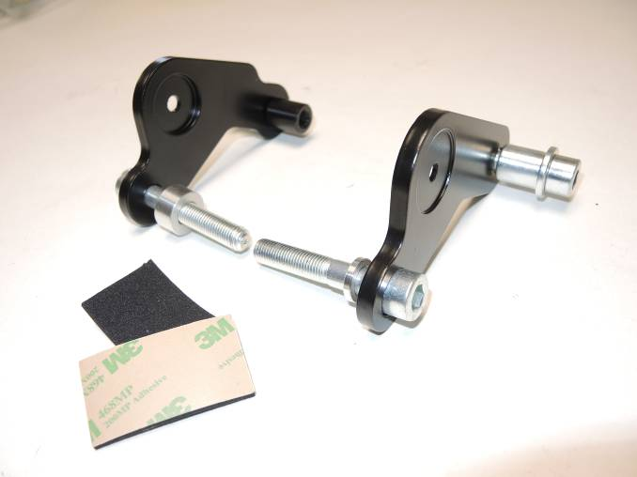
1
5
7
7
4
5
1
4
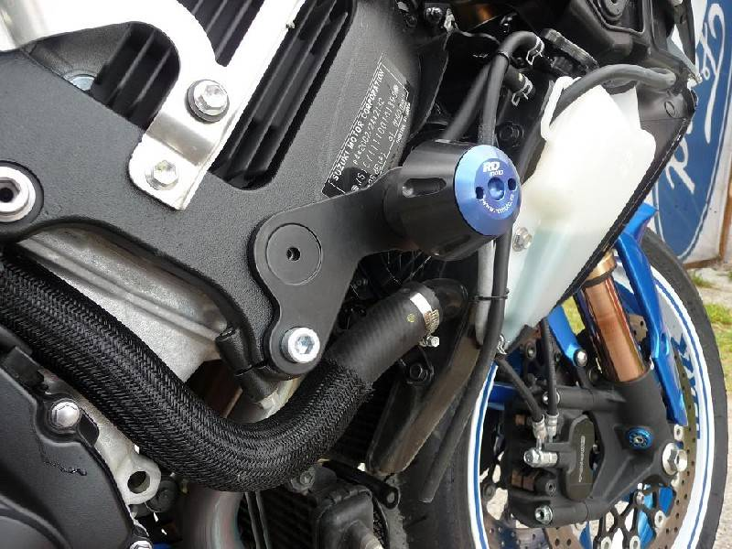
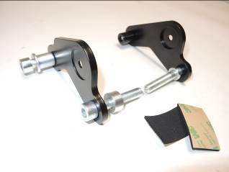
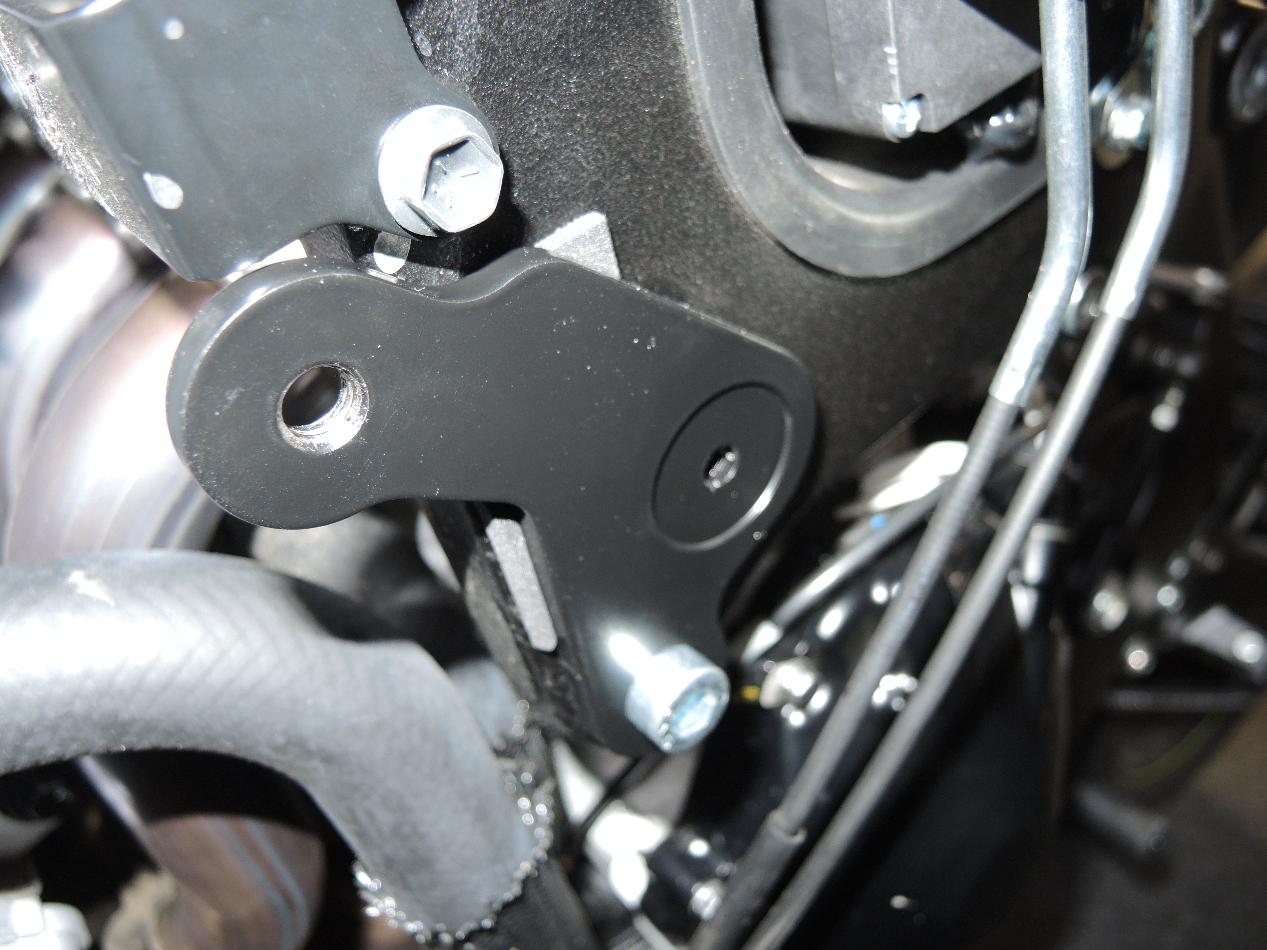
2
3
2
3

