S37SD
Suzuki DL650/1000 V-Strom 2017-

Kit for the Left Side: Kit for the Right Side:
ID | Description | Cat.No | Pcs
1 | Lock nut M12 | 811 | 1
2 | SLD adapter | 537 | 1
3 | Bolt M8x25 | 815 | 2
4 | Washer M8 | 800 | 2
5 | Dural. sleeve l=80mm | DV156 | 1
6 | Flat washer M12 | 803 | 1
7 | Stainless steel rod M12x495x30x30 |  | 1
ID | Description | Cat.No | Pcs
1 | Lock nut M12 | 811 | 1
2 | SLD adapter | 537 | 1
3 | Bolt M8x25 | 815 | 2
4 | Washer M8 | 800 | 2
5 | Dural. sleeve l=80mm | DV156 | 1
6 | Flat washer M12 | 803 | 1

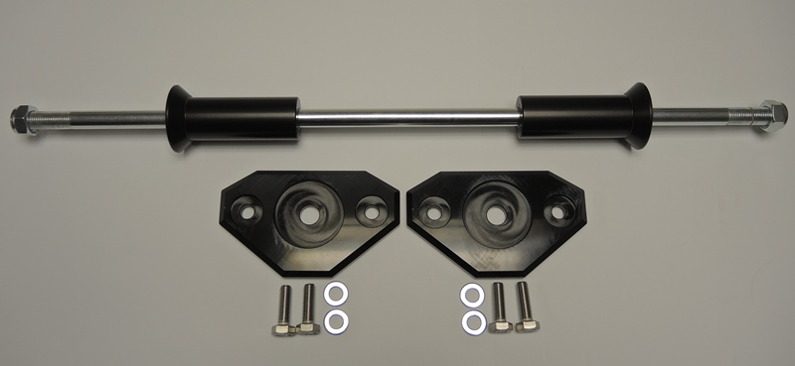
2

5

1

5

6
1
1

2
2

3
4

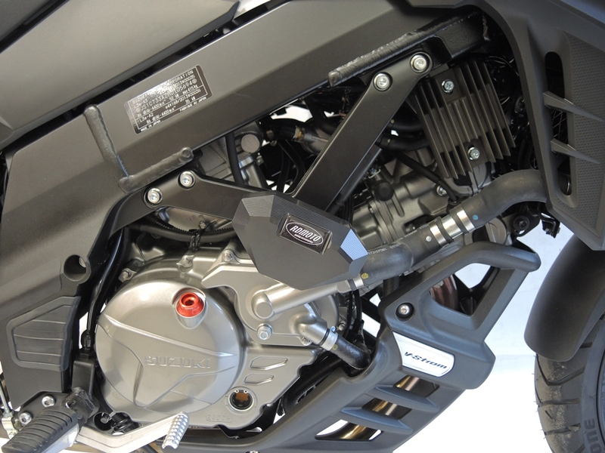
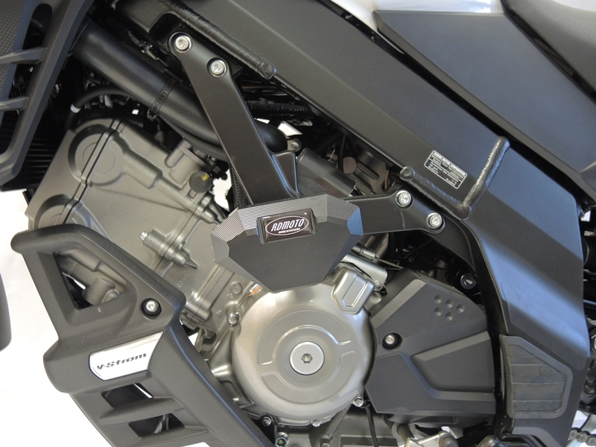

Instructions:

- Remove original bolts from the motorcycle frame.
- Insert the steel rod (ID 7) through the frame.
- Place the dural.sleeves (ID 5) on the rod.
- Place the slider adapters (ID2) and on the steel rod, M12 washer (ID6) and tighten with lock nuts M12 (ID1)
- Tighten the slider with two M8 botls (ID3) and M8 washers (ID4)

We recommend using medium strength thread glue during assembly.

