S37S
Suzuki DL650/1000 V-Strom 2012-

LEFT SIDE KIT RIGHT SIDE KIT
ID. | Description | Cat.no. | Pcs
1 | Special nut | X12 | 1
2 | Slider adapter | 314 | 1
3 | Bolt M6x25 | 877 | 3
4 | Bolt M4x16 | 876 | 2
5 | Dural. cylinder 50mm | 209 | 1
6 | Stainless steel rod M12x445x(1,25)x30x30 |  | 1
ID. | Description | Cat.no. | Pcs
1 | Special nut | X12 | 1
2 | Slider adapter | 314 | 1
3 | Bolt M6x25 | 877 | 3
4 | Bolt M4x16 | 876 | 2
5 | Dural. váleček d=50mm | 209 | 1
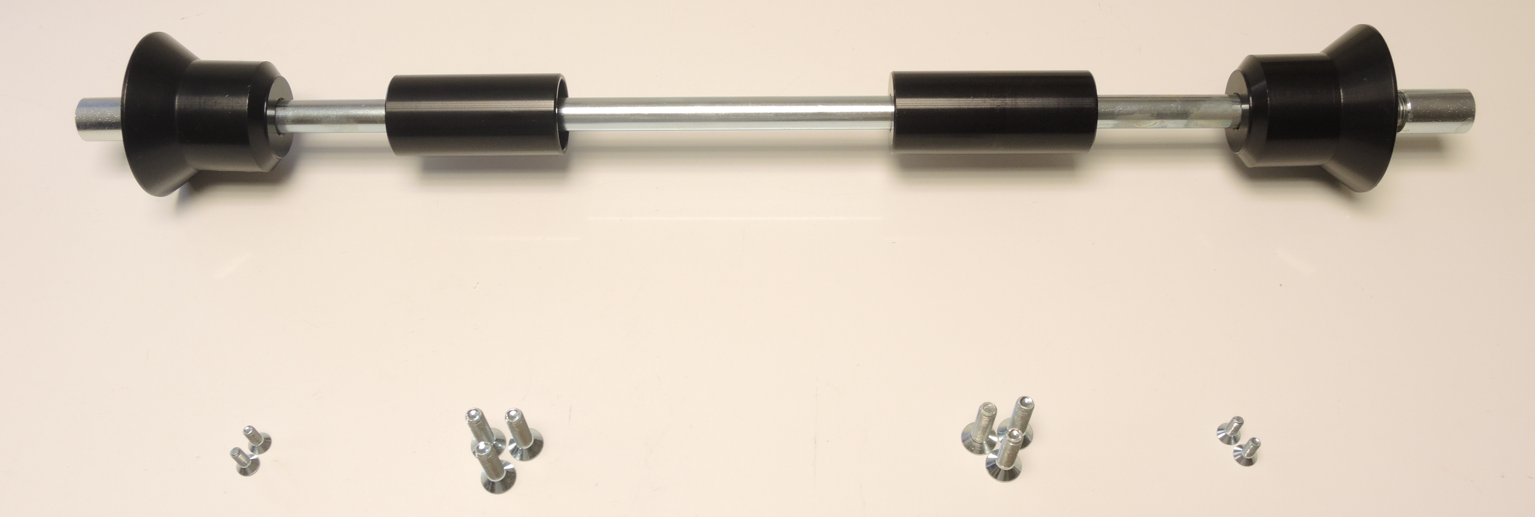
2

5

1

6

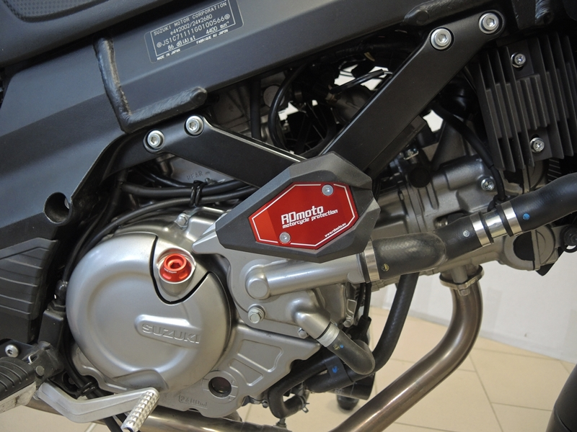
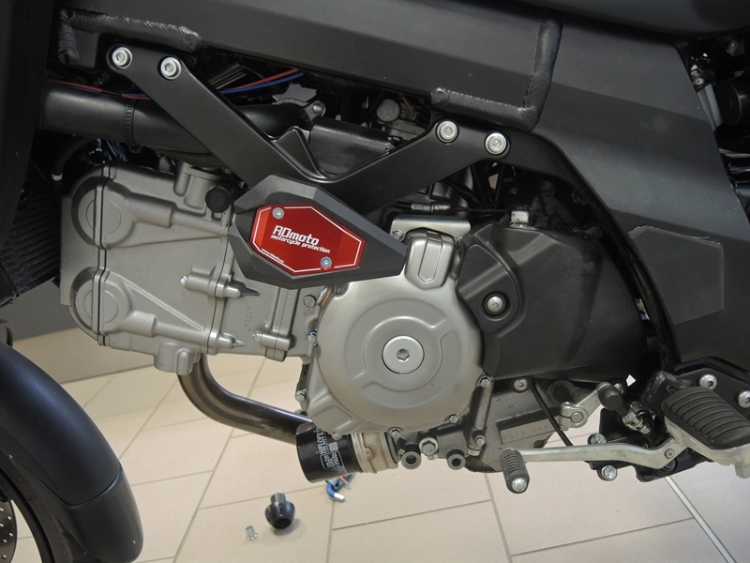
4

3

2

4

3

5

1

INSTRUCTIONS

- Unbolt original bolts from the frame.
- Place rod (ID.6) through the frame of motorcycle.
- Place drual. Cylinders ID5 and slider adapters ID2 on the rod. Tighten it using nut ID1.
- Fit slider using three M6 bolts.
- Fit cover using two M4 bolts.

We recommend to use safety glue on all threads (medium strong).

