S39S
Suzuki DL 1000 V-Strom 2014-
Fitting kit left side: Fitting kit right side:
ID. | Descrpition | Cat.N | Qt
1 | Dural. cylinder - 60mm | 1194 | 1
2 | Special nut | X12 | 1
3 | Slider adapter | 314 | 1
4 | Bolt M6x25 | 877 | 3
5 | Bolt M4x16 | 876 | 2
6 | Stainless rod M12x465x(1,25)x30x30 |  | 1
ID. | Description | Cat.n | Qt
1 | Dural. cylinder - 70mm | 296 | 1
2 | Special nut | X12 | 1
3 | Slider adapter | 314 | 1
4 | Bolt M6x25 | 877 | 3
5 | Bolt M4x16 | 876 | 2

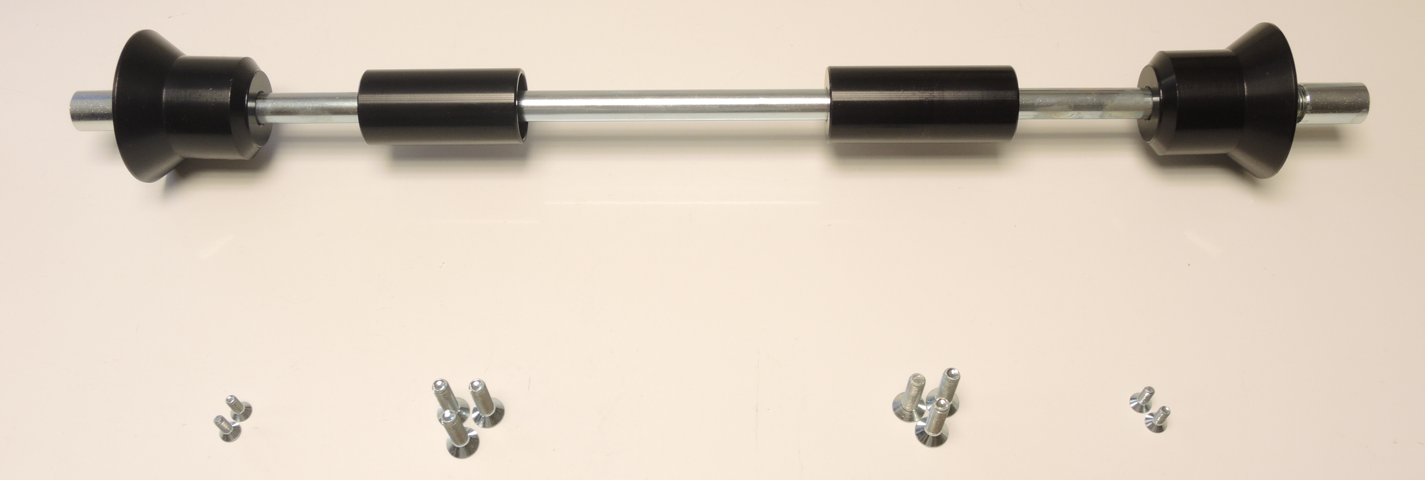
3

3

1

1

2

2

5

4

5

4

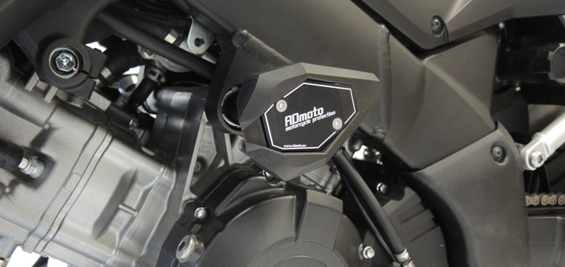
Instructions:

- Remove original bolts from frame of motorcycle.
- Insert steel rod (ID6) trhough the frame.
- Put dural cylinders (ID1) on the steel rod on both sides. Place Longer cylinder on the right.
- Put slider adapters (ID3) on the rod and tighten them using special nuts (ID2).
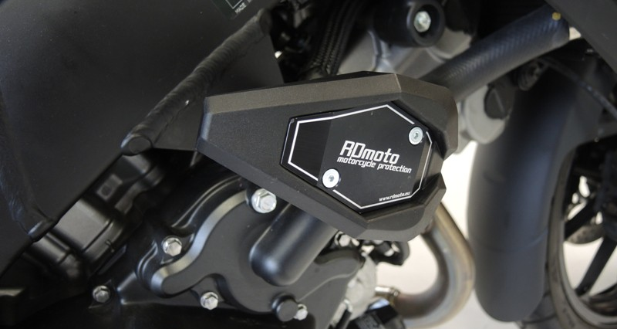
- Fit sliders on the adapters using three M6 bolts (ID4).
- Fit couloured cover using two M4 bolts (ID5).

We recommend to use glue on all threads.

