S3SDM
Suzuki SV650 N/S 2003-2006

LEFT SIDE KIT RIGHT SIDE KIT
ID | Description | Cat.No | QTY
1 | SLDM Adapter | 537/B | 1
2 | Bolt M10x130x1,25 | 905 | 1
3 | Dural.cylinder 20mm | 182 | 1
4 | Dural. cylinder 30mm | 11 | 1
5 | Washer M10 (spring) | 801 | 1
6 | Bolt M6x20 | 1024 | 2
7 | Washer M6 | 1023 | 2
ID | Description | Cat.No | QTY
1 | SLDM Adapter | 537/B | 1
2 | Bolt M10x180x1,25 | 969 | 1
3 | Dural.cylinder | 181 | 1
4 | Dural. cylinder 30mm | 11 | 1
5 | Washer M10 (spring) | 801 | 1
6 | Bolt M6x20 | 1024 | 2
7 | Washer M6 | 1023 | 2
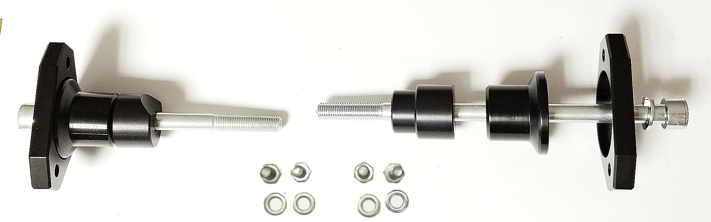
Instructions

- Unbolt original bolt from the frame of motorcycle.
- Put washer ID5, SLDM adapter ID1, dural cylinder ID4 and dural cylinder ID3 on bolt ID2.
- Fit this kit on the frame of motorcycle.
- Fit slider using two bolts ID6 and washers ID7.

We recommend to use the glue on all threads. Medium strong.
