S3SD
Suzuki SV650 N/S 2003-2006

LEFT SIDE KIT RIGHT SIDE KIT
ID | Description | Cat.No | QTY
1 | SLD Adapter | 537 | 1
2 | Bolt M10x130x1,25 | 905 | 1
3 | Dural.cylinder 20mm | 182 | 1
4 | Dural. cylinder 30mm | 11 | 1
5 | Washer M10 (spring) | 801 | 1
6 | Bolt M8x25 | 815 | 2
7 | Washer M8 | 800 | 2
ID | Description | Cat.No | QTY
1 | SLD Adapter | 537 | 1
2 | Bolt M10x180x1,25 | 969 | 1
3 | Dural.cylinder | 181 | 1
4 | Dural. cylinder 30mm | 11 | 1
5 | Washer M10 (spring) | 801 | 1
6 | Bolt M8x25 | 815 | 2
7 | Washer M8 | 800 | 2
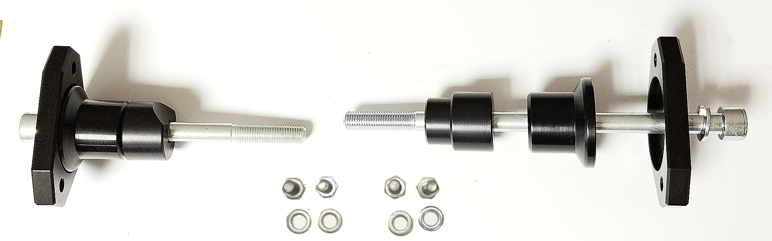
Instructions

- Unbolt original bolt from the frame of motorcycle.
- Put washer ID5, SLD adapter ID1, dural cylinder ID4 and dural cylinder ID3 on bolt ID2.
- Fit this kit on the frame of motorcycle.
- Fit slider using two bolts ID6 and washers ID7.

We recommend to use the glue on all threads. Medium strong.
