S40SD
Suzuki GSX-S1000 ´16-
Left side: Right side:
ID | Description | Cat. | Qt
1 | Dural. adapter | 537 | 1
2 | Bolt M10x90x1,25 | 890 | 1
3 | Dural. cylinder - 20mm | 1188 | 1
4 | Dural. adapter (cylinder) – 15mm | DV9 | 1
5 | Washer (stringed) | 801 | 1
6 | Washer M8 | 802 | 2
7 | Bolt M8x25 | 815 | 2
ID | Description | Cat. | Qt
1 | Dural. adapter | 537 | 1
2 | Bolt M10x100x1,25 | 892 | 1
3 | Dural. cylinder - 21,5mm | 1189 | 1
4 | Dural. adapter (cylinder) – 15mm | DV9 | 1
5 | Washer (stringed) | 801 | 1
6 | Washer M8 | 802 | 2
7 | Bolt M8x25 | 815 | 2

Instructions:
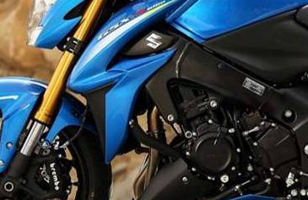
- We recommend to use the glue on all threads.
- Remove original bolt according to the picture.
- Prepare M10 bolt (ID2). Put stringed washer (ID5), dural. adapter (ID1), dural adapter (ID4) and dural. cylinder (ID3)* on bolt (ID2).
- Fit this kit on the frame of motorcycle.
- In the end fit protector on the adapter (ID1) using two bolts (ID7 + washers ID6).
*(note: dural adapter (ID3) is longer on the right side)
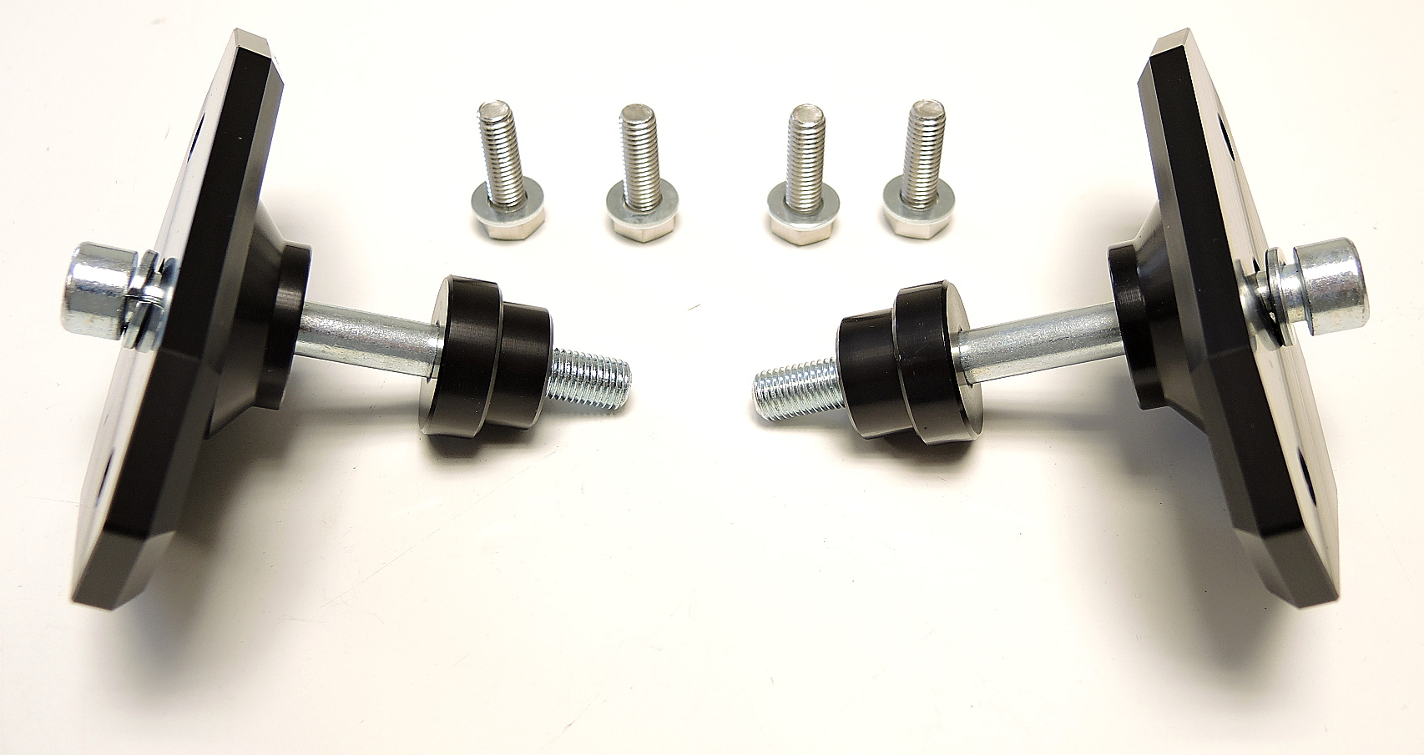
ID1
ID3
ID4
ID2+ID5
ID6
ID7

